The Psychological Continuum Model:
A Conceptual Framework for Understanding an Individual’s Psychological Connection to Sport
Daniel C. Funk
University of Texas
Jeff James
University of Illinois

Research on sport spectators and sport fans is examined to develop a model of the psychological connections that individuals experience with sports or sport teams. The Psychological Continuum Model (PCM) is introduced. It provides an extended view of sport spectator and sport fan involvement,
and outlines general parameters that may mediate the relationship between an individual and a sport or team. The PCM provides a framework that may account for an individual’s movement from initial awareness of a sport or team to eventual allegiance. Four levels are described and differentiated: awareness, attraction, attachment and allegiance. The model proposes that the psychological connections between an individual and a sport or team are governed by the complexity and strengthening of sport related mental associations. The PCM provides a model that integrates current research and suggests new directions for future research and applications. The extent to which people are interested in and follow sports and sport teams ranges from occasionally watching a televised game or attending a live event, to owning season tickets and attending or watching as many games as possible. One result of a strong connection to a sport team is that an individual feels a sense of personal success when the team wins and a sense of loss when the team loses. Pooley (1978) described a continuum that characterizes people’s interest in sport, with spectators at one end point and fans at the other:
Whereas a spectator of sport will observe a spectacle and forget it quickly, the fan
continues his interest until the intensity of feeling toward the team becomes so
great that parts of every day are devoted to either his team or in some instances, to
the broad realm of sport itself. (p. 14)
The growth and interest in research on sport spectators and fans has been grounded in a multi-disciplinary approach drawing theoretically from sociology, psychology, consumer behavior and marketing. Beginning with the work of Cialdini, Borden, Thorne, Walker, Freeman, and Sloan (1976), understanding the relationship between spectators or fans and sport teams continues to be a topic of much interest. What has emerged is a potpourri of instruments and concepts intended to evaluate this relationship.
Previous research has utilized demographic and environmental characteristics, examined attraction motives, measured cognitive, affective and behavioral factors, and profiled committed sport fans. Despite efforts to understand the unique characteristics of “fanship” in spectator sport, research in this area remains fragmented and inconsistent.
To date, no theoretical framework has been developed to guide our understanding of the underlying social-psychological process accounting for an individual’s shift from initial awareness of a sport or team to subsequent allegiance. Various terms have emerged to describe the connection that spectators and fans have with a sport or team. The terms used include: identification (Wann & Branscombe,
1990), attraction (Hansen & Gauthier, 1989), association, (Gladden, Milne, & Sutton, 1998), attachment (Funk et al., 2000), involvement, importance, commitment, and loyalty. As a result, any effort to review the literature becomes an exercise in untangling semantic differences.
This paper seeks to bring some order to the chaos by building a model of fan psychology that is grounded in the research literature and that differentiates spectators from fans. The resulting model – called the Psychological Continuum Model (PCM) – is intended to provide researchers with a platform for the systematic study of sport spectators and sport fans.
The different ways in which spectators and fans may relate to a sport object (e.g., a sport or team) have been conceptualized here in terms of distinct stages along a vertical psychological continuum. The continuum describes motives relating to the sport object and the evaluative processes by which a person internalizes features of the social situation. It seems unlikely that a person wakes up one day and finds that he or she is a loyal fan (buying season tickets, wearing related apparel, conversing about a team with friends, sharing in a team’s wins and losses). Accordingly, the PCM describes four general boundaries which operate on a continuum. Each boundary (or “floor” on the vertical continuum) represents a different level of psychological connection that an individual may have with sports and teams. The model further outlines a temporal process through which an individual develops a stronger connection to a sport or team.
The Psychological Continuum Model
A conceptual model grounded in theoretical and applied research is presented in Figure 1. The Psychological Continuum Model (PCM) specifies the general parameters in which a relationship between an individual, sport or athlete is mediated. Within the PCM framework, the object-related connection (e.g., a sport or team) is considered interchangeable. Much of the discussion, however, is devoted to athletic teams. The model represents a cognitive approach that places existing fan behavior theory and research under one conceptual umbrella. Four general boundaries operating along a vertical continuum are conceptualized to characterize the various psychological connections that sport spectators and fans may form with specific sports and teams. The initial floor, Awareness, denotes when an individual first learns that certain sports, and/or teams exist, but does not have a specific favorite. The second floor, Attraction, indicates when an individual acknowledges having a favorite team or favorite sport based upon various social-psychological and demographic-based motives. On the third floor, Attachment, a psychological connection begins to crystallize, creating various degrees of association between the individual and the sport object (e.g., a favorite team). Attachment represents the degree or strength of association based upon the perceived importance attached to physical and psychological features associated with a team or sport. Finally, on the fourth floor, Allegiance, an individual has become a loyal (or committed) fan of the sport or team. Allegiance results in influential attitudes that produce consistent and durable behavior.
Figure 1: The Psychological Continuum Model (PCM) – A conceptual framework for understanding an individual’s psychological connection to sport (3As to Allegiance)

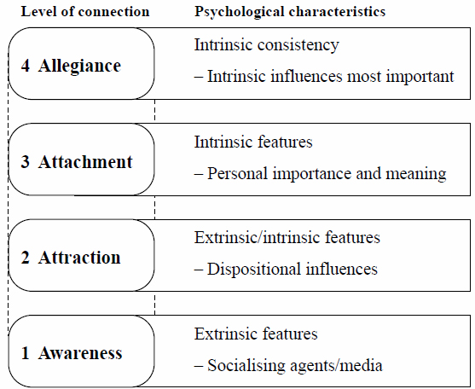
figure 1.
Distinguishing Between the PCM and Prior Models
Before presenting a fuller explanation of the PCM, it is important to note that this model is similar in nature to other models – particularly, the Hierarchy of Effects Theory, stages of adoption, and escalating commitment. However, the focus of these models is on the outcome of desired behavioral changes. In contrast, the PCM focuses on the psychological relationship an individual may form with a sport object (e.g., a sport or team) and identifies the different factors thought to influence the formation
of a strong connection relative to a sport object. A brief discussion of each model is provided and compared to the PCM.
Hierarchy of Effects Theory
The basic premise of the Hierarchy of Effects Theory is that in order for consumers to be motivated to a desired action (e.g., a purchase), they must be aware of a product’s existence, be interested enough to pay attention to the product’s features or benefits, and have a desire to benefit from the product’s offerings (Barry, 1987). These four steps make up the Awareness Interest Desire Action (AIDA) model first proposed to explain consumer purchase behavior. Barry (1987) explains that as the theory has
matured a number of models have been developed to explain the Hierarchy of Effects.

For example, Lavidge and Steiner (1961) proposed a model that takes into account learning theory and other models from the field of psychology. Lavidge and Steiner proposed that consumers pass through five stages: (a) awareness, (b) knowledge, (c) liking, (d) preference and (e) purchase. The different stages describe how an individual experiences three distinct phases of learning: cognitive (thinking),
affective (feeling), and cognitive (doing). These ideas form the basis for three competing Hierarchy of Effects models – Learning Hierarchy, Dissonance Hierarchy, and Low-Involvement Hierarchy (Solomon, 1996). The three competing models vary as to the temporal order in which the different learning phases occur, the impact that different phases have on attitudes toward an object, and the reason for purchasing a product.
Other models have also been offered to account for the Hierarchy of Effects. Ray (1973) proposed a Three Orders Model, suggesting that different circumstances determine which of the three hierarchies (learning, dissonance, low-involvement) was dominant in a given situation. The Three Orders Model sought to identify the appropriate effects ordering relative to the consumer’s involvement with a product and the availability of alternative products. An important aspect of the Three Orders Model incorporated in the PCM is the use of involvement to characterize the stage of an individual’s psychological connection to a sport object.

Stages of Adoption
Another approach for integrating the competing Hierarchy of Effects models is the
Transtheoretical Model (TTM). The TTM is a multidimensional accounting for behavioral change. The model proposes six stages through which an individual progresses in order to change his or her behavior: (a) pre-contemplation, not ready to change; (b) contemplation, thinking about change; (c) preparation, taking small steps to change; (d) action, overt change for less than six months; (e) maintenance, overt change for more than six months; and (e) termination, overt behavior ceases. The transition between stages is affected by a set of variables known as the processes of change, which include depositional balance (weighing the pros and cons of change), self-efficacy (confidence in the ability to change), and situational influences.
The Hierarchy of Effects models and the TTM are representative of the stages of adoption framework. This framework serves as a guide to understanding how people progress through various stages or phases and modify behavior. Brooks (2000) discusses the Active Lifestyle Stages of Adoption Model (ALSAM) in the context of promoting active lifestyles. This model incorporates stages of the TTM and tenets of decision-making theory. The ALSAM and the other Hierarchy of Effects models noted above illustrate several important concepts that have been integrated into the PCM.
The PCM is similar in nature to other effects and stages of adoption models in that it proposes that there are different levels of psychological connection that an individual may form with a sport object. The PCM is an integrative model in that thinking, feeling and doing are important elements in developing a psychological connection to a sport object. Moreover, the PCM can be used as the social psychological complement to these frameworks. Unlike other models, however, the PCM focuses on the psychological connection an individual forms and provides a framework for better understanding when different phases of learning are operative in relation to developing a stronger psychological connection to a sport or team. A key distinction from other models is the PCM’s focus on the social-psychological connection an individual makes with the sport object. This extends our understanding
beyond behavioral change by characterizing the formation of the psychological connection and the factors that influence a connection that is persistent and resistant to change. One other notable difference with the PCM is the movement among the different levels. A fuller discussion of the model will highlight the point that an individual may move from a higher to a lower level (i.e., a person’s attitude and feelings toward a team may change) or an individual may not progress beyond certain
levels (i.e., no progress beyond awareness of sports).
Models of Escalating Commitment
The PCM also bears some similarity to models of escalating commitment, particularly Mullin, Hardy, and Sutton’s (2000) Escalator Model of segmentation. There are, however, significant differences between the two. While the Escalator Model has been widely used, segmentation in the model is behaviorally driven. In contrast, the PCM concentrates upon the internal psychological processes that account for different levels of psychological connection. The PCM has some distinct advantages that allow for a more comprehensive interpretation of an individual’s relationship with a team. For example, two individuals may first become aware of a new team simultaneously. Individual A quickly proceeds through levels of attraction and attachment and becomes allegiant to the team. This has been evident in season ticket holders from one WNBA franchise. In contrast, individual B proceeds to the second level of attraction and spends time internalizing attractive components of the sport or team before moving to attachment. In this example, the path to allegiance and a willingness to proceed to a higher level signifying a stronger psychological connection is temporally different. Individual B may never choose to leave the attraction or attachment level.
Another difference is that the Escalator Model assumes individuals proceed at the same behavioral pace once they have climbed aboard and are only directed upward. Mullin et al. (2000) acknowledges that defection rates exist, but the model does not outline how an individual reverses direction and lowers his or her psychological involvement. The PCM accounts for how individuals can choose to decrease the importance of the relationship by moving to a lower level (e.g., due to work, family obligations, vacation, etc.). The next section provides a fuller explanation of the PCM, including a synopsis of research associated with each level. A discussion outlining the movement between the levels follows. Finally, potential application of the model and ideas for future research are given.
------------------------------------------------------
First Floor: Awareness
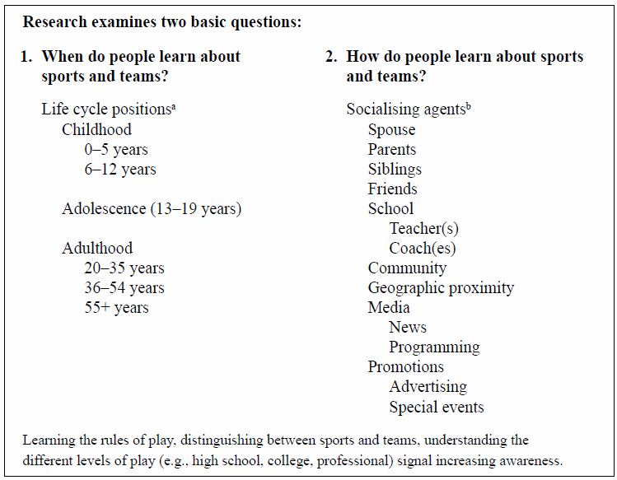
The process of forming a psychological connection to a sport or team begins with the notion of awareness. The initial connection to a sport object that a person forms is the recognition that different sports and teams exist. Two questions of primary interest at this level are: (1) When do people become aware of sports and teams? (2) How do people become aware of sports and teams? Awareness marks the low end of the vertical continuum; recalling a specific team (e.g., the Chicago Bulls) when cued by a word (e.g., basketball) signals movement upward within the awareness level. Increasing awareness would include understanding how a sport is played (the basic rules) and distinguishing between different teams and sports.
Introduction to sports may occur very early in life when parents dress their children in clothes with sport logos, or buy balls, gloves or other sport paraphernalia. Children may also learn about sports from playing with friends, through school activities, or by participating in community youth leagues. While a child may become aware of sports and teams early in life, they may not move “up” the continuum – learning about and distinguishing between specific sports and teams – until a later point (adolescence or into adulthood). Adults experience the initial level of awareness when new sports (e.g., extreme sports), teams (e.g., expansion teams), and leagues (e.g., Arena Football League) emerge during their lifetime.
Research Dealing with Awareness
Research on sport fans and spectators has not examined when people first became aware of sports and teams, or what factors influence the initial awareness of sports. Work done on the topic of sport socialization does, however, provide some direction for understanding the awareness level. Research has examined various socializing agents that introduce or draw individuals to sports as participants. Results have indicated that people are drawn to sports due to the influence of significant others – such as parents, peers and coaches – and institutions – such as school, church, community and media.
Parents shape a child’s interest in games and activities, and fathers play a primary role in introducing children, particularly boys, to sports. Research suggests that parents are the primary socializing agents during the preschool years (0–5 years of age). Once a child makes the transition to school and becomes part of a wider social network, friends are thought to have a greater influence on a child’s interests, which may include introducing them to different sports.
James (in press) looked indirectly at the notion of awareness by identifying when a child first demonstrates the characteristics of a team fan and what factors influence children to choose and form a connection to a particular team (i.e., identifying a favorite team). Findings indicated that children were aware of different sport teams at least by age 5. Consistent with earlier research, results have shown that fathers play an important role in introducing children to sports and teams by talking about and/or watching specific sports and teams on television. Interviews with children aged 5, 6, 8, and 9 years also indicated that television introduced non-traditional sports (e.g., gymnastics and swimming), particularly for girls (James, in press). No significant influence was found for siblings and peers with respect to introducing children to sports.
Awareness – Recognizing that Sports and Teams Exist
Once an individual knows that sports and teams exist (e.g., adults), he or she may return to the awareness level when new sports and teams emerge. The findings discussed above suggest that awareness of sports and teams for children is driven by the socialization process. Research examining awareness related to adults should also analyze the socialization process and the differential influence of various socializing agents. In addition to family, friends and the mass media, geographic proximity (moving to a new community), the influence of one’s spouse, co-workers, and even the emphasis a community places on sport or supporting the “home team” could influence an individual’s awareness of sport. With adults, awareness of sports and teams focuses more on the traditional role of promotion or the introduction of a new product (a new sport, team, or league).
Awareness marks the initial introduction to sports and teams, and can occur at different points in life. Table 1 provides a synopsis of different positions in the life cycle and the various socializing agents that may influence an individual’s awareness of sports and teams. Research at this level should explore how children and adults are introduced to sports and the differential effect of socializing agents at various points in a person’s life.
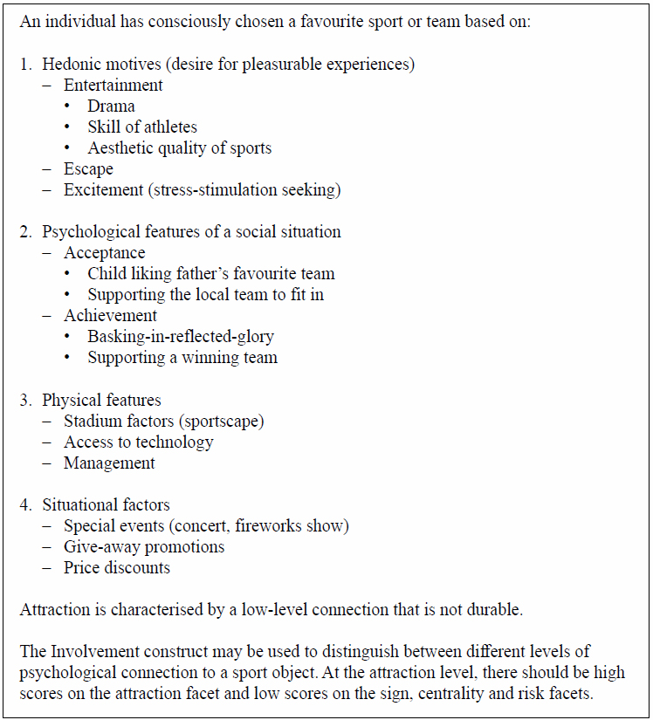
------------------------------------------------------
Second Floor: Attraction
Knowing that sports and teams exist, but having no interest in sports, signals that a person has achieved a level of awareness, but not attraction. For example, a person may know that popular sports in North America include football, baseball, basketball and ice hockey. The same person, however, may not like any of those sports and will not invest his or her time, money or emotions to follow them. As a person begins to distinguish between different sports and teams, learns the rules of play, knows the names of different teams, and understands the different levels of a sport (e.g., high school, college and professional football), he or she experiences an increasing level of awareness and moves towards attraction. Increasing awareness may lead an individual to compare and contrast different sports and teams and make the conscious decision that he or she likes one sport or team more than others. Selecting a favorite sport or team suggests that a person has reached the attraction level. It is important to note that attraction is the result of an individual willingly comparing and evaluating different sports and teams, and acknowledging that they have a favorite sport or team.
Attraction is thought to result from psychological features of the social situation and hedonic motives. For example, a child may choose a football team as their favorite because it is his or her father’s favorite team; the child’s connection to the team is tenuous at best. If the father changes his favorite team, so would the child. Moving to a new community may influence an individual to begin liking a local team because he or she wants to “fit in” and support the home team. Once an individual makes new friends, supporting the team may no longer be important. Deciding to follow a specific sport or a particular team may also be influenced by performance (e.g., jumping on the bandwagon when a team is successful). Moreover, various forms of advertising that promote specific attributes and benefits of the sport product (e.g., entertainment, an opportunity to escape) may influence an individual’s choice of a favorite sport or team.
Research Dealing with Attraction
Much of the research to date on spectators and fans has focused on identifying different motives (primarily hedonic and utilitarian) that influence behavior. Researchers have examined achievement (basking-in-reflected-glory, BIRGing), entertainment, escape, action, drama, physical attraction, social interaction, supporting women’s opportunities, stadium factors and wholesome environment. Results have demonstrated that people enjoy attending games of their favorite team as an escape from their daily routine (Trail & James, in press), to experience vicarious achievement, and to follow a specific sport for the opportunity to be entertained. Entertainment may come from watching the high level of physical skill found in college and professional sports (Trail & James, in press), enjoying the aesthetic qualities of sport (Trail & James, in press), or through ancillary activities before or after a game, such as give-away promotions, discounts or concerts. Research has also examined attraction in the contexts of service quality, utilization of technology, and managerial decisions. Hill and Green (2000) observed that stadium factors (e.g., cleanliness, food and beverage quality, parking) influenced game attendance intentions at three Australian rugby stadiums. Beech et al. investigated web-based strategies among Premier League clubs and reported that utilizing Internet technology could help to attract and monitor new and existing supporters. Nier and Sheard (1999) reported that management’s ability to attract new club members among elite rugby clubs was related to utilizing resources to maintain and promote values associated with current club supporters. Taken together, this area of research has identified a number of physical features related to the team that individuals find attractive and utilize to form a preference for one particular team over another. Table 2 provides a summary of the factors influencing the selection of a favorite sport or team.
Attraction – Acknowledging a Favorite Sport or Team
People at the attraction level may watch sports on television, attend games, and even wear team apparel. At this level, however, the motivation seems to be based on transient situational or hedonic motives. As noted above, a person may simply seek entertainment or escape; an individual may follow a team because his or her partner or friends like the team, because he or she wants to show support for the community, or because he or she is attracted by a special promotion or give-away offered by a team. An individual may also be attracted by the construction or renovation of a new facility. These ideas suggest that attraction can be thought of as a low-level connection to a sport or team that is not necessarily durable or stable. When situational factors change, or alternative entertainment options are available, an individual’s attraction may also change. This was the case with the Florida Marlins and is indicative of fair weather fans. The Marlins won the World Series in 1997, but in the next year were one of the worst teams in baseball. During the championship season there was no shortage of Marlins fans. One year later, however, ticket sales and television ratings indicated that the number of people who thought of the Marlins as their favorite team had dropped dramatically. The low-level connection that characterizes attraction has been documented in research dealing with cutting off reflected failure (CORFing). A person enjoys following a team while performance is good, but when a team begins to lose, the individual no longer supports the team. CORFing may be used to demonstrate that a person has reached the level of attraction. An individual at this level would be a spectator as characterized by Pooley (1978). Another area of research that provides insight to the attraction level is the work on involvement. A variety of research dealing with involvement has been conducted in general leisure and sport settings. Previous work has focused on characterizing involvement and developing instruments to measure the multi-dimensional construct. Involvement is defined as a “state of motivation, arousal or interest toward a recreational activity or associated product.” Involvement has been characterized using five facets that have received broad support: (a) attraction, the interest in an activity or product and pleasure (hedonic value) derived from participation or use; (b) sign, the unspoken statement that purchase or participation conveys about the person (e.g., playing basketball because that is the
game cool kids play; showing support for the home team in order to feel accepted by friends and co-workers); (c) centrality to lifestyle, encompassing friends and families centered around activities, and the central role of the activities (e.g., supporting a specific team) in an individual’s life; (d) risk probability, the perceived probability of making a poor choice (e.g., not attending a game); (e) risk consequence, the perceived importance of negative consequences in the case of a poor choice, perhaps supporting a losing team.
As a motivational construct, involvement provides a means by which to distinguish between attraction and attachment in the PCM. Such a distinction is based on the differential influence the various involvement components may exert. Researchers have demonstrated that the various components do not equally influence involvement with a product (e.g., a sport or team). Kerstetter and Kovich (1997) reported significant differences for enjoyment (attraction) and sign (the value associated with supporting the team – the importance to an individual that others recognize that he or she is a supporter of the team) among people attending women’s college basketball games. For booster club members (or fans, according to Pooley’s [1978] distinction) sign was a significant factor; for other respondents (spectators, according to Pooley’s distinction), sign was not significant.
The facets of involvement can be thought of as exerting differential influence on an individual’s psychological connection to a sport or team. Having sport consumers complete items measuring the facets of involvement could enable researchers to distinguish between different levels of psychological connection to a sport or team. For example, individuals at the awareness level would be expected to have low scores (low involvement) on each facet; they know that sports and teams exist, but are not interested in sports or teams. Individuals who have an attraction to a sport or team would be expected to score highly on the attraction facet of involvement (hedonic value), but lower on the sign and centrality facets. As we will note later in the paper, individuals who have an allegiance to a sport or team would be expected to score highly on the centrality facet (the importance of a sport or team to an individual’s lifestyle). The utility of the involvement construct for the model, however, is not simply examining high or low involvement to distinguish between levels of psychological connection; rather, it is the ability to examine the different facets of involvement within different levels of the psychological connection continuum. The strength of an individual’s psychological connection to a sport or team and high levels of involvement on facets such as centrality and sign are key factors that distinguish attraction from attachment.

------------------------------------------------------
Third Floor: Attachment
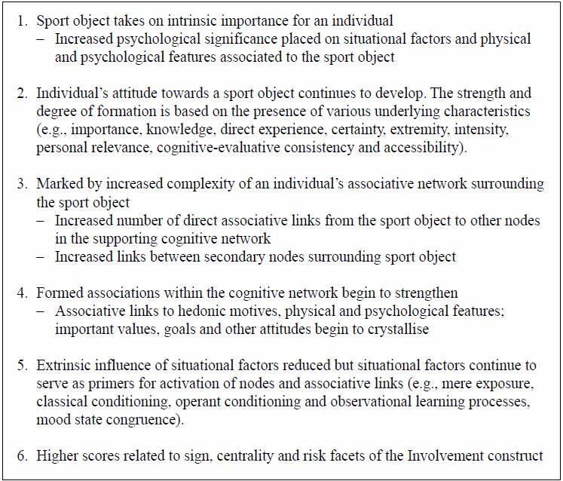
A person has reached the level of attachment when he or she has formed a stable psychological connection to a sport or team. We argue that attachment is based more on intrinsic than extrinsic processes. In contrast to attraction, attachment refers to the degree to which physical and psychological features (i.e., attributes and benefits associated with a team such as success, star player, stadium, identification, community pride) take on internal psychological meaning (Gladden & Funk, 2001). Attachment represents the “strength” or degree to which evaluative tendencies and responses elicited by a team or sport trigger certain associations that are meaningful – the classic components of an attitude. We conceptualize attachment’s distinctiveness from attraction in terms of the extent to which certain mental associations linked to a sport or team are intrinsically important. We now draw upon previous literature to highlight these differences.
Research Dealing with Attachment
In the context of attitude research, evaluative responses and the tendencies they elicit are regarded as differing in valence or direction along a positive/negative continuum. Previous research in spectator sport has essentially assessed the extent to which a person’s attitude towards a sport object is generally positive or negative, and the influence of that attitude on feelings and behaviors. However, recent theorizing suggests that valence is only one of several properties that attitudes possess. Various underlying properties such as valence, importance, extremity, certainty, intensity, knowledge, direct experience, and personal relevance have been measured to reflect the attitude’s structure and formation. In line with this perspective, previous work in leisure settings has diagnosed underlying characteristics of attitudes by examining properties related to extremity, certainty, prior knowledge, importance, and personal relevance. More recently, initial evidence has verified the utility of adopting contemporary attitude theory to investigate multiple properties related to attitudes towards professional sport teams. Among these properties, importance (i.e., psychological meaning attached to an attitude) has been observed to be a strong predictor of attitudinal commitment (Funk & Pastore, 2000). This initial evidence indicates that importance may represent the condition that produces the temporal difference in an individual’s attitude toward his or her relationship with a sport or team. Table 3 provides a summary of the influence of importance on attachment to a favorite sport or team.

Attachment – Formation of a Stable Psychological Connection
Traditionally, importance as an attitude property describes an individual’s subjective beliefs associated with the evaluation of an object based upon its perceived relevance. Importance represents the psychological significance and value attached to an attitude related to a focal object. In a sport or team context, attitude importance is thought to represent the psychological meaning and value attached to responses and tendencies elicited by a sport or team (Funk et al., 2000). This preliminary evidence suggests that the level of psychological significance and value connected to a team accounts for how attraction proceeds into attachment.

Attachment develops when the team elicits responses and tendencies from memory that strengthen internal links between the team and other important attitudes, values, and beliefs (core characteristics related to self-concept). This intrinsic process would help explain how meaning is attached to external associations (e.g., success, pride in place, stadium) and take on internal psychological significance (Gladden & Funk, 2001). Over time, continuous activation or mere exposure would strengthen these connecting links and embed the team firmly within the individual’s larger associative network, eventually creating a more complex network and stronger relationship (more direct associative links between the team and other central attitudes, goals and values). Essentially, importance serves to strengthen emotional links between the team and an individual’s self-interest, values and social identification, resulting in a strong psychological connection between the individual and the team. We also suggest that numerous associations may have to be developed and activated over time to create attachment’s foundation.
A multitude of associations linked to the team would probably be accompanied by increased levels of team-related knowledge, more direct experience with the team, and certainty in one’s evaluation of the team. For example, an individual who is attracted to a star player of a team may not become attached to
the team until other associations such as success, nostalgia, head coach, or community pride begin to take on importance. Teams may foster movement to the attachment level by providing more information about the players and coaches, by encouraging direct experience with the team (e.g., attending games rather than watching them on television, meeting the players), and developing an image that is valued within the community (e.g., hard work, giving back to the community). We suggest that attachment may result from a collective strengthening of various physical and psychological features linking the team to other important attitudes, beliefs and values. This would result in a more complex network of links that are activated when an evaluation of the team is primed (by ads, conversation, memory) and lead to a stronger relationship with a team; a relationship that would be expected to move to the final level of allegiance.

The strength of the psychological connection to a sport or team is the basis for distinguishing between attraction and attachment, and also between attraction and allegiance. One means by which to make such distinctions is through assessment of the facets comprising involvement. To individuals who have developed an attachment to a sport or team, the sign, centrality and risk facets would become important. The involvement facets may also provide a means of capturing the underlying importance of a team, helping to quantify an individual’s attitude strength.
------------------------------------------------------
Fourth Floor: Allegiance
Allegiance represents the zenith of the continuum. But what is meant by allegiance? The Random House Dictionary defines allegiance as “loyalty or devotion to some one, group, cause or the like” (p. 36). The notion that allegiance represents loyalty to a group is important here because the PCM focuses on an individual’s loyalty to a sport or team. Although the term “allegiance” has not often been used in the fan behavior literature, we use it to describe the construct of loyalty.
Research Dealing with Allegiance
Previous research has focused on the phenomenon of consumer loyalty in the areas
of marketing, consumer behavior, and recreation. Much of this work stems from the notion that brand loyalty plays a critical role in repeat purchase behavior – an idea that remains a common assumption among academic scholars and practitioners. While brand loyalty research continues to be widely used to study aspects of consumer behavior in numerous contexts, its application to sports has recently gained momentum.
In sport-related research, early investigations relied primarily upon game attendance figures to measure the behavioral component of loyalty. Due to the relative ease of measuring behavior and self-reports of behavior, the attitudinal component of fan loyalty has remained underdeveloped and largely ignored. However, just as consumer researchers discovered the need for cognitive, affective and behavioral factors in explaining brand loyalty for consumer products, researchers have also recognized that the loyalty phenomenon is more complex than can be captured by merely measuring attendance behavior.
Attitudinal Loyalty
Murrell and Dietz (1992) were among the first to develop an attitudinal measure to examine individual differences in support for a college football team. This research demonstrated that attitudinal support for a team did not depend on actual game attendance. In a subsequent study, Mahony and Howard (1998) observed that a “strong” positive attitude towards a favorite sport team was related to the consumption of sport events featuring that team. This study suggested that attitude formation and
related behavior should be considered when investigating fan loyalty. Dick and Basu (1994) conceptualized loyalty as representing differentiation within the level of attitude strength. In line with this perspective, Funk and Pastore (2000) observed that nine attitude strength properties were significantly related to team loyalty.
In line with contemporary attitude theory, we conceptualize loyalty in the model as an overall construct to note efficiently that allegiant fans possess highly formed attitudes towards a specific team – attitudes that strengthen the psychological connection. This strengthening occurs when responses and tendencies elicited by a team persist, resist counter-persuasion, influence cognition, and impact on behavior. Characteristics of this strengthening are presented in Table 4. Persistence would represent the activation frequency and duration of attitudes linked to a favorite team (i.e., related cognition activity in normal daily life: daily, weekly, monthly, over ten years). Persistent attitudes are thought to remain unchanged and stable over an extended period of time regardless of the type of information being encountered. However, when loyal fans encounter information contrary to previous attitudes, the degree to which these attitudes remain unchanged reflects a resistance quality. In addition to persistence, highly formed attitudes are thought to be resistant to change.

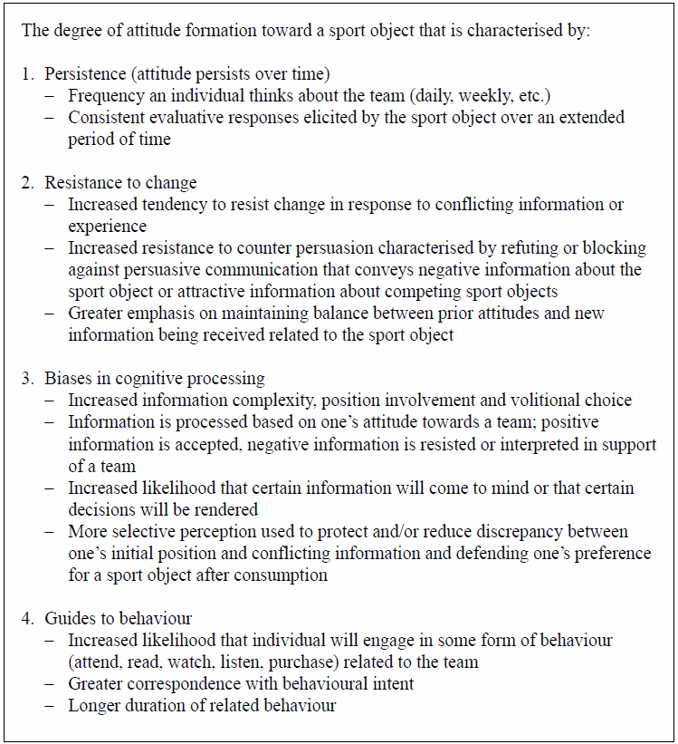
Table 4: Allegiance – Loyalty to a Sport Object
Several consumer theorists have suggested that resistance to changing one’s attitude represents the general underlying factor contributing to consumer commitment. Within the leisure literature, commitment is often conceptualized as a psychological construct. For example, Iwasaki & Havitz (1998) conceptualized psychological commitment as stemming from greater knowledge, certainty in one’s opinion, degree of consistency between feelings and beliefs, and personal relevance of information related to evaluating decisions to participate in a leisure activity. This type of commitment is also thought to reflect preference (i.e., volition) stability towards an object, brand or issue, as well as resistance to persuasive attempts promoting alternative choices (Crosby & Taylor, 1983; Dick & Basu, 1994). In a recent study, Pritchard et al. (1999) provided initial evidence that information complexity, position involvement and volitional choice contributed to patrons’ commitment to a recreation activity.

Mahony et al. (2000) integrated the resistance literature to develop an attitudinal dimension (i.e., psychological commitment) to examine individual differences in support of professional football teams. Mahony et al. Demonstrated that psychological commitment levels were related to frequency of games watched on television and games attended. Gladden and Funk (2001) utilized an attitudinal commitment component to examine the link between consumer associations and loyalty to a team sport. Hill and Green (2000) observed that team loyalty and psychological involvement accounted for future attendance intentions among rugby spectators. These efforts underscore the utility of incorporating attitude research to understand how attitudes influence cognitive processing and behavior related to a team.

This type of cognitive processing is thought to influence judgments made concerning information encountered about a particular object. For example, in an unpublished dissertation Funk (1998) demonstrated that individuals committed to a sport team possessed highly formed attitude properties, reported more thoughts, recalled more article facts and engaged in more biased thinking related to a newspaper article written about the team than individuals who possessed weak attitudes. Funk and Pastore (2000) observed that commitment was also highly correlated with reported behavior and behavioral intent for individuals of a professional baseball team.
In the model, we suggest that commitment to a sport team reflects an attitude (i.e., evaluation of that relationship) that persists over time, resists counter attitudinal information, biases cognitive processing and guides behavior. Moreover, this attitude toward a team is internally consistent with other core attitudes, values, self-concept, information processing and behavior. This internal consistency or stability of evaluation represents the core characteristic of allegiance to a sport or team by self.

defining a person’s commitment to that relationship. The notion that psychological commitment to a team may prove beneficial in understanding behavior for sport spectators and fans has gained momentum in the literature. We stipulate that allegiance reflects the extent to which an attitude is persistent, resistant, and influences cognition and behavior. These four strength-related consequences of an attitude are thought to represent causal indicators of a strong, stable and continuous relationship with an athletic team and are viewed as determinants of loyalty. From this perspective, we can conceptually elaborate upon previous definitions by partitioning the attitudinal component of loyalty into three independent yet related components: persistence, resistance, and cognitive processes. This approach also provides a more in-depth understanding of how the attitudinal dimension relates to the behavioral dimension.

Behavioral Loyalty
Our behavioral perspective is consistent with Jacoby and Chestnut (1978) who conceptualized loyal behavior as a phenomenon expressed by a biased, behavioral response, expressed over time, made by some decision-making unit, and with respect to one or more alternative brands in a set of brands. It should be noted that our allegiance perspective still encompasses the composite approach to understanding loyalty, but places emphasis on a reciprocal relationship that exists between how attitudes and behaviors shape strong, stable and continuous involvement with an athletic team. The behavioral component involves: (1) a behavior itself (e.g., purchase of ticket or merchandise, attendance at a sport event), and (2) a behavior that is expressed with some duration in a situational context (e.g., watching the team every Sunday on television).
------------------------------------------------------
Discussion
The purpose of this paper has been to introduce the PCM and to characterize concurrently the existing research on sport spectators and sport fans as falling into four general categories along a continuum. A secondary purpose is to provide researchers with a conceptual framework for understanding the temporal processes accounting for shifts along a continuum from awareness of a sport or team to allegiance to a sport or team. The PCM provides an initial framework for understanding and examining sport-related research in the context of an individual’s psychological connection to sport and exploring the temporal process through which that connection moves. Although the PCM offers general parameters in which a relationship between an individual and a sport or team can be characterized, understanding how movement among and between these boundaries is mediated is not fully understood. In attempts to further thinking in this area, the following section provides a discussion related to movement along the continuum, and suggests how different forces may provide the momentum for such movement. It suggests directions for future research.

Distinguishing Between Awareness and Attraction
General awareness of sports usually begins during childhood, but awareness continues to be pertinent over time because of the emergence of new sports, new teams (expansion), moving to a city with a particular team, parents supporting their child’s interest in a sport that they (the parents) are not familiar with, etc. Regardless of one’s position in the life cycle, research at this level will examine the degree to which socializing agents moderate the introduction to sports and the value placed on sports (i.e., the importance of sport from a societal perspective). Studies will focus primarily on extrinsic factors, the influence of family, peers, the mass media, and other socializing agents. Awareness could be characterized as knowledge that a team or sport exists (e.g., being able to list various sport teams), low scores on involvement facets, and no psychological connection (e.g., no preference for or no identification with a specific team).

When an individual consciously decides that they have a favorite sport or team, they have reached the second level – attraction. Liking one specific sport or team may result from situational influences (team performance, promotional giveaways, star player, etc.) and/or hedonic motives (desire for entertainment, escape, opportunity to be with friends, etc.). A key characteristic of attraction is that such preferences are not yet enduring. When a team loses consistently, or other entertainment options are available, an individual may decide not to follow or support a once-favorite team. Movement from awareness to attachment may be sparked through promotional efforts when a team is winning, or by a special event such as a championship or all-star game. Promotional efforts would serve to entice those who are aware of a sport or team to take a greater interest, and at the same time reinforce the existing links to a sport or team among those who are attached or allegiant. Teams may also foster awareness by targeting new residents to a community, perhaps through ties with community visitor bureaus. Research on attraction will examine the interest that people have in sports (hedonic motives), looking more closely for similarities and differences across sports, and the extent to which various situational factors influence decisions to follow specific teams. Attraction could be characterized through acknowledging a favorite team, higher scores on the attraction facet of the involvement construct, and a low level connection to a team (e.g., low team identification). Greater importance placed on promotional items such as give-aways or price discounts as influences on behavior could also be used to measure attraction versus attachment to a team.

Distinguishing Between Attraction and Attachment
At the level of attachment, an individual has developed an emotional connection to a sport or team that is stronger than mere attraction. This connection is valued, protected, and linked to other important attitudes, values, goals, and self-interests. As the relationship takes on greater temporal importance, the perceived meaning attached to the team (e.g., physical and psychological associations) becomes embedded within a larger, more complex network of links that contribute to the fan’s self-concept. In other words, when a person thinks about a specific team, this response represents an attitude that is considered strong to the point that it manifests some (though not necessarily all) of the following: persistence, resistance to change, impact on cognition and behavior. At this stage, there is greater complexity, internal consistency, certainty, affective-cognitive consistency, and personal relevance related to a team or sport. In this context, attachment is thought to reflect not only preference (i.e., volition) stability towards an object, but also a motivation to resist alternative choices. The transition from attraction to attachment to allegiance has received little research attention. More is warranted.

An individual who attends a favorite team’s games, watches the team’s games on television, and wears team apparel may be at the level of attraction or attachment. Attachment is distinguished from attraction by the importance of the sport or team to an individual. An individual scoring highly on the attraction and centrality facets of involvement would be at the level of attachment. Cognitive mapping techniques could also be employed to explore the complexity of the cognitive association networks evoked by a sport or team.

A person who has moderate or high team identification would also be at the attachment level. For this person, the team is important, the team is representative of personal beliefs and values. The individual at the level of attraction, however, has not assimilated the team into the self-concept. Feeling part of a team (not just supporting a favorite team) represents attachment to a team.

Distinguishing Between Attraction and Allegiance
The top of the model, allegiance, is characterized by persistence, resistance to change, and impact on cognitive processes and behavior. The key difference between attachment and allegiance rests in the individual’s commitment to the relationship. We argue that while attachment represents the point at which physical and psychological features associated with a sport or team begin to take on internal significance, commitment reflects the durability and impact of those associations that produce a strong, persistent relationship with a team or sport. The durability of this relationship reflects the formation and structure of attitudes that remain unchanged over time and in the face of counter-persuasive information (i.e., persistence and resistance). The importance of the relationship will also influence the extent of information processing, making it more likely that certain information will come to mind or that certain judgments will be rendered. One result will be that behaviors consistent with allegiance will be manifested.

Allegiance differs from attachment in terms of the extent to which cognition (e.g., attitudes – intensity, values, goals – to achieve) contributes to an internally stable and consistent evaluation of a relationship with a team. This internal consistency produces commitment and identifies the point upon the continuum that attachment becomes allegiance. For example, if information related to a favorite team conflicts with current beliefs, the attached fan will invoke cognitive effort to process and re-evaluate the information in order to restore internal consistency. Exertion of greater mental effort to restore consistency suggests that structural instability exists within the attitude network. In this situation, fondness for the team may be inconsistent with beliefs about the team’s ability to win, inappropriate actions of its athletes, or its ability to promote positive social values.

In contrast, the allegiant fan’s evaluative response reflects an involuntary process whereby inconsistent information is automatically rejected, or is processed in a biased manner that is consistent with previous knowledge, convictions and personal experience. The allegiant fan will invoke an automatic response that protects and restores consistency in the relationship. A rapid restoration of consistency signals that the person’s attitudinal structure is internally stable, thereby producing commitment.

Movement Along the Psychological Continuum
The PCM provides an important first step in furthering our understanding of spectator and fan interest in a sport or team by assessing the strength and structure of an individual’s psychological connection to the sport or team. The model helps us understand the differential influence of various factors along a vertical continuum. It is important to note, however, that the vertical continuum is not constrained exclusively to upward movement; nor do people necessarily move from one extreme to the other (e.g., entering at the first floor and going all the way to the fourth floor).

Most people, if not all, will have some awareness of sport if for no other reason than its pervasiveness in society. Beginning with awareness, many will continue to higher levels on the continuum, learning about different sports and teams and forming an attraction for specific sports and/or teams. Others, however, may never progress beyond awareness. They may know about sports, but have no interest in following sports. Among people who have a favorite sport or team, there will be those who continue to progress up the continuum by developing strong attitudes towards sport until a sport or team becomes psychologically important to them. Even further, some will develop allegiance to a sport or team to the point that their connection influences cognition and behavior. A person moving up the continuum may also choose to stay at any one of the different stages.

It is also possible that people will travel back down the continuum. A person may lose interest in a particular sport and go from being an allegiant fan to being a spectator (e.g., go from buying season tickets to attending one or two games per year). A person may also be at different stages for different sports. Someone may be an allegiant football fan and at the same time only have an attraction to baseball. Looking at movement down the continuum, and also stationary positioning at different stages are two areas that have not been addressed by researchers, and that provide opportunities for future study. Research at this level should include assessment of individual differences, such as personality traits, and the extent to which individual differences moderate movement between stages.

Application of the PCM Model
While the PCM is intended primarily for the study of sport consumers, there are a number of possible extensions. One interesting possibility for future work would be to use the model to analyze current relationships among business partners marketing through sport. In this context, the model could be applied by corporations seeking to understand how to effectively utilize sport properties through corporate sponsorship in developing long-term business-to-business relationships.

The PCM may prove a useful tool for market segmentation. Consumption patterns may vary as a function of consumers’ level on the PCM; responses to marketing communications or promotions may vary as a function of consumers’ level on the PCM. If either is the case, the PCM may help to better target marketing activities.

The PCM might also be useful in one of the fastest growing areas of collegiate sport: charitable giving. Athletic departments seeking to build long-term and profitable relationships with alumni, community leaders and corporations could incorporate this framework to effectively utilize incentives (e.g., affiliation, special recognition, parking privileges, social events, reciprocity) to increase donor activity. As when managing a brand, university athletic departments should explore how associations take on internal psychological meaning in the donor’s mind and are linked to the team and university. Identifying conditions under which certain features of a program become important (e.g., moving donor attraction to attachment) and linked to other important attitudes, values, and goals, contingent-giving programs could be instituted to foster affiliation and reciprocity motives to enhance donations.

Managerial Levers
Managerial levers developed through relationship marketing could be implemented to foster incremental movement up the PCM. The four levels generally associated with relationship marketing provide ideas to stimulate movement along the continuum. The first level of relationship marketing, financial bonding, concentrates on providing financial incentives, such as lower prices. Financial incentives may serve as an enticement to buy more tickets or attend more games; such efforts are likely to be most effective in fostering attraction. For example, people interested in a reasonably priced entertainment package may be motivated to attend games. Without the incentive, however, people at the level of attraction may seek other forms of entertainment.

The second level, social bonding, may provide the means for fostering movement from attraction to attachment. Social and interpersonal bonds can be developed by acknowledging sport spectators and making them feel important. For example, when the members of a team (operations and player personnel) learn people’s names and talk with them, and when people are acknowledged through special services (e.g., invited to team dinners, have an opportunity to talk with an owner or a coach), an individual’s esteem is bolstered and greater value is placed on the association with the team (i.e., greater importance). Efforts to personalize the experience of following a team contribute to forming a strong attitude toward a team. The third and fourth levels of relationship marketing, customization and structural bonding, may help foster movement from attachment to allegiance. Customization bonding focuses on tailoring services and experiences to individuals. In a sport or team context, the idea is to learn what fans desire from their connection to a team, and then work to satisfy those desires. Customization builds from social bonding and seeks to tailor experiences for individuals. Structural bonding involves providing services that are designed for a specific client or customer (e.g., fan loyalty programs, venue kiosks), often based on technology.

Although not discussed in the framework of relationship marketing, efforts to foster fan identification and strengthen attachment could also influence movement along the continuum. Sutton et al. proposed increasing team or player accessibility to the public, increasing community involvement activities, and reinforcing the team’s history and tradition. Each of these ideas may serve to foster a social bond, thereby fostering movement from attraction to attachment. Creating opportunities for group affiliation and participation, like customization bonding, could also stimulate movement from attraction to attachment. Reinforcing the team’s history and tradition or emphasizing the team’s connections in the community may foster movement from attraction to allegiance.
Conclusion
Although there is an emerging body of research examining differences among and within spectators and fans, there has not yet been a model to integrate the findings. The PCM provides that model. Several aspects of the model need to be addressed in future research. Very little research has examined how socializing agents influence awareness of sports at different points in the life cycle and the differential influence of various socializing agents over time. Moreover, no research has examined the transition from attraction to attachment, and what factors moderate or mediate the formation of relationships with sports or teams. Research that examines such facets as persistence, resistance to change, and cognition is also needed to develop measures of attitudinal strength. One area of research that has not been explored is movement downward – when an allegiant fan begins to reduce his or her connection to a team. The PCM provides a useful framework for work of this kind.

