Laws of Physics:

1. Simplicity to complexity:
Everything in the universe is ordered in a hierarchy (as a method of construction) from simplicity to complexity.
2. Everything in the universe is based on contagions (circles).
sub-law 1: The number "three," makes a crowd, and thus a contagion or a circle.
- Quarks have three basic components: up qark, and two down qarks. Atoms have electrons, neutrons, and electrons (a quantum field which is the energy projection of the strong nuclear force.
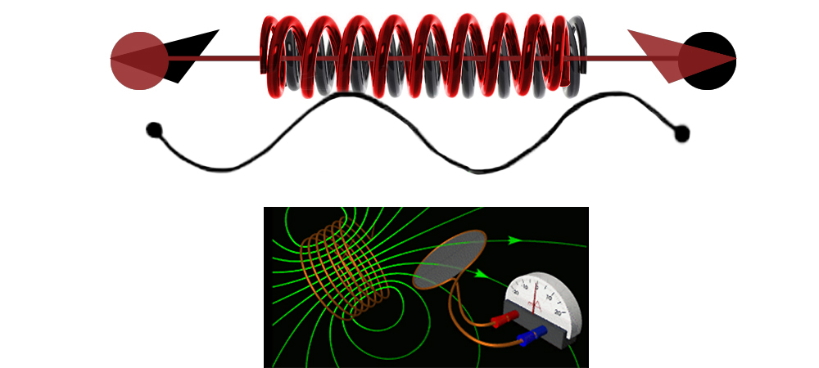
3. Each dimension prior, creates the next dimension after:
dimension 1:
line segments of strings of energy flow in a single direction.
dimension 2:
line segments (of strings) overlap each other to create the emergent property of going fowards and backwards and sideways, crossing over each other, thus creating strings or "coils" (relating to Faraday's Law of induction).
dimension 3:
the emergent properties of line segments overlapping each other in two dimensions allows line segments of strings to bend into circles, creating current, but also quarks.
dimension 4:
a result of the differentiation of energy disparities in space, thus creating spacetime.
4. When energy crosses itself in opposite directions, it creates a polar charge (a charge, + and - ):
Line segments of strings in the second dimension overlap each other, like springs interweaved, going in opposite directions.
5. The universe is equal to the number 12. And E=MC² is equal to the number 12.
Four dimensions * 1) energy, 2) mass, and 3) speed of light (causality).
4 * 3 = 12
1+2 = 3 (dimensions)
3 + 1 (time) = 4
360° ÷ 12 = 30°
30 + 30 + 30 + 30 = 120
120° + 120° + 120° = 360° (a circle)
6. The speed of light (c²), is equal to 1.
360° (a circle) = First 3 dimensions
3+6+0 = 9 (circle)
9+1 = 10 (circle + causality or 1 dimension to make it the 4th dimension = 1 Meaning: 3.14)
1+0 = 1 (the 4th dimension, is c² or speed of light)

