Abstract:
“Social-Spacetime”
Our social world explained as a visual construct of Einstein's spacetime.
A sports marketing perspective.
Work in progress from 2010-2021 (and still being worked on!)
© 2021 Dan Perceval
Introduction:
Social-spacetime is a visual construction of our social world. It is governed by laws: “The Laws of Social Fabrics.” These laws govern the properties of social-spacetime such as size, behavior, complexity, and nature of it. Social-spacetime properties are directly affected by two main agents of change: 1) social objects: people, ideas, and events, and 2) resources: food, energy, land, and technology. Both act as contagions or nodes inside social-spacetime, and are quintessentially “social-mass.” Social mass is an agent of change: the more you have of it, the more gravitational mass and therefore “gravitational pull” there will be and therefore the more likelihood of change.

Networks inside social-spacetime can materialize into more complex structures (social networks) that are akin to asteroids, solar systems, and galaxies, in ordinary cosmological spacetime.

Large network structures are the equivalent of culture in social-spacetime. Plasticity: how well formed a system is – whether an asteroid with satellites, a solar system, or a galaxy – all have spheres of influence within its gravitational reach. For example, contagions can crystallize into social networks and become a group, system, or societal networks. These networks have varying degrees of spheres of influence known as gravitational reach. The degree to which how large a network's gravitation reach and how complex its network structure is, determines the network's plasticity. The plasticity of a social network is equivalent to how resistant to change it is. For example, when a variable (social mass) is inserted or taken out of the its network structure, and how much of that change actually reverberates across social-spacetime, such dropping a little rock or a big stone into a pond and watching the degree to which the cascading ripple effect affects everything else in the pond – shows us the plasticity of a network by making a change to the contagion. The plasticity of a societal network's, for example (figure-1), has very little plasticity. It is a very rigid social structure that doesn't change often because of its large social mass. But it also has other networks inside of it – groups (as asteroids) and systems (as solar systems) – that are much more pliable (marked as blue and red dots – figure 1) and therefore are much more plastic (able to change).

At the core of a societal network, exists extremely powerful spheres of gravitational influence such as the economy and the government – as a blackhole would at is center – with its enormous pull. The core of a blackhole – such behaving as an enormous contagion – behaves as the “heaviest” social mass structure in the cosmological system. [It] in other words, holds the system together. Without it, the system will be thrown into chaos causing extreme perterbations throughout its network structure. Smaller social mass structures can also exist inside social networks with a lesser degree of gravitation spheres of influences, but they too, act in much a similar way in holding together the its network structure through the pull of its social mass.

Inside social networks, our biological instincts – driven by hormones through the wiring of our brains – act as agents of change inside a social system, thus becoming the agents of change of the overall system. Therefore, our biological instinacts (the laws of social fabrics) are the agents of change inside our own individual social fabrics. This bends the very fabric of “social-spacetime” (figure 1) in the social-spacetime around us. The “social” in social-spacetime defines social events in a visually constructive way akin to the organization and visualization and the properties of Einstein's ordinary spacetime.

figure 1.
Societal Social Fabric:
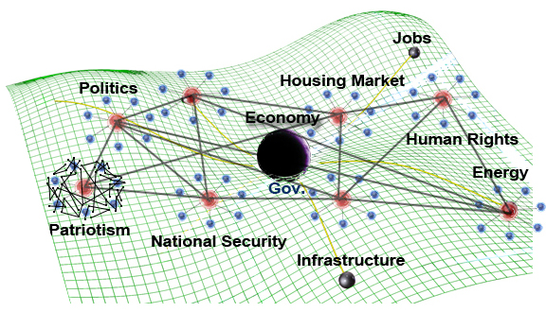
Inside any social network however exists causality created mostly by the decisions we make and the actions we take. [Resources] also affect social-spacetime in that they too affect the creation of causality (social events) – but not as much as our own individual actions (“we” as social objects) .
Our actions are mostly guided by our innate, hormone-driven behaviors called “The Laws of Social Fabrics” (chapter II). They represent our instincts, influencing the decisions we make. The laws therefore can serve as a prediction model of human behavior. For example, we are more likely to protect ourselves from an immediate threat, than to search for food or water at that exact moment (an Amygdala hijack). Or, for example, we are more apt to be aware of people standing in our own physical space than those standing at a distance from us (perceptual awareness). Using these predictive behaviors (laws) alongside the framework of social-spacetime we can build a real world model of our social world, predicting social events and epidemics before they occur (figure 1). Having proper data collection in place such as “big data,” and artificial intelligence, are needed for this system to work as an automated, self-learning, artificially intelligent system (such as an “answer engine” rather than a search engine).
Background of my research:
The research behind The Social Fabric Framework originally began as sports marketing research for a new sport I pioneered in 2005, “Xtreme Ice Skating.” While the sport came to a close in early 2013, my ongoing research into the matter never ceased. In late 2012 however, a few months prior to that event, my research morphed into something much more profound. It became about the nature of the “Social Fabric Framework,” soon after Hurricane Sandy reached my shore.
Immediately after Hurricane Sandy's landfall, most things in my town became inaccessible: electricity, hot water, heat, appliances, access to fresh food, and etc... The storm had suddenly stripped away our abundance of resources and technology, resulting in, society's complex social patterns instantly breaking down. We now had to work hard for the things that used to come easy. Conditions stayed this way for three weeks. The simple social patterns that emerged represented the needs of our “id” (our humanity). They are the underlying psychological principles that affect all our decisions, consciously and subconsciously. More fundamentally, they are our body's hormones maintaining homeostasis guiding behaviors. They remain the same regardless of complexity in society. Therefore, I categorized them into “The Laws of Social Fabrics” (chapter II). If the laws ever [did] change or become inconsistent, then biologically, if we're ever faced with an immanent threat such as an attack by a viscous animal, we might not react with a “fight-or-flight” response – an Amygdala hijack – as expected. This would greatly reduce our chances of survival even in situations where our lives are endangered in a different way and our energy and focus is required. “Safety” therefore is the first, most important law in The Laws of Social Fabrics as it is fundamental to our survival. It takes precedence over everything else, including food, water, shelter, etc..., which are all higher levels needs of our “id,” within the first law, “safety.”
I had experienced the first law “safety,” Amygdala hijack, while walking home one night during the aftermaths of Hurricane Sandy, in near pitch dark conditions in front of a school near my home once, when a van had suddenly stopped and idly followed alongside of me in the middle of the street for the distance of fifty feet or so. Almost immediately, as soon as this happened, I immediately experienced a “fight-or-flight” response. An Amygdala hijack. My immediate reaction was “fight.” Abruptly I pulled off my hoody showing the driver I was male, about-faced the driver of the vehicle, and gave the driver a sturdy, angry look, cocking my head downward and clenching my fists while taking a took forward ready to attack... The vehicle then immediately took off at that point (luckily). When I returned to my normal state of awareness, I focused on my goal of reaching home safely. This cognitive state, “goal-seeking,” marked as the third law of social fabrics consists primarily of conscious thought processing. Not all laws in The Laws of Social Fabrics, however, are processed in this way. For example, the second law, “physical closeness,” is processed both consciously and subconsciously. We're both aware of the physically closeness of other people (or animals or things), but we're also subconsciously aware of them as well – always processing information about our environment (“Blink,” Malcolm Gladwell; 2005). This explains why sometimes you may feel slightly on edge when others are physically near you.
I had observed this second law, “physical closeness,” during the aftermaths of Hurricane Sandy, while waiting in fuel lines during fuel rationing. People, in these fuel lines, had a sense of awareness that was more heightened than usual, during these types of situations. Their state of arousal could be explained by the fact that strangers were physically around them (the second law “physical closeness”). Gasoline was also in limited supply so the person in front of them could end up getting the last ration of fuel. The very thing people were waiting on line for, meant survival. It meant people being able to keep their jobs, buy food, and maintain living in their homes. The primary catalyst (or hormone) affecting this heightened behavior – in the fuel lines – is cortisol (stress). Typically we feel stress or some inkling of an underlying stress when we're “physically close” to other people because of a lack of trust. You can test this theory yourself: next time you walk up behind someone waiting in line, see if you notice their head turn over their shoulder to get a quick glimpse of you in their peripheral vision. People want to know if you're a threat or not. Likewise, the same thing happened with people in the fuel lines, but there was also another law at work, “safety.” The threat, was safety, getting one's ration of gasoline. Two laws therefore, were affecting people's behavior in the fuel lines: “physical closeness,” and “safety.”
In a broad sense though, these survival mechanisms, “safety,” and “physical closeness,” exist as laws of a system (our bodies) that protect its very existence. Survival depends on not only these instincts, but other instincts as well, such as finding food, water, shelter, reproducing, and anything to do with survival (the first law of social fabrics: “safety”). During Hurricane Sandy, for example, while waiting in fuel lines, we maintained our place in line with a heightened sense of awareness because our survival was at play. Obtaining gasoline meant being able to get to work the next day, and protecting our jobs. Our jobs (as a resource) provide us with money to buy food, clothing, shelter, and etc.., all critical to our survival.
Animals too behave in the same way, in protecting a resource they need for survival, such as food. But lets consider a different scenario. What happens when there's more than enough food for the surrounding animals to all eat, given a specific geographic area, and where they all have enough physical space to eat that food source all at once, such as a bunch of polar bears eating a dead, beached whale? There's little reason for the polar bears to fight among each other because there's plenty of physical space (second law) for them to all eat at once, and plenty of food, which no longer puts their survival at risk (the first law). However, what happens though, when there's plenty of food to eat but not enough physical space for the animals to eat at once? This could be a dead buffalo killed by a herd of lions. While there's plenty of food, there's not enough physical space (second law) for the lions to all eat simultaneously. Safety and survival (the first law) therefore, is put a risk again. The the lions will have to fight over the food because there's not enough physical space for them to all eat at once. The second law, “physical closeness,” is the law that's currently affecting the lions in this situation.
You can see how “safety” and “physical closeness” – the first and second laws of social fabrics – are instinctually are connected to each other in relation to survival. These laws, and others that proceed them, are the underlying principles representing our hormones affecting our bodily systems and decisions we make that are meant for us to survive as a species. It's a physiological process creating psychological connections to ideas that affect behavior. Mammals seem to share these common laws up until, the third law, “goal seeking.” It has to do with the mammalian brain in how ideas are processed in cognition: of the “id,” the “ego,” and “super-ego.” The “ego” carries out the needs of the “id” in a realistic way, to find food, water, shelter...., and that, is the common connection among all mammals (brain structure, especially having neocortex).
In our own world in society during normal times, our abundance of resources and technology emanate complexity. Most complex societies therefore create complex culture and social behaviors that go with it, affecting our instincts to allow our social behaviors to align to that social complexity. For example, why do people walk across the street while staring at their phones unintentionally putting their lives at risk? If you could put the world in your hands (such as your phone), and while knowing that you could trust the rules of the road and how drivers may react to your walking across the street, would you blindly trust the system as well? This all comes back to survival instinct (the first law). Technology takes over the role of survival in a sense, changing how we instinctually react to threats in our environment taking them away perceptually even though they still exist. In this case, the orderly systems that we have created: the rules of the road and the traffic markings – all forms of technology – are a system of trust that we have trusted and our instincts no longer react to the threats within them as they should (for example, a drive may decide to run the red light as you're walking across the street with your head in your phone).
Complexity therefore, is not always beneficial to our survival. We can see complexity affecting our social behaviors too, just no longer as an apparent threat. For example, why do a group of friends all spending time with each other talk to every one else on their phones, but the very people they are meant to be with? Biologically, this behavior is very far separated from our natural instincts. If I were to put those same group of friends in a room together without any of their technology, then undoubtedly they will be talking to each other again. Our instincts (the laws) make us social creatures – because it protects our survival. In this case, the law “physical closeness,” is the law I am referring to. Our biology is always reminding us that we are physical, social creatures. Next time you're with someone you really care about, give them a big hug, and see how it feels. It feels amazing, or at least it should. It's an instant rush of oxytocin. Our biology is telling us that we should trust the people whom we we are physically close to who we really care a lot about. This instinct (as the second law of social fabrics) strengthens our social relationships and helps to reduce the stress in our lives, all while protecting us from unknown dangers constantly around us (Simon Sinek, “Circle of Safety”).
While complexity may not always be good for our survival – at least instinctually, we can still see its affect in social-spacetime. It is like a ripple moving across society like a wave (figure 2, below). The further you exist outward from the origin of the ripple, the less you'll see its affect on objects out there.
figure 2.
Gravitational wave affect in social-spacetime:

“Social-spacetime” is a relatively new idea in network science (as of 2015). I had discovered the idea independently of outside research in 2012. A few months later I found the concept – but to a lesser degree – in a research paper called “Network Cosmology” (Krioukov, Kitsak; 2012). In it they suggest that “the laws that govern spacetime are somehow linked to the same laws that govern our social world (Krioukov, Kitsak).” This theory they are alluding to, is (in my opinion) the concept of social-spacetime. Marián Boguñá, one of the leading scientists and researchers who worked on Network Cosmology suggest that “large scale social networks such as the internet, social, and biological networks, may be related to the laws of the universe.” She goes on to say that, “we discovered that the large-scale growth dynamics of complex networks and causal networks are asymptotically (at large times) the same, explaining the structural similarity between these networks.” “Such an explanation,” says Marián, “could one day lead to a discovery of common fundamental laws whose two different consequences or limiting regimes are the laws of gravity (Einstein's equations in general relativity) describing the dynamics of the universe, and some yet-unknown equations describing the dynamics of complex networks." Marián Boguñá is a member of the research team who worked on Network Cosmology from the Departament de Física Fonamental at the Universitat de Barcelona, Spain.
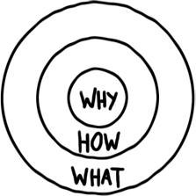
figure 3.
Simon Sinek's “Golden Circle”

We can see the concept of “social-spacetime” in Simon Sinek's “Golden Circle” (figure 3). In his diagram (figure 3), he models the human psyche – the id, ego, and super-ego – as a circular, hierarchical structure, similar to a node on a social network, that represents us, as individuals, with our physical presence in both time and space. However, Simon describes his model differently: “we each have our own 'Golden Circle' – a kind of big megaphone we each project out into the world, projecting it every where we go.” Perhaps we can interpret this “big megaphone,” as our place in the social world, in social-spacetime, as an “Individual Social Fabric” (figure 4). Everyone's social fabric has “social gravity,” which warps social-spacetime based on our physical presence in the world, our social reach to others and other resources, and our connections we make inside social networks. This visualization is presented in figure-4, wherein the elements of our cognition: “P,” the ego: “E,” and the super-ego: “S,” – just as in Simon's model – all are nodes on a network. These nodes (S,E,P) represent how we attach to ideas over time, across a continuum (The Psychological Continuum Model – chapter III). Time is required to “gravitationally attract” other nodes and social objects to it, unless it's an Amygdala hijack or emotional hijack (which is discussed later). But time itself, as represented in this model (figure 3), is the major component that represents the framework itself, in social-spacetime, as the time element.
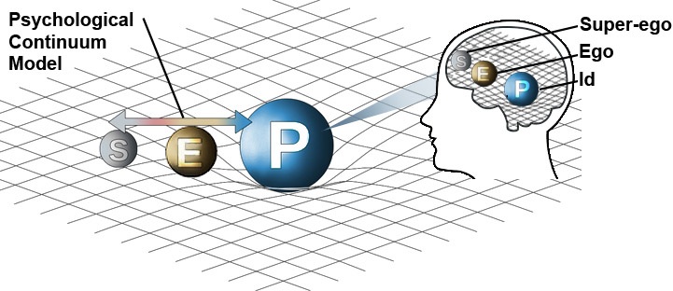
figure 4.
Individual Social Fabric:
(S = super-ego, E = ego, P = “personality” or id)

I had created the basic components of the Social Fabric Framework shortly after experiencing the affect Hurricane Sandy had on society and on people's social behavior. These basic components I created are the following: 1) the Micro Perspective: how people make decisions instinctually, and 2) the Macro Perspective: how people and resources merge to create social events (causality). Together, they created the Social Framework, which is a framework that can be explained by Einstein's laws of general relativity and the laws of human behavior (our instincts), known as The Laws of Social Fabrics (chapter II).

Power of intent/ Power of blame assigned to social gravity (to protect survival mechanisms or to undermine them based on the size of the mass of a social fabric):
The power of intent is directly correlated to the amount of social mass (social gravity) that a social object (a person) and/or network has. A network that has a lot of social mass – for instance, a company with a lot of social resources – will have more intent assigned to it (or correlated to it) then one with very little social mass because they have more power to protect or undermine something. Therefore, the more social mass a social object or social fabric has, the more intent is assigned to it (or is correlated to is). That is why leaders are always blamed for everything, because they have a lot of social mass (social gravity) to do something about a situation or to stop it.
Hormones (Sociobiology):
Adrenaline (energy):
Energy chemical: feelings of power and control. Adrenaline in combination with dopamine and feelings of helplessness, creates feelings of revenge.
Endorphins (painkiller):
Feelings of perseverance.
Testosterone (pair-bonding chemical):
Feelings of desire and trust through sexual desire.. Eradicates feelings of disgust (such as during sex). Increases aggressive behavior and risk-taking.
Estrogen:
Pair-bonding chemical: feelings of desire and safety. Eradicates feelings of disgust (such as during sex).
Cortisol:
Flight-or-fight chemical; stress chemical.
Monoamine Oxidase (stopper of aggressive behavior or fight-or-flight responses):
This hormone breaks down neurotransmitters that regulate the flight-or-fight response. With too much neurotransmitters that signal flight-or-fight response, the body responds violently even to low levels of stress.
Noreprinephrine (focus, arousal, alertness, attention):
Increases arousal and alertness, promotes vigilance, enhances formation and retrieval of memory, and focuses attention; it also increases restlessness and anxiety.
D(dopamine) – Selfish / goal-oriented chemical, feelings of addiction
----- Chasm of selfish vs. unselfish chemicals ------
Actylcholine (slows heart rate):
This hormone potentiates (makes more powerful) behaviors that are adaptive to environmental stimuli and decreases responses to ongoing stimuli that do not require immediate action.
Follower chemical: people have our best interests at hand: trust, safety.
Serotonin: Leadership chemical, feelings of pride, acclaim, and trust in others.
Oxytocin: Love chemical: feelings of trust, bonding, calm, and safety.
II. The Laws of Social Fabrics:
Introduction:
Each law in The Laws of Social Fabrics represent not just our biological instincts as hormones, but their respective cognitive and hormonal counterparts: the id, ego, and super-ego (figure 4). Each on of these areas of cognition represents the psychological component in its superimposed region in its social fabric (figure 4). For example, “P” (figure 4) represents the first law, “safety.” The second law, “physical closeness,” represents a combination of both “P” (the id) and “E” (the ego). As mentioned prior, “physical closeness” is a law that is processed both subconsciously (the id) at “P,” and consciously (the ego) at “E.”
You can understand what decisions people might make next if you can understand the law or laws that are applicable to that given situation. Once this known, you can then correlate a law(s), to that social behavior. Even more so, you can also understand how people psychologically attach to ideas over time, and not just being able to predict their behavior. This can be known through the model, The Psychological Continuum Model (Daniel C. Funk, Jeff James; 2001), which you see its affect in (figure 4).
Laws:
1. SAFETY/TRUST/SECURITY/FEAR (the 'id', survival, self-gratification):
● The principles of this law occur in the brain at the mesolimbic pathway and Amygdalae in the brain. The feeling of safety occurs subconsciously and unconsciously, and is tied to the “flight-or-fight” response. We process feelings of fear in the amygdalae. A flight-or-fight response is a subconscious reaction to an immediate danger or threat, affecting bodily systems, overriding normal conscious activity. Feelings of trust are processed in the anterior insular cortex. The feelings of trust and safety bring brought on by oxytocin, bring about feelings of contentment, calmness, and security.
Social fabric location affected: The center “P” region (our “id”) of social fabrics including all sub-laws below.
1. General definition of SAFETY/TRUST/SECURITY/FEAR, FACTS (the 'id', survival, self-gratification):
Sub-laws of the first law “SAFETY/TRUST/SECURITY/FEAR/ATTACK” in order of importance in accordance to survival:
------ simple survival -------
1st: Amygdala hijack (immediate self-preservation – SAFETY/TRUST/DANGER):
Protect the-self at all costs such as being attacked by wild animal, unless it's for a cause greater than the-self.
2nd: Fulfilling immediate basic needs (energy, and homeostasis: heat, staying cool, dry) : water (energy), food (energy), clothing (homeostasis), sleep (homeostasis), shelter (heat or fire, and staying cool from too much heat or sun - homeostasis), paying rent (shelter – homeostasis). For example, we stay cool by sweating, or by seeking out shelter from the sun.
3rd: State of well-being such as illness or sickness (immune system: homeostasis).
4th: Sex and maternal/paternal instinct, childbearing, innocence (reproduction or survival of the species).
------ complex survival ------
5th: Socially complex resources that make SAFE, or make us feel SAFE: Money, Power, Fame, Religion: The values of money and power can take the place of the first 1st law if they devolve to immediate safety and trust. For instance, [money – as the 5th law] can take the place of the 2nd law when people can no longer afford food. And when lack of food turns into starvation, [money] becomes the 1st law of survival (as well as the search for food in the environment).
6th: Love (family, relationships): Do I love someone?
(love, bonding, relationships, acts of kindness, witnessing acts of kindness.)
7th: Health: Psychological and Physical health (Health, Education, Inspiration, Happiness, and well-being): Is my psychological health and physical health intact?
- Psychlogical health (mental well-being): Freedom of speech (as noted in the U.S. Consitution).
8th: Freedom to CHOOSE, to protect lower level sub-laws (highest level complexity of survival): The power to choose one's own will in society to protect their own survival mechanisms or someone else's. The freedom of choice does not include conscious free will, such as wanting to do something or goal-seeking, because these notions are conscious thoughts.
2. PHYSICAL CLOSENESS – the “Neighbor Effect” (the “id” and “ego”):
Physical closeness, called the “The Neighbor Effect,” determines whether you trust somebody physically close to you or not. Physical closeness is based on feelings of trust and security, as well as potential risk. Feelings of trust are processed in the anterior insular cortex. People who are physically close to us are more likely to affect our current state of mind than those who are at a distance from us.
Social fabric location affected: the center “P” region (self-gratification).
1st (trust): Can I trust someone physically close to me? This relates to feelings of self-preservation, or love, sexual infatuation, disgust, anger (relating to the anterior insular cortex).
2nd (danger): Entering too close into someone's personal space. If someone whom you don't know or don't trust gets too physically close to you, this might set off your fight-or-flight response, depending upon the level of physical engagement of the situation. Likewise, if you walk up to someone unannounced or get too close to them, you might make them feel extremely uncomfortable. But if you start charging at someone, they will definitely react out of immediate fear or sense of danger.
3. GOAL SEEKING (the “ego”):
Goal seeking represents the ego. The ego fulfills the needs of the id. Area of the brain most affected: medial prefrontal cortex (goal directed behaviors, where things get “re-categorized”).
- Seeking out or finding something you're looking for, or attaining something such as money, a job, car keys, food, chores, a lost item, a family member, fixing a relationship, and other real-world self-goals related to the reality principle. The reality principle has to do with how the mind best comes to understand the world in accordance to our survival mechanisms (relating to the first law).
Goal seeking tied to sub-laws of 1 through 8.
4. VALUE SYSTEM – Personal beliefs & Morals (“the ego and super-ego”):
Value systems represent the ego and super-ego, which is higher level thinking. This is where more complex thoughts and emotions occur and are carried out and in a conscious, self reflective way. This is where we understand things to be good or bad with a high level of both complexity and abstraction.
1st: “Do I perceive someone's beliefs or their system of values (such as morals and ethics) to be in alignment with my own?”
Description: We seek out experiences and relationships with those who have similar values and beliefs, because of feelings of trust and safety.
Types of value system connections:
1. Direct value system connection (id): Sharing similar or same emotional ideas or values. This value system has an automatic component of trust built into it, where seamless social connections are made.
2. Semi-direct value system connection (ego):
3. Indirect value system connection (super-ego): Sharing similar or same rational ideas or values. Does not have an automatic component of “full-on” trust built into it because the connection is not emotionally salient, and does not directly connect to a contagion in an 'id' to 'id' fashion, or ego to ego fashion. This is not related to goals – just similarity in rational ideas. The connection is “super-ego to super-ego.”
5. PROTECTING-OR-CHANGING THE SYSTEM TO WORK FOR THE-SELF (the “super-ego”):
Protecting or changing the system represents the super-ego, which is very high-level thinking and relates to social resource control or social resource manipulation (relating to the Grand Theory of Social-SpaceTime).
1st: Does the system, or person (or people) maintaining the system work in favor of “my” needs and values, both for the short-term and long-term?
2nd: If the system does not favor my needs and values, I therefore must change the system so that is protects my survival mechanisms and my higher-level needs.
We actively work to protect or destroy the system [if]:
1. my immediate needs in the system are being threatened (taxes, healthcare, power, health, wealth, resources, freedom, etc...); or,
2. my value system (law 4) inside the system is being threatened; or
3. I have a greater need to destroy or save the system because my life is being threatened or my freedom is being threatened.
Social fabric location: the “S” region of social fabrics
The Laws of Social Fabrics are “nested”:
The Nested Laws of Social Fabrics is the same model as the Laws of Social Fabrics (chapter II) except that it is represents laws nested inside one another. By nesting laws, it allows you to see the complexity of social situations broken down in a simple yet hierarchical way. For example, if you see a bear in the woods and it starts running at you, your immediate reaction would be to run. These behaviors show you are acting on the first sub-law of the first law: immediate danger, while the bear closing in on you is acting on the second law, physical closeness, and in accordance to survival mechanisms (protect its young, or food). To make this thought experiment slightly more complex, consider the bear running at you is much further away (the 2nd law, physical closeness). You would now perceive the bear to be less of a threat. However, lets add more social complexity to the situation to see the true nature of social complexity. I want you to imagine that this time when the bear is running after you, your child is next to you running from the bear as well. And as the bear closes in on the two of you, the bear starts making a mad dash towards your child instead of you. Your immediate reaction will be to either fight the bear to protect your child, or for you to run away instead. The point is that, whether you protect your child's life or your own, you will immediately react to the threat to protect life, whether your own life or your child's. Either way, your reaction is based on the first sub-law of the first law of social fabrics, immediate survival.
The context of this situation shows us that physical closeness – the second law – is very important to the first law, survival. The law of physical closeness plays a predominate role in how you behave in physical space in accordance to survival. For example, often times when you are goal seeking (the third law), you are searching for food, water, or sleep to fulfill the needs of survival. Often times though, these basic needs are already met, and therefore higher level needs come into play. For example, you're might be searching for your car keys to be able to get to the movie theater. This means you are acting on higher lever laws of complexity, rather than lower level laws of survival. However, you still need your car keys [and your car] to go to work every day so that you can continue to make money (5th sub-law) so that you can put gasoline into your car so that you can continue to go to the movie theater (higher level laws). So you can see, there are various Laws of Social Fabrics nested inside one another.
Thought experiments like these about the car keys and the bear, show us that life's situations can be both complex yet really simple at the same time. If you learn to think this way – by exploring social situations using the Nested Laws of Social Fabrics (figure 5), you can be able to understand the simplicity of social situations within all its complexity. By exploring the social dimension of reality (the 5th dimension), you'll be able to observe very complex social situations with ease, such as understanding the climate crisis and be able to fix it.
Thought Process:
Our minds intuitively work in this way; our minds are comprised of thoughts nested within thoughts. They originate at the subconscious level, as simple survival mechanisms, and work their way up to the consciousness level becoming complex behaviors. The process works in a specific way: when you perceive an emotionally salient stimuli in a social situation, any previously neutral stimuli perceived in that situation are outweighed by other emotionally salient stimuli. They then are compared to previous neural pathways of the same nature, like a “hand in fist” formation of what we perceive and what we already know. This processing over time then becomes learned behavior, what you might call “automatic thinking.” Your view the world therefore is a lens of everything you experience, of what's good and bad (survival mechanisms), and what's helpful vs not helpful (social resources) in accordance to whether you feel trust and safety in those things, thereby creating a reality best suited for survival (called the reality principle) that your mind believes to be true.
Our minds are always seeking the most important, relevant ideas about the world to give us the best snapshot of reality so we can best survive in it. As previously mentioned above, this is based on things we trust and mistrust, and things we perceive as safe and as dangerous. But whether we are driven by trust and mistrust, safe and dangerous, or even just neutral thoughts, we are led to believe often times, the wrong conclusions about social situations. This reason is because our subconsciousness, which is driven by feelings of safety, fear, and trust, overrides our conscious thought processes. These subconsciousness feelings attached to our passions, goals, and desires in the consciousness, then project back onto our subconscious as coupled values, creating a negative feedback lack, causing us to believe things which are not safe tied with things that we believe to be true. That is why I continually see people walking across a busy intersection with their heads in their phones as cars are flying by them – their subconscious feelings of trust and safety got attached to things that they believe are true that are not safe.

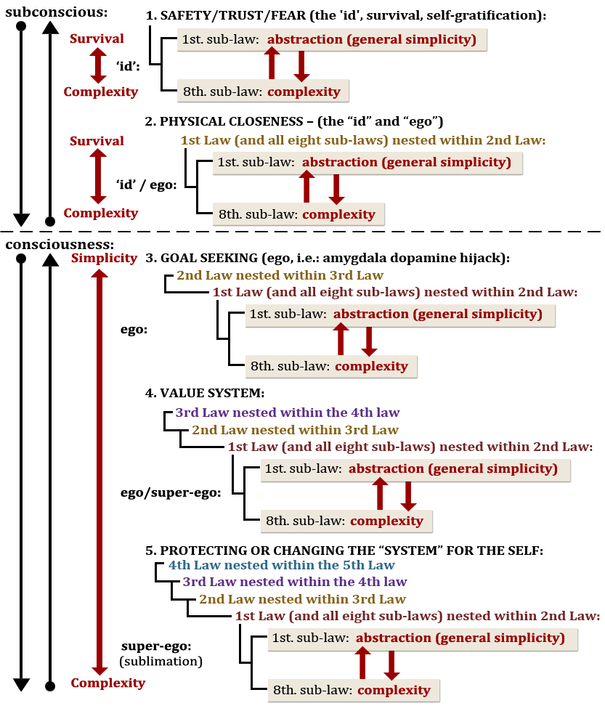
III. The Psychological Continuum Model:
Written by Daniel C. Funk and Jeff James (2001), the PCM was written to explain “sport spectators and sport fans in order to describe the psychological connections that individuals experience within sport or sport teams.” The PCM (figure 4) has four stages of cognition to which this happens: awareness, attraction, attachment, and allegiance. However, this model signifies more just than how we process sports-related ideas, it is an explanation of how ideas are represented in the human brain in time as a continuum (an ongoing back and forth process to which neural networks in the brain are strengthened or weakened).
figure 4.
Psychological Continuum Model (PCM):
The “floor model” is the author's original illustration of this model not presented above).

Awareness:
When we are exposed to new ideas, we become aware of them; we are at the awareness phase of cognition (figure 3). Once we have become aware of an idea, we potentially move to the next phase of cognition.
Attraction: After the awareness phase, we enter the attraction phase (see attraction in figure 3). It is the second phase of cognition. It is a phase where “favoritism” starts playing a role in cognition. For instance, “I have a favorite sports team.” Or “I prefer to spend time with my friend Lisa over Bob.”
Attachment:
As we reach the attachment phase however, our ideas and perceptions become internalized (intrinsic). We're starting to feeling a deep, psychological attachment – relating to the self – during this phase. If I were to date someone else during the attachment phase, it would hurt me emotionally to do so. They have become part of me, intrinsically (see attachment in figure 4). If playing volleyball is something I'm attached to, I couldn't just stop playing because I found an alternative to the sport. Not playing all of a sudden would cause negative feelings – as if I lost something that was part of me. Social objects in the attachment phase are personal, relevant, and important to who we are. Importance is the deciding factor between what it means to be in the attraction phase and the attachment phase. Favoritism does not imply importance. Favoritism is an extrinsic idea whereas importance is an intrinsic idea. Your friend or best friend (during this phase) is someone whom you have deep, commemorative experiences with – meaning your experiences and your relationship with each other are psychological constructs of your minds. In this state of cognition, both of you share values and perceptions that have “become attached to an attitude” (“P.C.M.,” Daniel C. Funk & Jeff James; 2001). Attitude means that your best friend is not an expressed “favorite,” but someone of importance (expressing feelings and compassion).
Allegiance: Finally, the most profound phase of the PCM is the allegiance phase. This is where we have “fallen in love” (with a social object). For example, I don't just go ice-skating, but I am an ice-skater. The allegiance phase recognizes ideas as being consistent with ideas of self-concept and lifestyle. For instance, when I go to the beach, I am still an ice-skater, even though I may be engaged in beach activities. While at work, or elsewhere, I am still an ice-skater. Being an ice-skater is a self-concept meaning a central facet to my life. Feelings and perceptions towards are felt intrinsically and consistent (with regards to ice-skating) with my own internal beliefs, values, and attitudes. Moreover, being allegiant to someone or something means that we are willing to suffer enormous inconveniences and setbacks just to continue experiencing those things. When two people love each other, they work hard to remain in love and suffer great hardship at times to continue that condition. Love is an allegiance to someone or something. It's a continuous state of commitment and passion which is inspiring. Love, however, is not a permanent state of mind. People who are in love, fall out of love. Just look at the divorce rate in the United States, it is quite high. Equally, we may also lose “love” our allegiance to something such as sports, hobbies, organizations, or any idea – it doesn't just have to be people. Furthermore, life-changing events can tear apart these relationships prematurely. Ordinarily though, the natural discourse of life pursues, and many times we fall out of love (out of allegiance) in its natural process. We slip back into the attachment phase or attraction phase or perhaps even all the way back to the awareness phase, a state of mind where we don't even engage with that person or activity at all.
However, the PCM only describes how we process ideas; it doesn't describe the sociological impact of them. How we we make decisions in society, and what is the order to which we place on them? The answer to these questions, it turns out, gives us closer clues to who we are as a species, and the social patterns that emerge from that. This is discussed in the next section describing my experience living through Hurricane Sandy, a “simple society,” in 2012 on Long Island, NY.
IV. Social Fabric Framework with the PCM (Psychological Continuum Model):
figure 5.
Social Fabric Framework & the PCM
S: Super-ego
S/E: Super-ego / ego
E: Ego
P: Personality (the id)
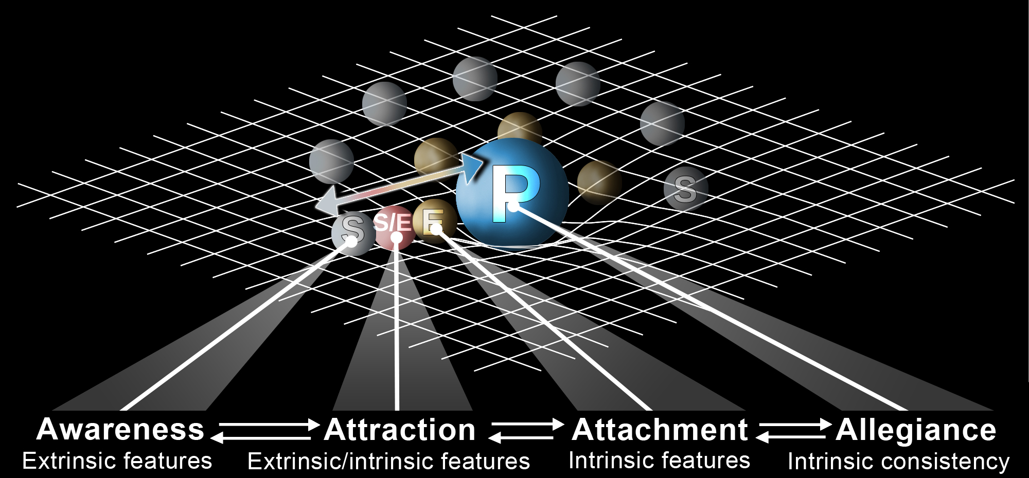
Contagions:
Contagions can be thought of as any social object or resource that has social mass with significantly more social gravity than other nodes surrounding it, thereby allowing the contagion to coalesce into a network from surrounding nodes. Contagions are typically contagious ideas: one's with a purpose, cause, or belief (Simon Sinek). They are already popular, and tend to attract more social objects and resources to its network than other contagions less popular. More popular contagions therefore have a greater degree of interconnectedness in social-spacetime than others similar to it. Therefore they are more likely to succeed. For example, a local ice-cream shop may have a popular brand name as compared to another one that does it, making the one that's more popular more likely to succeed, because it has more interconnectedness within the community (more word-of-mouth marketing, in other words, and brand recall). A contagion is not just a contagious idea. It's a shared social object or resource that has more social gravity and interconnectedness than other social objects and resources in its network, and within other surrounding networks.
When we act as nodes in a network, behaving as social objects with social gravity, we therefore are able to connect to contagions, and socially organize around them with other people (social objects) in the network. We therefore, in the encapsulation of a contagion, can create the potential for social groups and other larger scale networks to form with social mass being alike to all social objects in that network connected to the contagion. Once formed, a contagion – functioning as the heavy mass object in a social network holding it together – has the complexity to accomplish things that no single member (or node) of the network can do singularly. This organizational power creates a sort of “social intelligence” ( Nicholas Christakis, 2012). A flock of birds for instance have a certain degree of social intelligence within their unique “V” shape structure, wherein each bird in the flock adjusts its behavior around the same contagion, of saving as much energy as possible during flight. Similarly, fish act in the same manner but around a different contagion, to create confusion by not allowing their enemies to single out a single member (they all act in unisons).
“Sticky Messages” (socializing agents) vs. Contagions:
Sticky messages (as Malcolm Gladwell calls them) are what I call “socializing agents.” They make things more memorable or attractive, such as Arnold Shwarzenegger's phrase “I'll be back” from his Terminator movie series. Sticky messages are not contagions, even though both are contagious ideas. Only contagions have the capacity to create social groups because they are common contagious ideas. Sticky messages lack the broad appeal of a contagion. You can name your business a name everyone will remember and a name that everyone will want to talk about, but that doesn't mean your business will attract customers. Equally, just because two people like ice hockey doesn't mean an ice-hockey team will form. Perhaps one person likes ice hockey for a very specific reason which doesn't attract other people. There needs to be a common appeal among nodes (or at least two hockey players) for a contagion to emerge. If both hockey players shared a common value, such that the game is “fun,” then perhaps a hockey will form. The contagion in this sense, is “fun” paired with the value of “hockey.”
Social Cues (social objects and social resources): Social cues (called social objects) have social mass. They are defined as:
- pleasurable experiences (excitement, drama),
- psychological features (acceptance in the group, achievement),
- physical features (physical landscape such as people and place), and
- situational factors (price discounts, special events, promotions).
Social cues projected in a hockey team for example, surround each player of the team like orbiting satellites of a planet, but in social-spacetime. Over time, social cues begin to strengthen each team member's feelings and attitudes toward each other and toward the game itself (as a contagion), shaping and forming the hockey player's views and experiences as a result.
Group, System, and Societal levels of the Macro Perspective (figure 4): All objects in social-spacetime have social gravity. The more social gravity they have the more they become stable social structures. Likewise, the more interconnected the social object becomes in society (which is the source of its stability). Social objects and social networks therefore have different levels of social stability. The more stable the network is, the less affected it is by social events (causality). For example, a small sports team among friends is more likely to experience cultural swings than a professional sports team, such as the Yankees. A social network such as a small sports team among friends operates on the group cluster level (figure 1) – a small social group that is highly unstable. A larger scale network such as a major league baseball team as the Yankees, operates on the system cluster level (figure 3) – a network that has relatively medium stability. Likewise, ideas that have been around for a while and are fully integrated in society are likely to have sustainable stability.
Contagions operating at the system level (figure 1) such as the government and the economy, have the most stability in social-spacetime (among many others). They are called societal cluster networks.

VI. What is a Social Fabric? (figure 4):
A Social Fabric is a reflection of our own individual beliefs within social-spacetime (the social world around us). Our rational and emotional thoughts are entwined in memories, habits, and ideas that interpret everything we do, see, and how we interact in the world around us in social-spacetime. Contagions are popular ideas in social-spacetime, and they bend the very social fabric social-spacetime, akin to a large object in cosmological space.
There are Individual Social Fabrics and Group Social Fabrics in social-spacetime. Individual ones represent the human psyche: the id, ego, super-ego through the perspective of that single person. These individual social fabrics are objects in social-spacetime called nodes, connect with and pull in other surrounding social objects if they become contagious, developing into heavier “gravitational” social contagions as they become popular. This effect occurs even faster as the contagion becomes a compelling force: an idea that contains attractiveness based on self-values (emotional ideas and influences). It moves masses of people around a contagion (a popular idea).
Figure 4. Social Fabric:
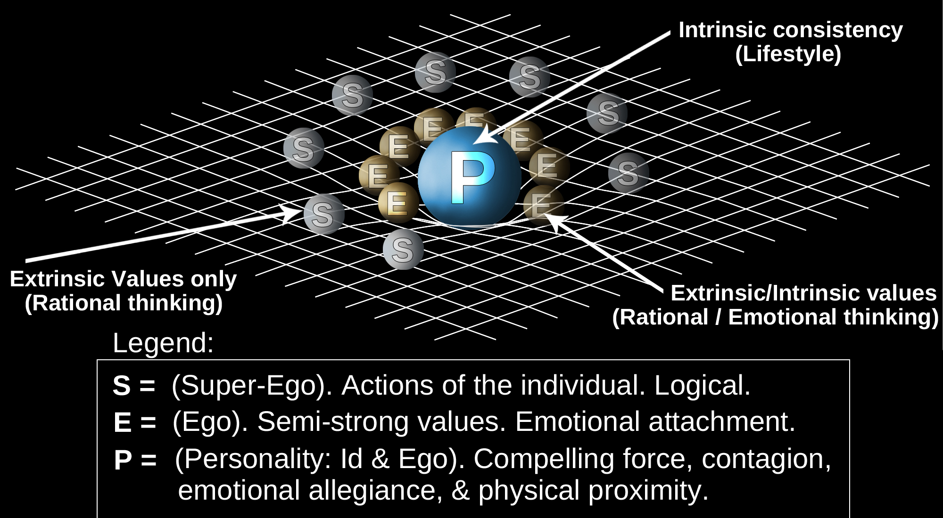
A compelling force, shown at “P” (figure 4), has a higher gravitational “pull” than other surrounding social objects or nodes, and represents intrinsically consistent ideas such morals, beliefs, and values. In Group Social Fabrics, contagions are simple, powerful ideas that inspire people to take action and to follow. Contagions in social-spacetime are gravitationally heavy objects (figure 4 – “P”) that are responsible for creating social movements.
“Gravitational” regions of Social Fabrics, explained (figure 4): “S” or (super-ego) – the “super-ego” region of Social Fabrics that consist of rational thoughts and ideas and are less likely to contain ideas of self-concept. Social-spacetime gravity here is weak. This region's values, ideas, and beliefs are mostly extrinsic.
“E,” or (ego) – the “ego” region of Social Fabrics where emotional attachment begins to take place along with semi-strong self-values – both intrinsic and extrinsic. This region represents a combination of both rational and logical thinking and feelings of happiness and some emotional thought-processing. There is also a strong liking or attitude towards something in this region. The ego plays a strong role here, where it attempts to accomplish real-world self-goals through the demands of the id. The ego also attempts to sublimate (make more socially-acceptable) the demands of the id, and self-ideas therefore begin to materialize.
“P,” or (id, meaning: “personality”) – the “id” region of Social Fabrics that contains very strong self-values. This region resembles features of self-gratification (the id), the sub-conscious mind, and the unconscious mind. It is a region in Social Fabrics (and a cognition of the mind) where strong emotional values exist. Ideas here are mostly unshakable. They are hard to change, such as political, moral, behavioral and religious beliefs. These ideas and other elements of emotional thought-processing are derived from childhood memories, behaviors, morals, values, biology, sex-drive, sub-conscious, unconscious, and other intrinsically consistent thoughts and behaviors (“The Brain, Decision Making and the Unconscious,” Andy Habermacher). A breakdown of these values can be seen in the Micro Perspective (Dan Perceval, 2012). This “P” region called the compelling force of Social Fabrics and it is where self-gratification and goal-seeking become realized – it is where all contagious ideas emanate from and what moves people to take action. Contagious ideas have a significant emotional element to them such as inspiration, passion and energy, and aspiring to do something larger than oneself out of self-concept, all which come from deep within the brain located in the anterior insular cortex and the Amygdala – the emotional processing centers of the brain.
Ideas can both emanate from and be influenced by rational thought processing (“S” region, as the super-ego). However, ideas in the inner “P” region where emotional thought processing occurs, is located in the region of Social Fabrics where “gravitational weight” bears the most influence in social networks, particularly as the social mass of a contagious idea. The “P” region contains ideas related to the self. They are most related to unconscious and subconscious beliefs, thoughts, values, experiences, and memories. These deeply connected ideas resistant change (such as religion, political beliefs, morals, and scruples). There, exist powerful self ideas lying at the center region of its social fabric, as intrinsically consistent values.
As we enter the gravity-well of another's Social Fabric (in social space-time), our emotional thoughts and self-ideas become particularly important in our overall decision-making process, becoming more influence to us. As one falls deeper into a gravity-well of another's Social Fabric (as falling in love with someone), his/her rational thought increasingly becomes less relevant and emotional processing takes over. The comparison between the two, is referred to as “hot reasoning” vs “cold reasoning,” how we favor emotional ideas over rational ones. These concepts are explained later on in this paper.
Social Fabrics and the PCM (Psychological Continuum Model):
As a standalone model, the PCM describes how the process to which how ideas are processed in cognition across a psychological continuum (a forward and backward state of thinking, non self to self ideas). The Social Fabric framework shows how ideas arise in cognition, warping social-spacetime and thereby pulling in nearby social objects: people, ideas, social networks,and etc... in social-spacetime. A universal model can therefore be created if we fuse the Social Fabric Framework and the Psychological Continuum Model (figure-7). This model depicts a visual diagram of the human psyche in social-spacetime: how we become psychologically attached to ideas throughout a “psychological” process or continuum to which our mind remains in a variable state of ideas in cognition.
When the Psychological Continuum Model (figure 7) is meshed with Social Fabrics, this merging describes the confluence (coming together) of contagious ideas and contagions in society. These ideas and contagions have distinction regions that reflect the human psyche in accordance to gravitational regions know as: “S (super-ego),” “E (ego),” and “P (personality or 'id')” as shown in (figure 7) below. These areas in the unified model below depict both the science of the Social Fabric Framework and the PCM. Together, both models [as one] accurately depict how thoughts and contagious ideas are processed in social-spacetime.
As said prior, all social-spacetime social-objects are psychological representations of the human psyche: “S” and “E” and “P” respectively. And they all vary depending on the nature of their connection to other social objects. These objects can be connected extrinsically, extrinsic/intrinsically, intrinsically, or consistently intrinsic.
Additionally, social epidemics and contagions can also exist in social-spacetime as “Group Social Fabrics.” This means that epidemics and contagions have more than one node connected in their network.

figure 7.
The Psychological Continuum Model's role in Social-SpaceTime:
S: Super-ego
S/E: Super-ego / Ego
E: Ego
P: Personality (the id)
As an individual becomes attracted to an idea or contagion, they start experiencing different phases of psychological connection to the contagion (“P”). Each phase is defined by extrinsic/intrinsic features and value connections to the super-ego, ego, and id. During the attraction phase of the PCM (“attraction,” figure 8), extrinsic/intrinsic features such as hedonistic motives, are most prevalent – motives which represent a “liking” or favoritism towards something, or a current disposition. This phase is a mixture of the super-ego and ego. Feelings of happiness, pleasure, and joy start becoming of psychological significance to the individual. The contagion affecting this phase starts to gravitationally “pull in” the individual to it's “P” region in social-spacetime. The social-spacetime region of individual reflects the human psyche – socially – as well as the neural network of the brain of the individual. As the psychological attachment process starts, the individual's emotional values and ideas pertaining to self-concept start becoming more important to the contagion they are connected to. (“P.C.M.,”Daniel C. Funk & Jeff James; 2001).
It's important to note that once a sport participant reaches the allegiance phase of his/her connection to your sport (or business), there is no guarantee they will cognitively stay at the phase of loyalty. They can move backwards along the Psychological Continuum Model at any time, even reverting to the awareness phase, meaning they've completed given up the sport, but remain aware that the sport still exists.

A bigger picture:
Figure 4.
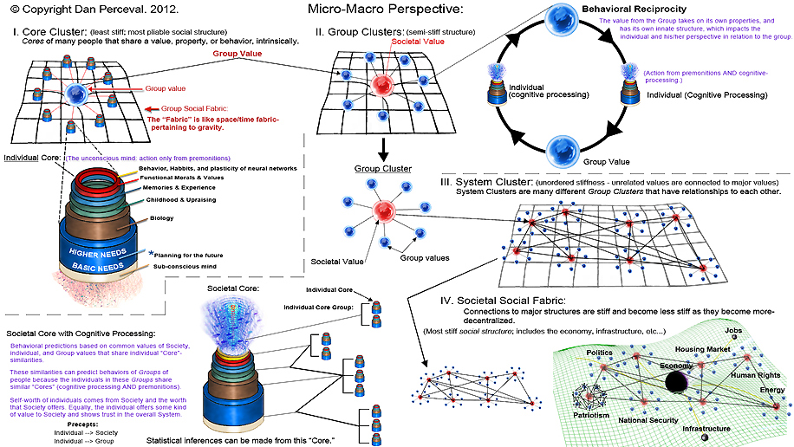

VII. The Micro-Perspective – cognitive processing of ideas:
The Micro Perspective describes how new thoughts arise in cognition. The process starts at the unconscious level. When a new thought arises, it pairs with groups of similar ideas called cognitive value-clusters – “birds of feather flock together.” These clustered ideas are then assigned to a value system, then attached to an emotional element of cognition (see the Micro Perspective). This emotional element attached to thought helps us derive meaning from thoughtc process. This very process is how our brains form the “best understanding” of the world around us that it believes is consistent, for more likelihood for survival. This happens unconsciously while at the same time we learning, experiencing, and processing thoughts.
Unconscious Bias:
“Emotions operate unconsciously,” says Andy Habermacher. “Their strength affects how they're processed in the brain” (“The Brain, Decision Making and the Unconscious,” Andy Habermacher; 2011). “This pre-processing of ideas based on one's own experience and values in life is called 'unconscious bias,' meaning our brains try to create a consistent view of the world from our unconscious network of memories, habits, associations, and emotional tendencies.” The brain is always trying to draw a realistic picture of the world. However, our senses can sometimes fool our perceptions, for example: looking at a mirage in a desert, or at hot pavement on a blistering hot summer and thinking “I see water.”
“Unconscious bias” is a thought-assembly process that assembles thoughts and feelings in our unconsciousness cognition with some level of emotional salience (intensity) of thought processing that is a preconceived subconsciously (assembled for us automatically before realizing the idea itself). For this reason, many neuroscientists continue ask: “Are we really in control of our own thoughts?”
Making split-second decisions like this, called rapid cognition (Malcolm Gladwell, “Blink,” 2005). How we behave during split-second decision making is a likely indicator of who we are unconsciously. Even more telling, it is likely who we really are as a person. This level of cognition represents our “id” of our psychological profile (id, ego, and super-ego). But rapid cognition does not always occur during most situations. Normally we have opportunity of [time] to think and reflect about things, called our “rational mind” (super-ego), before making decisions. The rational mind normally runs the show and sublimates (makes more socially acceptable) our unconscious bias, except during times of “fight or flight,” called an Amygdala hijack.
Emotional Hijacking: An “emotionally hijack” is when the thought assembly process during cognition is hijacked at the unconscious level before thoughts bubble up to consciousness. This occurs when someone's cognition is primed with an unconscious bias, with an intense emotional construct of feelings that the person already strongly agrees with. The emotionally hijacking idea then attaches to self-values of the target individual, and emerges as a conflated value of two ideas – one, the person already agrees with – and the other, the person doesn't realize the emotionally intense value is already attached to it. For instance, “water” and “sea” might fire together when “having fun” such as swimming or surfing. But when that same idea is emotionally hijacked, for instance: “driving one's boat recklessly even though they're having fun” might be able something we can convince someone of, so long as “no one gets hurt.”
During cognitive thought processing at the unconscious level, cognitive value clustering occurrs (see “core value clusters” to the left) when our brain tries to make sense of the world around us. This is based on who we are – known as our “unconscious bias” – and what we really believe. So during a hijack, we're attaching an emotional value the person already agrees strongly with, to another idea their brain believes supports that value. This is called value clustering, when the brain tries to assemble ideas based what it already believes and its past experiences about the world – that it believes to be already true. Over time this creates strong neural pathways of values and ideas that fire together. Over time, like pavlov's dog, this continual process of emotional hijacking: strong emotional values and ideas firing together, can reshape someone's ideas and beliefs. This is how Hitler came to power. But it is also how great leaders like Mahatma Ghandi have changed humanity for the better.
The emotional hijack works not just because the hijack inserts external values into our self-ideas at the unconscious level, but because the hijack works on our most basic level of trust. We trust that which we already believe to be true. When the inserted values (of the hijack) enters into our consciousness, those values are already pulling us strongly (emotionally) in a certain direction about what we already believe to be true – and that we believe to be of our own thoughts. And it's human nature to justify our own beliefs by doing and saying the things that reinforce how we already feel. We typically don't seek out that which is at at odds of how we think. Although a very rationally-minded person might possibly do that. It is possible to second guess yourself whenever you consider a thought. But for most of us, we typically don't engage in this self battle. In other words, “the brain believes itself,” says Andy Habermacher. We typically do things in life to reinforce our beliefs. “The rational brain tries to justify our unconscious biases,” says Andy. “Our brain builds associations based on experience, and this experience will be emotionally anchored and drawn to our attention again and again, creating a viscous circle of self justifying unconscious beliefs” (“The Brain, Decision Making and the Unconscious,” Andy Habermacher; 2011).
Amygdala Hijacking: Inspiration and fear can also override ordinary thought processing, but in a different way than an emotional hijack. If we suddenly experience imminent danger or a sudden burst of joy, then this would be an Amygdala hijack. In these moments, we simply react to a situation rather than rationalizing it. We therefore can deduce that there are two major types of cognitive hijacks:
- an Amygdala hijack: what happens during rapid cognition and “flight-or-fight”;
- and an emotional hijack: what happens during unconscious cognitive thought processing called “unconscious bias.”
- Inspirational hijack: Sudden burst of joy, seeing something in awe, or falling in love (infatuation).
VIII. Sport Culture in Social-Spacetime (figure 2): Culture is a set of social properties or values that connects individuals to a contagion, and to each other. Culture in sport plays a crucial role to the sport's development, growth, and potential sustainability. Ask any sports fan about how well their favorite sports team is doing. They will likely respond, “my team is doing great, or my team is losing.” When someone answers “my team,” they are indicating their psychological attachment to the sport or sport object, and to each other – as a social group embedded in the social fabric of the sport contagion (figure 2). Culture is simply the social structural and social relationship of a contagion in social-spacetime. Without culture (or values), our social organization becomes harder to crystallize. As we become embedded in a social network – a sport for example (this embedding represented as the gray or blue spheres in figure 2) – we start connecting our extrinsic ideas to intrinsic ones (the orange sphere, the contagion), and we connected to the social network itself as well (the blue lines). Once a sport fan or athlete has become firmly embedded in a particular sport – the sport – has become an intrinsic idea to them. “I am a baseball player,” they would say if a sport has become intrinsic. The sport literally has become embedded in the center of the person's social fabric in social-spacetime even though physically, they can exist in the social fabric of the actual sport itself (figure 2). In other words, social-spacetime has four dimensions: the three dimensions of space, and time (Krioukov, “Network Cosmology”; 2012).
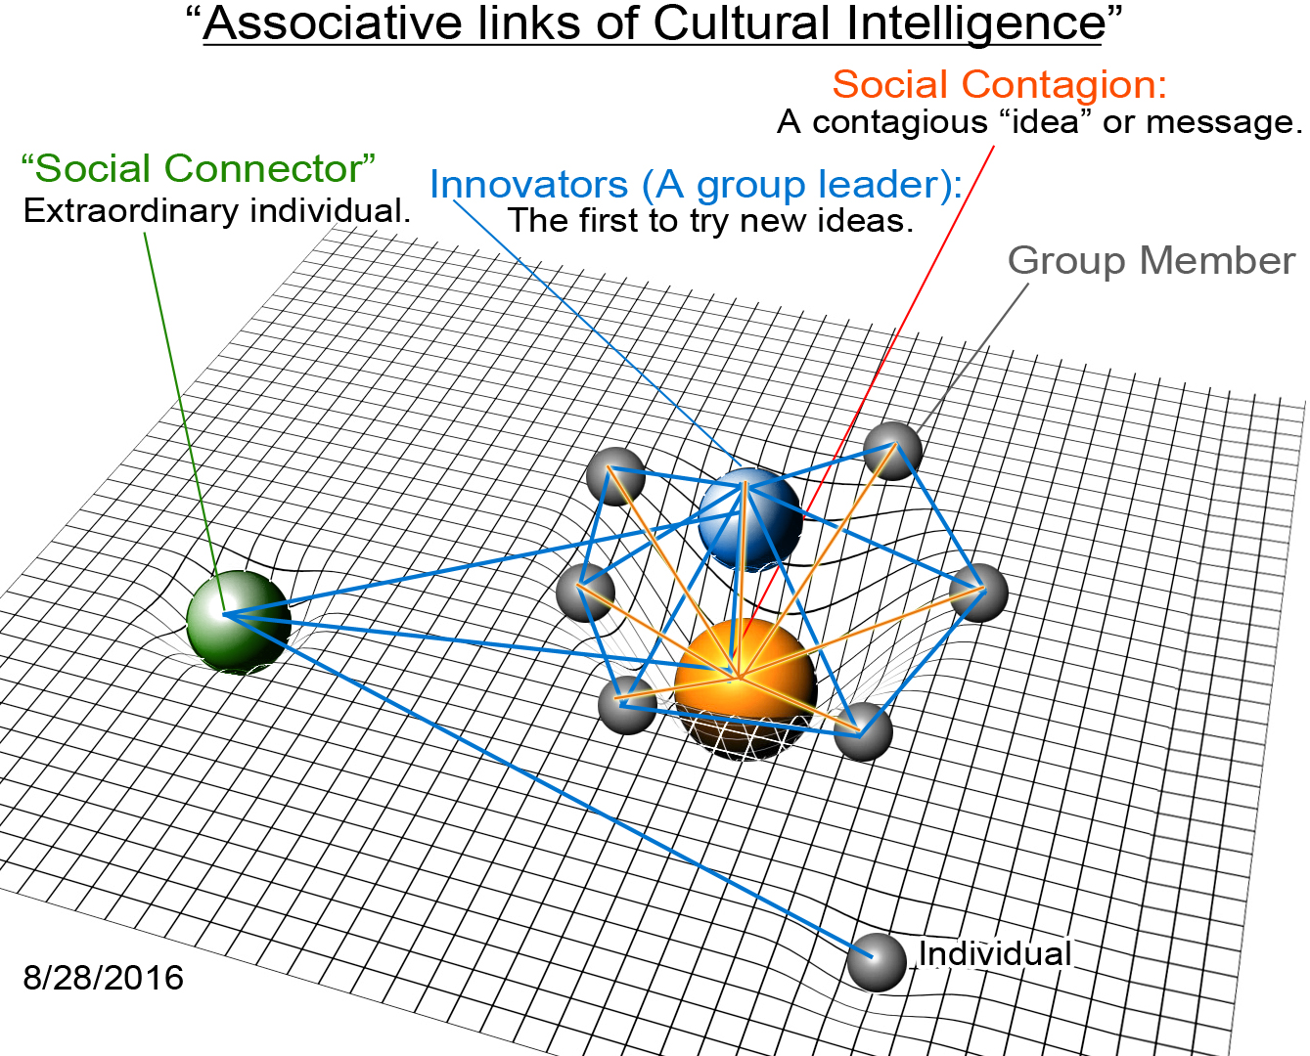
Figure-2.
A Psychological, Sociological Perspective of Creating Sport: Creating sport is a continuum of ideas, starting out as perceived extrinsic ideas – in the mind of the sport participant – then becoming intrinsic by nature, as the sport participant further internalizes the sport through social and psychological experiences of it. This process of extrinsic to intrinsic internalization of sport is called the Psychological Continuum Model (figure 7). It is a process which is similar falling in love. All things start out, outside the self, and in time, become internalized until they potentially reach the point of becoming merged with the self. In my experience creating sport, I found that it takes at least two years to go through this process.
The social-spacetime fabric in sport, exists as a functional, dynamic entity that has social objects and resources. The psychological attachment to sport therefore, includes these things.
As sport participants internalize a sport, they become surrounded by ideas of sport surrounding their own self social fabric, becoming assimilated into their neural network.
We've talked about the affect of sport on an individual sport participant. But what about the affect of sport on society, as a whole, culturally speaking? On a macro perspective side of things, as a sport grows, it begins embedding itself into small social groups and sport teams. This level of sport development marks the the “group level” as it penetrates into society as a contagion (see the Macro Perspective “group level”). And as the sport bears more influence in society – meaning, gaining greater social gravity – it becomes part of the system level where it influences many other disconnected parts of society that now have become connected. For example, a sport has a significant impact on a community, but the sport's overall cultural affect has not touched other parts of society such as music, film, fashion, etc... Once it has done this, it has reached the final level of cultural impact called the “societal level.” Football and baseball are sports that are good examples of sports that are at the societal level. The more widely accepted a sport becomes in society, the more the sport embeds itself into the fabric of society. At the same time, the sport's social structure and its network also becomes stiffer: more resistant to change. Stiffer structures include system level and societal level social fabrics.
In the olden days, however, before the advent of technology (circa 1960's in my opinion), new sports came about primarily as the result of sales from new products meant for recreational activity. The normal process we see today is complex marketing, advertising, branding, sporting events and etc...that all try to capture and hold onto a market until the sport starts feeding in upon itself. The economic impact of the sport and its broad mass appeal holds the sport into place at the societal level (if it ever reaches that far).
The old world vs. the new (technologically) of how new sports come about:
The creation of new products back in the olden days were typically inspired by pre-existing, similar products repurposed for a new activity. For example, the first snowboard was inspired by skiing and surfing. Sherman Poppen, the inventor of the snowboard, “invented a toy for his daughters by fastening two skis together and attaching a rope to one end so he would have some control as they stood on the board and glided downhill as a surfer would (Wikipedia.org).”
But the key thing Sherman did was, he marketed his snowboard as both a product and a recreational activity. He called it “Snurfing.” It's important to point out though that he didn't market “snurfing” as a sport. He did not pursue it in terms of the structural components of sport (figure 2). Nor did he concentrate his marketing efforts very much on “snurfing” as a discipline – teaching the sport. His main concentration was on the board itself, the sale of the board. But then again, he didn't have to promote “snurfing” back in those days. New products – new anything – were fancied quiet rapidly in society as something new to do, a recreational activity that coalesce into a sport based on social factors. (Society today no longer has these cultural elements to create this appeal.) Others who came after Sherman pursued that very same goal, marketing snurfing as a sport by teaching it to people at their local ski slopes, where it slowly transitioned into a sport over time, when eventually it was called snowboarding. In the olden days however new sports typically came about this way, from the release of a new product. And over time, the product seeped into the market place by having enough people doing it, to congregate into social group, forming teams, and the backbone of a sport (figure 2), and thus into a social network. Snowboarding came about simply by a saturation of “snurfboards” in marketplace and alongside a culture of “play” – in a world with little technology – has allowed the structural components of sport (figure 2) to occur naturally. As snurfing became more popular, so did its components of sport: mass media following, a discipline, money and sponsorships, and a cultural dissemination of the sport throughout society. Any new sport at that time typically started off this way, as a decentralized social network, acting as a hub to other other decentralized networks until a broader, central social network was formed, creating mass market appeal. Similarly, skateboarding in the 1960's was a recreational activity that started in Southern California, a surfing town, known for its traditions in cross-cultural links to snowboarding. Essentially, snowboarding was very much like surfing. Today, however, social movements are more complex. Youtube and social media for example have transformed how we think, communicate, and socially organize with one another. Technology has changed society. We are now living at the epicenter of a significant societal shift in our culture. It has affected how we think however, our natural human instincts have remained the same. They are called the Laws of Social Fabrics (chapter II).
If Sherman marketed his “snurfboard” today, I suspect that I suspect he would have a hard time getting it take off. Our attention span – our dopamine responses – have been changed, desensitized by all things new in our modern era.
IX. The Role of Exceptional Individuals in Social Movements and Epidemics:
In society exist “exceptional individuals” who have extraordinary social talents capable of tipping an idea or a trend into an epidemic or social movement. Malcolm Gladwell called these exceptional individuals “The Law of the Few” (Gladwell, 'Tipping Point' 2000). The Law of the Few are the few people (in society) who have a “rare set of social gifts” who instinctively turn contagious ideas to social movements by their natural social abilities and behaviors. Exceptional individuals easily convert ordinary ideas to “sticky messages” or popular ideas. In this paper I refer to sticky messages as socializing agents. For example, Schwarzenegger’s “I'll be back” line from “Terminator” became a socializing agent after people saw the movie because Scharzenegger's spoken word became a viral idea. [Schwarzenegger] in this example, became a SalesPerson (a type of exceptional individual) for popularizing the Terminator movie because of his ability to popularize “I'll be back” into a sticky message that spread throughout society. There are other types of exceptional individuals involved in social movements. Malcolm Gladwell categorized them into three distinctive groups: “Salesmen (or SalesPeople), Social Connectors, and Mavens,” defined below: 1. SalesPeople: are very good at selling ideas to others. They are people who are able to persuade others to follow who are still unconvinced (Gladwell, “Tipping Point”, 2000). 2. Social Connectors: know lots of different people from various large social networks (e.g. sports, music, entertainment, travel, fashion, etc..). More importantly, Social Connectors know individuals who are connected to many unique sub-cultures. For instance, the sport bodyboarding can be considered a sub-culture of surfing. Social Connectors link unrelated sub-cultures and social networks to a common idea or belief. This video clip further explains how certain individuals may effect the rise of contagious ideas (Nicholas Christakis, 2012). 3. Mavens: are extremely knowledgeable about certain topics and love to share their knowledge and experience with others. They also will elect to give their knowledge and suggestions to others simply because they're passionate about what they know. They love sharing and trading information, and sometimes conveying “the message” (Gladwell, 2000) for starting social movements.
X. Diffusion of Innovations and Social Movements:
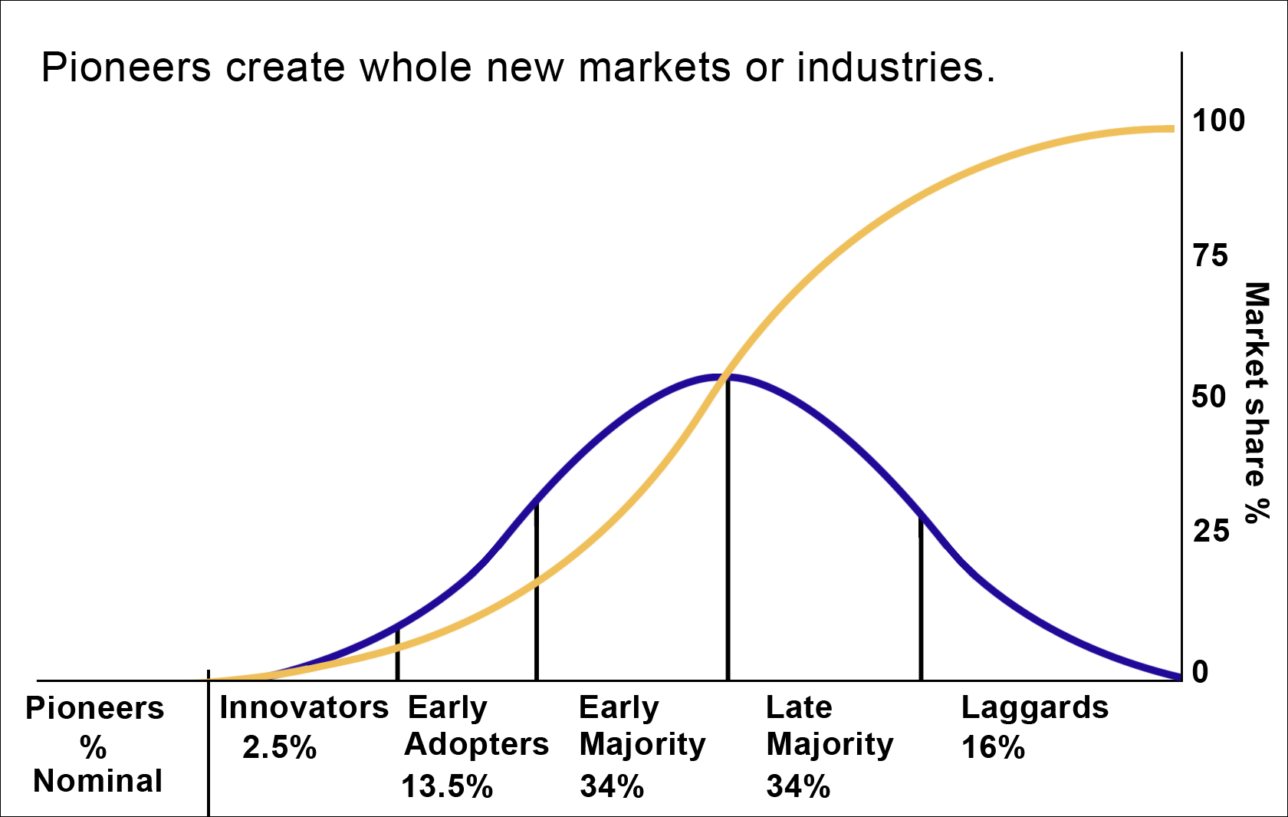
figure 2.
Diffusion of Innovations:
(by Everett Rogers, 1962) – (but modified by Dan Perceval, 2016):

Quick summary:
Pioneers typically create whole new markets or industries. They're creative, huge risk-taking individuals that are extremely passionate and persistent at what they do.
Innovators take existing ideas and add something to them, or change something about them to make them their own idea for a whole other purpose or need. Innovators tend to be entrepreneurs (as well as Pioneers). Innovators are adept at taking pre-existing ideas and transforming them into new products and/or new services. They are the first followers of new ideas and risk-takers who bring those new ideas to life. Innovators are fearless in this regard. They put themselves out there in front of a crowd all alone, fearlessly, on purpose to let every one know they are doing something new or different.
Early Adopters are also risk-takers, but they differ from Innovators in that they only try something new if someone else does it first. The Early Adopters who initially joined the lone nut's dance movement were the most courageous of the group, whereas last wave Early Adopters were the least courageous of all the Early Adopters.
Early Majority (figure 2 & 3) are the early mainstream public who follow what's trending or popular (Gladwell, 2000). the Early Majority are not risk-takers, and nor are they concerned about specific details the Innovators and Early Adopters care about; they're only concern is with popular ideas and being inclusive to those ideas.
In summary, the type of people involved in a particular social movement are going to be innately attracted to it. When one person comes up with an idea, another may follow. The person that follows is an Innovator. The next bunch to follow, are also Innovators, until another tipping point is reached, wherein the risk to join has greatly decreased. Some followers in the network are not willing to join alone, but are willing to take the social risk of joining with someone else. They are the early adopters. Early Adopters need someone, like a friend, to bring them into the movement. Word-of-mouth marketing begins to work for a business, for example, when your first customers bring friends, Early Adopters. Innovators therefore are the effectuators of social movements – or any network. Innovators therefore, are leaders. They stand out alone, projecting values of movement to which they stand for, and by. The Early Majority are the opposite in behavior. They don't take risks to join something new. They join, because it's already popular. The general rule in social movements is that, as crowd size increases, the risk to join decreases and thereby making it more attractive for risk averse individuals to join the movement. And since most people are risk averse, they make up the majority of social movements. This process, is explained by the model, “Diffusion of Innovations” (figure 2).
Mavens are people who are very skilled at something and/or know a lot about a particular subject matter, more than most. They're passionate about conveying what they know to others. “Mavens are like data-banks,” says Malcolm, “they trade and share information (Malcolm Gladwell, “Tipping Point,” 2000).”
“The Power of Context” (Gladwell, 2000) is a social phenomenon that puts people and places under the same emotional feelings and social expectations. If social expectations are served consistently, then they can have far reaching outcomes.
If the Early Majority does not perceive an idea as being popular, they will not follow. The Early Majority follows only because an idea is popular.
Once you understand the power of social movements, and the leadership skills and social skills to make them happen, there's no stopping the Innovators, Early Adopters, and Early Majority from doing what they naturally do in social movements.
The Role of Innovators, Early Adopters, and Early Majority in Social Movements: In social movements, the first to follow them are Innovators (figure 3). They are innately a group of people who represent the most passionate, most loyal, driven followers of social movements. In politics, they're the “base” of a political party who always show up to vote (or to protest). In Xtreme Ice Skating, Innovators were the first followers of the sport. Innovators are “Innovators” (figure 2) because of their risk-taking tendencies during social situations. Innovators are usually first followers and almost always the most passionate among the rest who follow. Innovators follow movements that reflect who they are and what they believe in. They are guided by their passion and the seat of their pants and will live that role relentlessly, and never backing down because they believe in a purpose that is part of themselves. Their emotional intensity, passion, persistence, and social risk-taking defines them.
Likewise, the dance hill Innovators were the first ones to approach the lone nut because they wanted to prove to themselves, and their friends – and everyone on the hillside for that matter – that they too had the guts to approach an unpopular lone nut (soon to be popular) and be seen doing something risky for a brief moment in the spot-light. All of the Innovators that approached him thus far did so for the same basic reasons: they wanted to take a risk and show off their ability to be seen with the lone nut proudly in front of their friends and/or anyone watching. This behavior is a normalcy in Innovators and is what sets them apart from everyone else in social movements (and/or sports).

Cross Cultural Connections:
Innovators at the start of the sport took up Xtreme Ice Skating as their own cause, immediately adopting it as a self-idea. They followed Xtreme Ice Skating for inspirational and emotional reasons. Many were sport participants, but the majority were fans and followers. Xtreme Ice Skating served as a source of inspiration for them – often times for a different sport, usually a sport very similar to Xtreme Ice Skating, which resulted in a “cross cultural connection.” For example, aggressive inline skaters followed Xtreme Ice Skating after having seen the sport's Pioneer build ramps and grind-rails for the sport on ice. While many aggressive inline skaters profess that they had been thinking about doing this idea for a very long time (perhaps even decades), they've never actually followed through with it until they saw someone else do it first. Therefore, Xtreme Ice Skating served as an inspiration for aggressive inline skaters and other sports as well. In another example of cross cultural connections, in 2016 an aggressive skater from Canada tried outfitting an aggressive inline skate with custom bladeholders meant for the ice capable of grinding on rails. While he's been working on this concept for quite some time (since 2014), they broke – shown in his video, but someday he will likely succeed and create a bladeholder that works. It is his perseverance and connection with followers that will some day increase his popularity with ice-skaters that will help bring his product to market. They are the Innovators and Early Adopters. His inspiration and passion is what people care most about, and it is that idea that people follow, not just his bladeholders concept. And it is most likely that he acted on his concept idea from from those who came before him, who inspired him to do very similar ideas, such as Xtreme Ice Skating's (concept) and some other proof of concept . Both of these and his ideas of bladeholders that combine ice-skating and aggressive skating, are a cross cultural connection. It is a connection made between two sports: ice skating and aggressive inline skating, that socially connects both sports and their sub-cultures. This connection illustrates the power that fans and followers can have on your brand or social movement – those who are not directly involved, but who have a stake in the brand because it represents a greater purpose to which they are part of.
Every social connection we create in sport or in a social movement, we must consider the follower's social role in the movement. Are they an extraordinary individual, or do they represent another sport or cultural network to which you may gain access to through them? Cross cultural connections function in this way, to bring about greater public recognition to a cause (or sport) by connecting to a similar sport or culture with some kind of similar semi-rational, or emotional value(s) they have in common. One example is skateboarding and surfing are both extreme sports, ridden on a board, standing up, facing a single direction. The feeling of both sports is very similar. A strategy that makes cross cultural connections from your sport to another, or from your idea to another similar culture, would strengthen your own contagion or brand by re-purposing it to inspire who ordinarily might not fit into your target market. This creates elements of both your brand and their passion as a conjoined value, making for a cross-cultural connection. This is why knowing why your contagion inspires others because it can be an asset in ways you never have imagined. Perhaps your product or service inspires others who would never buy your product or service but they're willing to promote your ideas because they are inspired by them anyway. This creates the foundation for a broader social movement which can help you sell your product or service even though they are not direct buyers of your product or service. In social media marketing, these people are called “influencers.” In scientific theory of Social Fabrics, these people are called extraordinary individuals. They are individuals who are able to kick-start social movements because of their unique social skills and talents they possess.
Promoting your idea in front of the masses (crowds) is the first step to transforming a contagion into a social movement. When the masses are exposed to your idea, extraordinary individuals such as SalesPeople, Social Connectors, and Mavens; Gladwell, 2000) – some of them may attach to your contagion, either through a direct or indirect value connection. As a result, followers of your contagion may spread it more effectively than everyone else in the network because of their unique connectivity that network, for example, Mavens who are extremely talented at something and who also love to share what they know about their talent.
Athletes from different ice sports had psychologically attached to Xtreme Ice Skating's contagion through many different inspirational ideas. These ideas were attractive elements of the culture of Xtreme Ice Skating and were in common with other similar sports. Some similarities pertained to an ice ramp (a combination of elements from aggressive inline skating and Xtreme Ice Skating). Other elements included cross-training in figure skating (example video), or Xtreme Ice Skating tricks and inspired by biking, skateboarding, and speed skating such as the “Apolo's Turn.” These are called cross cultural connections and inspired athletes in their world to innovative idea(s) in their own sport, or, simply had inspired them to pursue feelings towards their own sport they have never felt before. Xtreme Ice Skating's contagion in other words became a source of inspiration. It contained contagious ideas communicated through its brand which set up the foundation of a complex social network to emerge. Athletes were invigorated towards a new cause that eventually became their own. Followers of the sport therefore worked together to achieve what they didn't think was possible because now they were feeling intense emotions – and accomplishing goals – they never were doing before. For example: before the first sub 4-minute mile was ran, no one thought it was possible for any human to run a mile under four minutes. In 1954, a man named Roger Bannister broke that record by running a 3:59.4 mile, making him the first person to ever obtain that goal. This achievement inspired a whole generation of runners “to-be” who would soon go on to run a sub 4-minute mile like Roger Bannister did in 1954. When we can see our goals, they become much more attainable. When you can inspire others to follow based on a vision of the future they can see coming alive, than you can inch-by-inch prove your vision for many others to follow. This is why when great brands make a promise to their followers, they consistently fulfill those promises. It creates a social connection and feeling of trust that your future reality (your purpose) they want to live in, is born through the leadership you project.
Ideas and social connections in Xtreme Ice Skating connected to ideas coming from others sports, are called “cross-cultural-links.” For example: figure skaters and aggressive inline skaters to Xtreme Ice Skating, in a broad sense (such as a social movement).
Cross cultural connections therefore can be powerful because they form “associative link structures” (figure 11) which connect different cultures in society (and sports) together, forming one contagious social network, existing at a much broader, more complex, stable network, called a “System Social Fabric” (see Macro Perspective Model – right side of image). The behavior of social movements of broad networks can be seen in “memorial day parades” in which a town or community comes together based on a cross cultural connection: ideas that cross cultural barriers to an overarching, common contagion. The contagion, in this sense would be patriotism, honor, and service to one's country (a Societal Social Fabric, figure 16). Once a social movement has been established, their leader(s) must provide a vision while projecting social forces (leadership, passion, purpose, and inspiration) that are responsible for turning ideas – into self-ideas – so that followers will pursue these efforts as if it were their own idea – much how followers pursue the goal of curing cancer.
The effect of SalesPeople on active consumers in a social network:
SalesPeople, who make up some of these extraordinary individuals are very effective at convincing others of an idea who are still not yet convinced. But there are those who are not SalesPeople but who still have a greater impact on people because a convinced consumer is a more trusted source of information. A convinced consumer is called an “active consumer,” – “word of mouth marketing” as it's called. They are the people who have already been convinced themselves, and are therefore more convincing to others of that product, service, intellectual property, or idea. Dunia López-Pintado, a research on this idea, explains the impact of active consumers on a general population of people around them. In her research she states: “There is an importance of the absolute number of active consumers among neighbors and the total number of neighbors. In particular, it depends on the fraction of active consumers among neighbors” (“Diffusion in Complex Social Networks,” Dunia López-Pintado; 2004). So in other words, the more active consumers there are in a given population, the more likely they will be convinced of a product or idea. And this theory is remarkably consistent with the marketing we did in Xtreme Ice Skating. When exhibitions where given they helped convince onlookers of the sport's contagion converting that energy into the sport as an emotion – like watching a live performance – onlookers become active consumers (fans, followers, or sport participants) because they have been inspired by the game. This exhibition events led to a greater number of people in the local community following the sport Xtreme Ice Skating. They became active consumers who later convinced many others [in their community] to follow or participate as well, in the sport. Promoting the sport during public sessions on a daily basis (and/or speaking to them online) was key to building successful brand awareness and attraction. In addition, exhibitions also helped create socializing agents: highly talked about ideas. A socialize agent in the sport usually was as a jump, a skilled performer, slogans, or a certain camera angle to record tricks, and etc.. Whether it was active consumers or socializing agents, both helped transform non-followers to spectators and/or active consumers.
XI. Emotional Connections in advertising (figure 9): Emotion becomes more prevalent in an individual's thoughts, perceptions and actions of the-self during the attachment phase inside a Social Fabric (figure 8). During this phase, the ego is most active, highlighting intrinsic features (figure 9). Strong emotional stimuli in one's Social Fabric at “P” (figure 9) activates it's intrinsic cousin “E” and emotional thought processing starts taking prevalence over rational thought processing. A direct value connection is then made if intrinsically consistent ideas emotionally connect with another Social Fabric's intrinsically consistent ideas “P”. For example, a surfer seeing stimulating surf advertisements (on television). The surf advertisement – acting as a contagion has it's own Social Fabric; the surfer has his/her own Social Fabric (figure 9), and makes a direct connection to both, creating a direct value connection between the surfer and the contagion – a “P” to “P” connection.
Figure 9. Direct Value Connection: (Shows a picture of a surfer watching a surf advertisement on TV of the sale of surf boards)
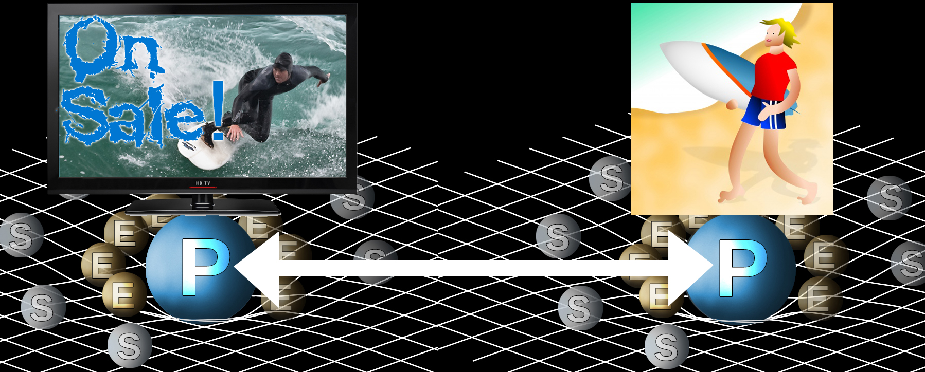
At the attachment phase “E” (figure 9) of intrinsic thought-processing from the surfer, it is possible that the surfer's extrinsic values “S” can still activate his/her intrinsic values “P” through reinforcement of associative links “S,” super-ego: (figure 10). Extrinsic values act as a priming agent, strengthening intrinsic ideas through value association and conditioning “S,” activating “P”. As a result, the mere thought of the surfer having surfing thoughts (whether rational or emotional), strengthens the surfer's pathways of surfing “E”. As a result, “associative links to hedonistic motives, physical and psychological features; important values, goals and other attitudes, begin to crystallize” (Daniel C. Funk & Jeff James; 2001).
figure 10. Indirect Value Connections:
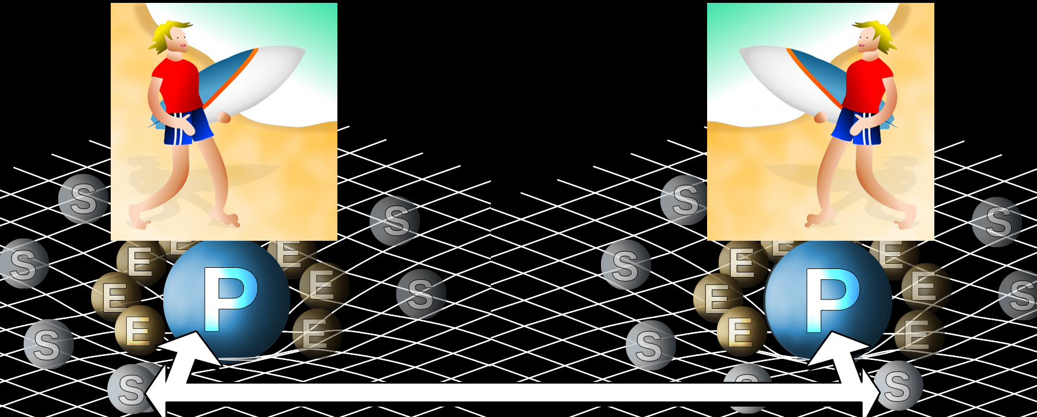
(Rational conversation between two surfers about surfing):
As shown in (figure 10), the surfer engages in rational conversation about surfing, such as how to ride a big wave. The conversation of big wave riding still activates and strengthens intrinsic emotional values. This is called an indirect value connection (figure 10). It is a connection where extrinsic values “S” and intrinsic values at “E”, strengthen intrinsically consistent values at “P” (figure 10). For instance, a surfer is innately going to be “connected” to beaches and waves, but not always in an emotionally, engaging (intrinsic) way – super-ego related ideas might be rationalized instead. However, super-ego related thoughts may still serve to strengthen emotional thoughts connected to the surfer's love of surfing. For example, a surfer logically reasoning the timing of waves between sets (sets of waves), might still strengthen his/her love for surfing. These are called indirect value connections, and always strengthen values at “P” (personality) – not the other way around. “P” values can not strengthen “S” (super-ego) values. “P” values are part of an emotional cognition called, “hot reasoning,” – a cognition which overrides rational reasoning, called “hot reasoning” (“The Brain, Decision Making and the Unconscious,” Andy Habermacher). Also, “P” can never strengthen “S” because “S” does not contain emotional cognition.
Direct Value Connections vs Indirect Value Connections (ref: figure 11): When the surfer's intrinsically consistent values “P” are activated by the surf advertisement at “P” – (figure 9), the advertisement's contagion becomes gravitationally heavier (as a social object) because a direct value connection has been made. If many surfers watch a surf advertisement and develops the same psychological connection, than the surf advertisement (brand) starts to become popular – a contagion. The surfer is therefore is highly connected to the surf advertisement's values, beliefs, and attitudes (“Surfer's attachment to Surf-Ad” figure 11). The surfer (in social-spacetime) moves closer to the surf advertisement's gravity-well. When the surfer only connects extrinsic value connections “S” to another surfer's extrinsic values “S”, a “S”-to-“S” connection, the “rational conversation about surfing” (figure) merely reinvigorates the surfer to strengthen his/her own connection with to “P” and “E”. This is called an indirect value connection. No movement is incurred in indirect value connections. The two surfers (in social-spacetime) are not pulled into the gravity well of the center surf advertisement (figure 11).
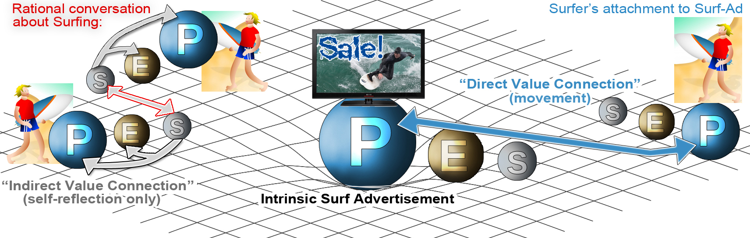
figure 11. Indirect Value Connections vs. Direct Value Connections:
Full emotional hijacking vs partial emotional hijacking: Amygdala hijacking is a fight-or-flight response (Wikipedia.org). However, unlike Amygdala hijacking, where fear and strong and intense feelings persuade us to move to action immediately – usually unconsciously – an emotional hijack is quite different in that it's not a split-second decision. Rather it deeply affects our overall decision-making process, which is based on personal values. Emotional hijacks attach to these emotionally, salient values, and override rational thinking when the two are compared (hot reasoning vs. cold reasoning). These values and emotional states can be positive or negative – but they always are overridden by inspiration or fear. We can't force someone to believe something, but we can inspire them or frighten them, or both. When we inspire others, it is usually done with a contagious ideas, called a contagion. Contagions (“P” – figure 11) intrinsically connect to our cognition alongside other values, morals, and beliefs we agree with. In order for an emotional hijack to create a “direct value connection,” a person must first be affected by the contagion: (another person can act as a contagion rather than the contagion strictly coming from a sport or social movement). When we perceive that our values are similar to someone else's, an aura of trust and commonality forms between us, and we emotionally connect in a way to that person that makes us feel comfortable. For example: say we were to meet on a crowded beach and through normal social interaction find out they're both ice-skaters. Immediately, the thought occurs to each of us that “hey, that person is like me; they represent my values, because I too, am a skater.” And because the power of context states that the vast majority of beach-goers are not passionate ice-skaters, us meeting in a sea of non-ice-skaters is a direct value connection (figure 11, right-hand side).
And there are instances where partial emotional hijacks exist, rather than full-on emotional hijacks (which includes the essence of time, in the order of months to years). Full emotional hijacks are akin to becoming loyal to a brand or engaging in a sport until it has become lifestyle.
However, partial emotional hijacks occur when people connect emotionally to a contagion in a very short amount of time. Television commercials try to achieve this affect. What usually causes this affect is an “unbearable itch” that's created, by forming a direct value connection between the person being affected, some kind of stimuli (a fight or flight response), and a value (an idea).
A violinist for example, may be out on a stroll in urban city. And they may happen to walk by another violinist who's actually performing right there on the bustling street, but not attracting any crowds. This violinist out on a stroll takes notice and might approach the performing violinist and engage in a conversation with them simply because they both play the violin. In other words, there's a direct value connection (or strong commonality) between the two.
If the performing violinist was attracting a crowd, however, then this would make the performing violinist – in context of a compelling force – an “unbearable itch” meaning, someone you can't refuse to approach. The performing violinist therefore becomes even more attractive to the approaching violinist out on a stroll because of the popularity factor, not just the fact they both play the violin. This is called the “Power of Context.” The Power of Context makes a social situation a potential “partial emotional hijack” for those observing it. Is there a sameness of everyone around us? Or is everyone uniquely similar except for those few that stand out? And why do they stand out? What does that person have that makes him or her so special? Perhaps they are attracting a crowd because of a skill. The attraction of a crowd is the compelling force when someone gives off a sense of popularity and intrigue that inspires others to follow.
Full on emotional hijacks however, work much like “partial emotional hijacks,” except that full ones take time to become self ideas. An emotional hijack can take place in many different contexts. For example: say you loved to drink wine, so you visited a winery. Your experience at the winery intensifies your love of wine in of itself because the different aspects of the experience further enhance your love for wine. You love tasting wine and seeing and smelling the wine. All of these experiences serve to strengthen your love of wine. They serve as strengthening agents. All of the sensory and emotional experiences associated with wine strengthens and reinforces your love for wine.
But for people who only have a slight “liking” for wine – which would be someone in the attraction phase of the PCM for wine – a winery experience such as the ones described above – will only bring about associations to wine that are mostly extrinsic, or partially intrinsic, but not fully intrinsic (self ideas). Formulating new intrinsic behaviors in Social Fabrics: Emotional hijacking is about inspiring people to take on new intrinsic ideas and values towards your brand by projecting powerful social forces: leadership, passion, purpose, and inspiration. These are the embodiment of your brand and make it a contagion (a Social Fabric). But it is not a Social Fabric yet until you have followers. It should be noted that individuals possess Social Fabrics automatically because we're human beings, we have to power to affect anyone at any time through social interaction. However, a Social Fabric that encompasses a brand does not turn into a Social Fabric until people are attracted to that idea. In other words, it pulls gravitational weight in social-spacetime. Turning your brand into a Social Fabric requires you to demonstrate some kind of social appeal or a compelling force: a projection of leadership and skill. People will follow if you stand out and give them a reason to want to follow you (your idea or brand). Through projections of leadership and contagious ideas, people will follow for emotional reasons. Showing that your brand offers a lower price, or better features, or higher quality than your competitors is not an emotional reason. These reasons are called added value proposition. They reside at the “S/E” region of a Social Fabric. This S/E (super-ego – ego) region is a combination of the “awareness” phase and “attraction” phase in the Psychological Continuum Model (figure 7). Awareness and attraction are designated as the super-ego and ego, and are rational and semi-emotional states of cognition. This S/E region is known for “ego identity,” meaning: attaining a goal, such as “how to be better than your competitors.” It is an extrinsic/intrinsic cognition of thought perception, but does not represent self-concept yet.
On the more deeper, more emotional state of cognition, is the intrinsic phase of thought processing. Followers who connect to leaders who are able to inspire new ideas or modify self ideas in others are either intrinsic or intrinsically consistent in nature. Modifying intrinsically consistent values and ideas such as religion, morals, beliefs, or politics is extremely difficult. Loyal attitudes and beliefs stay relatively unchanged because they are ideas that have been hard wired since childhood. They are ideas that represent childhood memories, longstanding beliefs, memories, and morals, concrete views about the world, and other intrinsically consistent beliefs.
Inspiring someone however to take up new ideas however, especially those that do not come in conflict with hardwired beliefs is a much easier feat. For example, consider the following notion: “In the beginning, 'I' contributed to the cause of curing cancer because it felt good” – which is an semi extrinsic thought value. It feels good, but it doesn't characterize how one defines themselves. Not yet. But years later, after pursuing this cause consistently, “I now feel like being part of the cause to help to cure cancer is now part of who I am.” During the first statement: “because it feels good,” exemplifies an extrinsic/intrinsic value perception. It serves to satisfy an immediate pleasure called an indirect value connection. It indirectly connects to a contagion through semi-emotional thought values. The second notion: “it is now part of who I am,” is an intrinsically consistent value, a reflection of self-concept. This is designated by the “P” region of an individual's Social Fabric (figure 8). It is reflective of values that are centric to who someone is and are processed almost entirely at the unconscious level. This is where emotional hijacking occurs, because we can influence someone emotionally at the unconscious level before they're aware of this fact once it reaches the conscious level of cognition.
Friendship and personal closeness in Emotional Hijacking: An emotional hijack is the process in which followers become psychologically attached or allegiant to a contagion but remain unaware of the spark of inspiration that starts the process. A follower's connection to a contagion can be exploited at the connection of someone else whom we trust.
What is even more surprising in emotional hijacks is that they occur all the time in society, particularly when we're exposed to ideas and values which suit our own internal way of thinking. And this happens in the social-spacetime of businesses, family life, outings, sport life, and other social situations where we are vulnerable to some one or group capturing our best interest or heart at mind.
In a sporting example (regarding emotional hijacks), say your friend introduces you to their favorite sport: football, for example. Over time you happen to form a psychological, intrinsic connection to football. For some reason or another, you just happen to like football whether from a brief encounter with the sport during your childhood or some other inspirational cause. Over the months or years of playing football with your friend, at some point you end up as an avid participant of the sport. If this occurs, it would be because of your close social relationship with your friend and to the sport of football and the influence of both on you that firmly places you within the social fabric of the sport.
“This is why every single person alive and who has ever lived has been biased in more ways than we can describe - it comes with having a brain that wires to stimuli it encounters and then prioritizes this with current schema and emotions. “ - Andery Habermacher.
But what if you didn't like football? What if you only participated in football games because your friend did it and they wanted you to do it too. Unless football inspires you, you may form a liking to football in a basic way (an extrinsic connection) – but not for love's sake. You would likely be unable to form a love for the game because your emotional hijack of the sport would not prevail. Social interaction with your friend and sharing of common values is a contributing factor towards your liking of football, but not a good enough emotional reason for football to become a lifestyle to you.
The social factor during emotional hijacks plays a big role in psychological attachment to sport. Say for example you went to a party with people whom you like. You would be more likely to enjoy the party. It's a simple concept. But what if you were to go to that same party and mingle with people whom you disliked? Chances are, you would not like that party. Social experiences are very telling of how well we connect to ideas, and how well those ideas coinciding with people and values connect to each other in a social fabric of space and time (social-spacetime).
This situation lends itself to a level cognition called “me” versus “them.” We typically feel safe around those whom we trust and enjoy spending our time around, while those we don't trust or like, we tend stay away from. Psychologically, this creates a “me” versus “them” perception.
But when in the company of those whom we trust, we create “social circles.” Social circles protect us from dangers all around us. Our natural defense mechanism protects that circle, and therefore us. If you've ever been introduced to someone through a friend, that person is automatically given right of passage to our “circle of safety” or “social circle” because we share a common friend with whom we both know and trust. This condition however is contingent on the fact that that person consistently acts on our best interests.
Emotional hijacks literally hijack the feelings of trust by inserting a disconnected idea into the center of a circle of safety that didn't have the value before. Emotional hijacks inspire new contagions (new, contagious ideas) into our circle of safety (or mesolimbic pathway) at the unconscious level by way of inspiration and of pairing of values. When we are inspired, new ideas and values being inspired are inserted into our state of emotional cognition. Once inside, if these ideas and values are intrinsically consistent to our own ideas and values, then we will already have some inclination to act towards them with a sense of trust once they have become consciously aware of them – similar to the friend scenario above. A contagion emotionally hijacks us when a set of ideas or values have successfully paired themselves to our emotional level of cognition of self-concept. This is called unconscious bias (“The Brain, Decision Making and the Unconscious,” Andy Habermacher).
Emotional hijacks typically have a greater affect on people who are either Innovators and Early Adopters because they react to a given person or situation with an emotional salience. These types of followers form a psychological attraction to a contagion based on values and beliefs (emotional ideas). They will make their transition of attraction towards your contagion to attachment in the Psychological Continuum Model (figure 7) if they are socially involved in the sport (or contagion). Some people however, can become psychologically attached and even loyal to something on their own team. But in most circumstances, particularly in my experiences in Xtreme Ice Skating, psychologically moving sport participants from the attraction phase to the attachment phase (a self-idea) required social interaction to pursue that cognitive goal. The authors of the Psychological Continuum Model make reference to this fact: “as the [social] relationship takes on greater [chronological] importance, as their (sport participants) perceived meaning attached to the contagion (physical and psychological associations), they became embedded into a larger, more complex network of links contributing to self-concept” (Jeff James, Daniel C. Funk, “Psychological Continuum Model”; 2001). The paper's authors also make this point literally when they say, “social bonding, may provide the means for fostering movement from attraction to attachment.” And “Social and interpersonal bonds can be developed by acknowledging sport spectators and making them feel important.” This means that in terms of an emotional hijack, our internal emotional state – the ways in which we personally connect to people and form deep relationships with them – is the result of our recognition of others in their increased feelings of pride and status, reinforcing our social relationship to them. A hormone, serotonin, called the “leadership drug,” is supposedly responsible for reinforcing social relationships. It is a social, survival mechanism that is meant to bring people together (Simon Sinek, 2016).
In a reference to the surfing example, most surfers engage in surfing individually. But when they are out on the water catching waves, they sometimes share their current experiences with others around them. These conversations serve to strengthen the surfer's psychologically connection to surfing itself. This type of social interaction further strengthens a sport participant's psychological attachment to their sport.

XII. The spread of contagious ideas in Social Networks:
Figure 12.
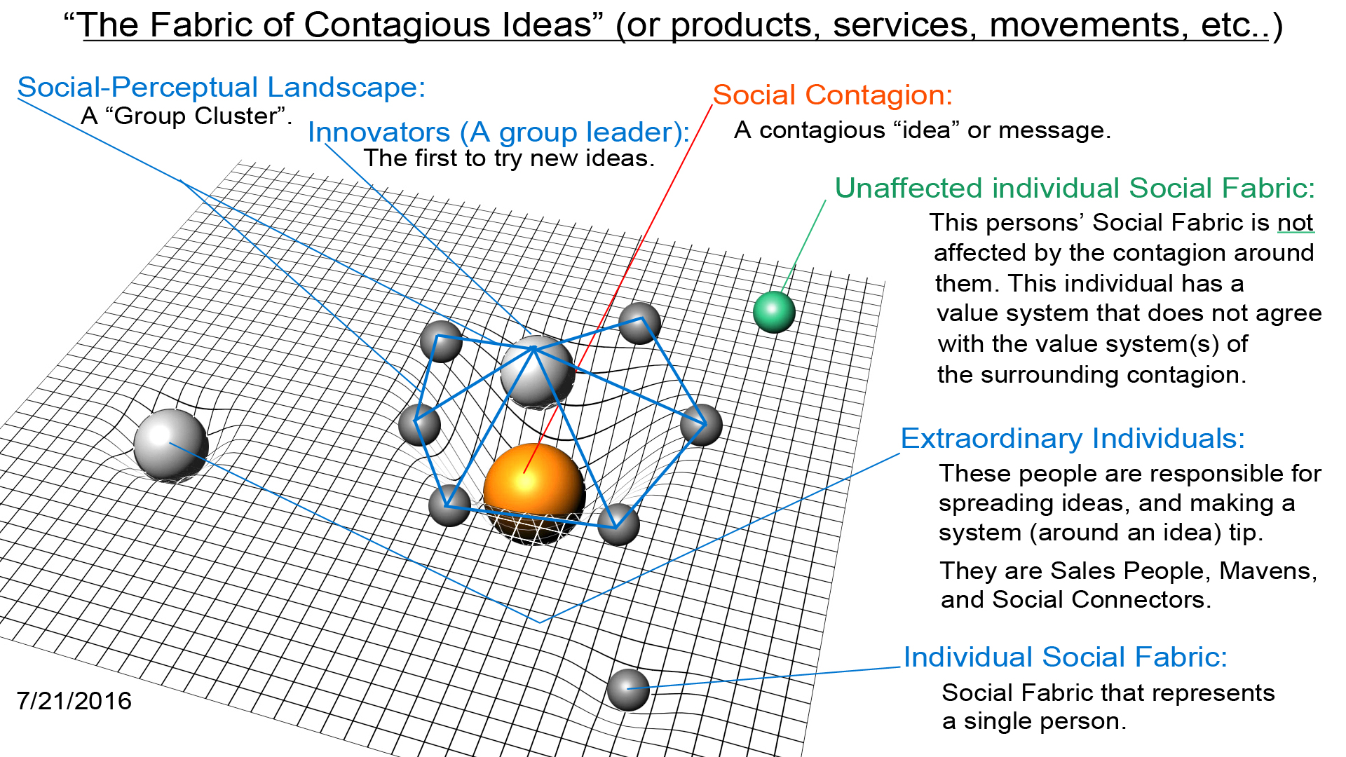
A description of a Social Fabric landscape and contagious ideas (figure 12):
Contagions in social movements tend to have a natural progression toward greater growth in complexity: from social risk-takers who join at first, then to non social risk-takers, and from complexity of ideas at first, to simple ideas as the idea grows in size (followers). When social contagions first start, they attract Innovators, people obsessed with details about who started or pioneered the social movement and why. Early Adopters follow the Innovators to the social movement because they are more risk averse. The Early Majority are even more risk averse than the Early Adopters and typically follow social movements which have already formed and are already trending in popularity. The Late Majority follows the same pattern but with more rational thinking. Each time a social movement is born, the movement attracts followers which has a natural progression (called the Diffusion of Innovation – figure 2) of social participation. For the rest of the crowd who didn't join the dance (in social-spacetime), they are called “unaffected individual Social Fabrics (figure 12).” Unaffected individuals could care less about what the social movements going on around them. They will never join, ever. And that is why their individual Social Fabric in (figure 12) isn't warping social-spacetime at all in accordance to the contagion. Secondly, the Innovators and first-wave Early Adopters care a lot about the lone nut and their attraction towards him (for what he stands for). The Early Majority on the other hand were only following what they perceived as “popular.” Specifically, Innovators and Early Adopters join social movements for the specific details they represent (why we do what we do). And their participation simply prove who they are in the context of those movements. Whereas the Early Majority, follow what is either popular or trending. They follow social movements not for the specific details of the movement, but for what the overall movement represents and its popularity. They find pleasure in connecting with big ideas and the people who created them. This is what gives rise to celebrities and particularly, super-stars. This is why the majority of people of a given population follow pop music (or popular music), whereas the Innovators and Early Adopters follow a music that is not mainstream specifically because it is not mainstream. This is not to say that people who are part of the “majority” of a given social movement (such as a type of music) only listen to popular music and not specific, niche-related music. This principle is merely a general behavior of how people popularize and follow social movements.
In summary, contagious ideas are translated by those who first follow them: Innovators, to the (Early Adopters) who follow the initial followers (the Innovators). When the original idea is translated, from Innovator to Early Adopter, the idea itself gets simplified in a new way, but keeps its original stickiness or contagiousness.
The Emotion of Politics:
It is extremely difficult to influence someone's intrinsic self-values once they have become intrinsically consistent (meaning unchangeable, such as politics, religion, etc..). When ideas become intrinsically consistent, ideas firmly become embedded in one's sense of self about who we are as a person, our religious or political beliefs, and any cognitions that may inspire us. Once ideas become embedded internally and consistent in nature (called psychological allegiance in the Psychological Continuum Model), allegiant ideas become almost impossible to change because they are a construction of the “id.” These strong beliefs/values are deeply ingrained in the hard-wiring of our brain, usually made up of our childhood memories and experiences, morals and values, and ethics which have become the essence of our subconscious and unconscious cognitive pathways. When drawing upon these cognitions, such as remembering something, they likely play a pivotal role in our emotional reasoning – represented by the “id” of the psyche, the “P” region of Social Fabrics. When someone attacks our “character,” who we are as a person, we tend to get offended because our “P” region (our id) or “personality” is challenged. The attack is felt as an attack on ourselves, not just on our beliefs or something we are closely connected to.
Assuming that it is possible to change someone's political beliefs because they happen to be moderate in belief, marks a reflection of an individual's psychological attachment to their self-values in relationship to a particular contagion. Moderate beliefs tend to not bring about feelings of threat or anxiety (generally speaking). The Amygdala however, these feelings do occur because the Amygdala is considered the emotional “hot center” of the brain and is responsible for feelings of threat or anxiety generally we called the “fight-or-flight” response. In this state of cognition, emotional decision making called “hot reasoning” takes place. The opposite to this cognition is “cold reasoning,” a way of thinking and perceiving rationally (mostly void of emotion).
A recent study on political beliefs from USC finds that “people who were most resistant to changing their beliefs have more activity in the Amygdalae (a pair of almond-shaped areas near the center of the brain, the emotional processing center of the brain of fight-or-flight feelings) and more activity in the insular cortex (which controls thought perception, motor control, self-awareness, cognitive functioning, and interpersonal experience), compared with those who were more willing to change their minds” (“Hard-wired: The brain's circuitry for political belief,” Kaplan, 2016). An individual's attraction towards extrinsic political beliefs that conform to one's own beliefs therefore, may serve to strengthen internal, intrinsic political values. This means that rational thoughts may strengthen emotional ideas if both ideas are of the same nature or political content (a visual example of this is in figure 11 where “S” – an external node – strengthens the “P” internal disposition of personality). The Psychological Continuum Model uses almost this same exact language in regard to sport participant's connection to sport during the attachment phase of a sport: “Over time, continuous activation or mere exposure would strengthen connecting links and embed the team firmly within the individual's larger associative network, eventually creating a more complex network and stronger relationship meaning: more direct associative links between the team and other central attitudes, goals, and values.” Likewise, the same thing happens in politics when political beliefs become of personal importance which aligns to ideas of the-self. Therefore, to influence someone's political beliefs from one perception to another goes beyond mere rational persuasion. Drew Weston's research describes this process: “political partisans believed their ideas to be true regardless of evidence presented” or more simply, because political partisans are emotionally (intrinsically) tied to political ideas, attitudes, emotions, and beliefs become representative of who they are and how they view themselves. Emotional ideas “invariably win” over rational ideas. Politics becomes akin to a cult or a religion.
When emotion collides with reason (Emotional vs. Rational thinking): Emotional values, memories, and habits lie at the center of an individual's Social Fabric (“P” region – figure 6). These values are considered to be “concrete values” or hard-wired pathways in the brain, that represent skills or things we already know how to do, things we might do automatically. The areas of the brain that harbor these ideas can not be easily changed, particularly if they are attached to strong emotions. These cognitions are part of the “id” of our personality including emotion, self-gratification, unconscious and subconscious thoughts. And even if they are not of strong emotional conduct, it is not easy unlearning a habit only to relearn it in a new way. But in the sense of strong, emotional attachment to ideas – persuading a couple who are in love to simply fall out of love simply because I told them is merely impossible. I not not persuade a Hockey player to suddenly become a figure skater because I explained to them the pros and cons of each sport. These are rational arguments that can not win over emotional attachments to ideas. Based on Andy Habermacher's research, rational reasoning. . When set against emotional reasoning, invariably loses. Emotion is a more powerful force than rational decisions. This also relates to other emotional decisions in life such as those who are for or against a particular political party: Democrat and Republican:
The results replicate those in hot and cold decisions: when deciding for their own political candidates. The more emotionally linked part of the prefrontal cortex was active in comparison to deciding on opposing candidates. Drew Westen notes that when emotions collide with reason, emotion invariably wins. These are not conscious processes – the partisans genuinely believed their opinions to be better and more reasonable and supported by evidence; it wasn’t – (“The Brain, Decision Making and the Unconscious”, Andy Habermacher).
In a sporting example, any attempt at persuading hockey players to become figure skaters through sheer rational debate would be ineffective. The only way we could persuade a hockey player to become a figure skater would be to inspire them. And this would be done through an emotional hijack as well as embedding them in a social fabric of figure skaters closely related to a hockey contagion. However, most hockey players would likely not be inspired to take on figure skating because of the problem of the value system between the two sports. The “P” region of their Social Fabric and a figure skater's “P” or personality region are very different. Both sports share the feeling of “power” as a common contagion, however, it's how power is perceived that is notably different. In hockey, hockey players have a major conflict with ideas of power vs grace. In their minds, you are either one or the other. You are can not be both. Require lots of power to be played. Similarly, it would be like trying to inspire a staunch Republican to switch to being a Democrat. The value systems between the two are too far apart, even if an indirect value connection can be made. In hockey, the notion of “power” is about being tough and rugged, in a sense. After all, hockey allows fighting. Public perception of the sport has a huge influence on the player's perception and emotional connection to it as well. Figure skating on the other hand is about power too, but power in figure skating means athleticism and the ability to do amazing jumps. Also, figure skating places greater importance on the value of “grace” than “power.” Grace, as a common contagion, is therefore in conflict with hockey's “power and manliness” contagion. Therefore figure skating and hockey can not share the same contagions. However, Hockey players and figure skaters both share the common contagion: “passion for the ice” even though both athletes come from different sports: team and individual. There is an indirect value connection between the two. An indirect value connection is a semi rational-emotional connection between two ideas. Additionally, there are cross-overs between team sports and individual sports called cross-cultural-links. They are found in both hockey and figure skating (such as as “passion for the ice,” though a very common connection). In Xtreme Ice Skating, cross-cultural-links were elements of aggressive inline skating found in Xtreme Ice Skating such as ice-skates you could grind on (which was a prototype). These links are common contagious ideas athletes from both sports shared. Cross-cultural-links therefore are not necessarily a compelling force, but rather a reason for interest. Cross-cultural-links build interest in an idea, such as attracting people towards a brand, or building a broader social movement based around a more a common contagion that includes more people. For instance, we could create “New York” sport. The sport would include all New Yorker's around New York values. However, if we wanted to build a more broader social movement for the sport, we could inspire “being an American” as the sport's more broader vision, attracting a much larger audience.
When deciding which type of sport we like: team sports or individual sports – the one that is based within the emotional thought-processing of ourselves – reflecting who we are – is the type of sport we are likely to favor. We emotionally choose sports (and other things) to reinforce how we think about ourselves. But this also occurs at the unconscious level where we innately make snap judgments, which is based on who we are and how brains have come to understand the world.
Our “ideal” partner when dating, for example, is never the person we actually fall in love with. Its the person whom we automatically, emotionally connect with. This represents our “type.” Most people have a “type” of person they're innately attracted to. Our emotional decision making in this cognitive process is called “hot reasoning.” Hot reasoning or emotional reasoning, invariably win over rational reasoning (called “cold reasoning).” [Feelings] usually win over rational ideas. We often hear people say, “when you meet the right person, you'll just know it.” The “ just know it part” is the feeling – the emotional construct. A feeling is an emotional construction of ourselves, emanating deep from our unconsciousness. But when we decide we don't want to date someone based on how they might look on paper – that, is a rational idea. A rational thought is merely a conscious idea, something our super-ego can easily change over time. That's why political elections aren't won by rational thought, but rather by emotional ideas that people can feel and “connect” to subconsciously. When feelings bubble up from our unconsciousness (our “id”), they already are emotionally pulling us in certain direction without our awareness. Our unconsciousness is like the construction builder of ideas. When the builder is finished, all the ideas the builder created, are presented to us in our consciousness.
Similar to the construction builder, whether we decide to play a team sport or an individual sport – the decision to engage is ultimately based on how we have socially and emotionally experienced similar sports in our life, which is the prebuilt emotional salience of those ideas and experiences that bubble up from our consciousness as ideas that come to mind. Children however, react a bit differently because they haven't developed a strong sense of self yet and therefore tend to stick to team sports because of team sport's social appeal, and because their parents are huge decision makers in the process too. But when the children become adults they make the decisions to try a new sport for the first time based on emotional and rational ideas constructed deep in our “id” (our unconscious bias) – of who we are, and what our past experiences and habits have been like. This vision, is the brain's version of what it thinks the world most realistic and likely to be. These assimilation's are not just mere associations between self and sport, they are part of a entangled process called “balancing of emotions.” In the research paper, “The Brain, Decision Making and the Unconscious,” Andy Habermacher talks about “balancing of emotions”:
“Decision-making therefore is not a rational process but rather a balancing of emotions, memory and habit in the brain. This is processed almost completely below our level of consciousness – as when a tennis player hits a ball. This is where unconscious bias is processed – we will not notice that a whole list of emotions, habits, associations are formed and instantaneously processed giving us answers for or against a person, a gender, and a race. Also, these unconscious biases are biological pathways that are deeply anchored in the brain. These are built up through our socialization process: our interactions with the world around us.
In short: our life experiences are a built-in bias that we often drawn upon, that is reinforced (the “Confirming Evidence Trap”), meaning that we have instinctive unconscious biases built in and it directly impacts our view..” – (“The Brain, Decision Making and the Unconscious”, Andy Habermacher).
This kind of “emotional thinking” is equivalent to “hot reasoning”:
“Hot reasoning is when emotional constructs are involved and cold reasoning is in the absence of emotional constructs. What we can see in experiments is that the cold centres, the more reasoning centres of the brain are further at the front and higher up in the prefrontal cortex namely in an area called the dorsolateral prefrontal cortex (DLPFC). Those more emotional constructs, “hot” reasoning, are processed more in the ventromedial prefrontal cortex...” – (“The Brain, Decision Making and the Unconscious”, Andy Habermacher).
Being inspired to play a sport is a form of hot reasoning. The diffusion of popularity in Social Networks: As a person becomes more popular across a social network, their attraction towards unintegrated individuals and groups also increases. This attraction also occurs at a faster rate between those who are already popular. Existing, already popular ideas take less time to become more popular than those that are not. Researcher Dunia López-Pintado discusses the “popularity effect” in her research paper called, “Diffusion in Complex Social Networks” (Dunia López-Pintado; 2004). She describes how popularity relates to the spread of a product and its influence across a social network.
Dunia's research describes how networks with “exceptional individuals,” those who are SalesPeople and Social Connectors, who exist in “scale-free networks, have a significant proportion of hubs (or nodes) that have very high connectivity compared to the average (person or hub in a network).” In high connectivity networks these “hubs” behave like Social Connectors. These people reach out like branches of a tree. They know lots of individuals and social groups from different “walks of life.” Furthermore, Social Connectors (or hubs) play a crucial role in spreading products across a social network since hubs easily adopt the product due to the hub's high [social] connectivity,” says Dunia. In other words, Social Connectors (people acting as hubs) increase the rate of spread of a product due to their vast social connections. This means that Social Connectors (or hubs) lower the threshold or tipping point to which ideas can tip or go viral in a social network due to the sheer amount of people they reach at any given moment in time. This factor is exponential.
Dunia's research also highlights that social networks which have “active consumers” have a greater capacity to influence the sale of a product than those networks which have little or none (active consumers). Active consumers behave as SalesPeople in networks because they're able to convince others who are not yet convinced to try a product (through the 3rd law of Social Fabrics called, “the neighbor effect”). For example, we're more likely to buy a product suggested by someone we already know. This has to do with common values, and those whom we trust simply because they have similar common values to us. Active consumers (or SalesPeople) establish a direct value connection between themselves and potential customers. This is an emotional value connection between people in a system of trust (called the “Circle of Safety,” in relation to Simon Sinek's work). This law of trust is the fifth law of Social Fabrics called “Value System” (section VI). The establishment of a direct value connection between a potential consumer and product through a common value is why “testimonials” on book covers work, particularly by trusted sources such as a major outlet or organization. When we meet people who already agree with our own views, we're more likely to trust them since we have common values to them. The reason why it feels good to meet people who share similar values is because it makes us feel safe and accepted (the 2nd law of Social Fabrics). It's also an emotional connection that two people share. A relationship can not be built without trust.
The second principle in Dunia's research, is when a significant amount of active consumers who are already in close physical proximity to each other – whether in a network, or real-world social movement – they are more likely to convince others nearby to become active consumers as well, because of their underlying influence in what they perceive as popular. For instance, if fifty active consumers bought the same product, and they all convened in one physical place together, promoting the use of that product, then all those watching would then likely perceive that product as being “popular.” That is why companies create events – to achieve that very affect. Events, or “grand openings” are meant to create an aura of awareness and popularity to onlookers who may become active consumers. But this is achieved primarily through the popularity effect, or the number of active consumers in a network convincing others nearby. Similarly, as Dunia points out that, the rate at which products spread across a network is largely dependent upon how popular the product's appeal is (how many initial active consumers there are). She further exemplifies this point in her research:
“The threshold that determines the diffusion of the product, depends both on the connectivity distribution of the network (P (k)) and on the particular diffusion function considered (f (k, 1)). Specifically, in order to assess the existence or not of some positive prevalence, it is enough to consider what happens in a neighborhood with only one active agent. As highlighted above, this is merely a consequence of the fact that, for positive diffusion to occur, the state with no active consumers has to be unstable. Notice that, If λ > λp then, in the long-run, the product spreads and becomes persistent in a fraction of the population. The degree of the diffusion, however, might depend on the initial conditions. If, on the contrary, we assume λ ≤ λp then, if there is only a small fraction of initial adopters, in the long-run, the product will disappear from the market. In other words, we either never reach a state with a positive fraction of active consumers or, if we do, it must be because there is a sufficiently high “stock” of “initial adopters.”
If any given network or social movement exists, it contains people who are “SalesPeople” (active consumers) who are good at convincing others who are not yet convinced. And these SalesPeople who also happen to be Social Connectors at the same time (called “hubs”), increases the rate at which a product spreads across the network exponentially compared to those [networks] which do not have many active consumers and hubs, or in other words, networks that do not have many SalesPeople, Social Connectors and people who are both.
Social-Spacetime and the “Neighbor Effect”:
The “neighbor effect,” (chapter VI. Law 2) is the second law of Social Fabrics. It relates to Dunia's research in her idea of “active consumers” in that both relate to how we feel when we're physically close to someone. Trust. When someone enters our personal space we typically either feel delighted (because we know them), or we feel apprehensive because we don't trust them. Turst has to be earned. If we don't know someone, we might feel slightly apprehensive based on how close we are to them, or even a surge of an adrenaline rush, a rise in blood pressure and heart rate depending on the situation. The person in our space – now the center of our social-spacetime – affixes to our cognition because of this “neighbor effect.”
The second similarity of Dunia's research is the “gravitational weight” principle (relating to social-spacetime theory). This theory relates to Dunia's “popularity effect” principle, or “high stock of initial adopters.” In marketing, this is called “Fastest with the Mostest” strategy, and is typically inline with the first-mover advantage strategy.
When people popularize ideas, they form contagions and create a heavy gravitation weight in and around them in social-spacetime. They create a contagion with lots of appeal and value, according to Dunia's “popularity effect.” What's more revealing about her research, particularly in relation to Social Fabric Framework theory is that popularity-effect also relates to emotional decision-making in social-spacetime. Popular ideas are an emotional reflection of who we are in the world around us. More broadly, emotional reasoning tends to bring attention to any idea or thing of value. We can think about the “popularity effect” in another way, one that is perhaps, indirect. For instance, traffic slows to a crawl on a highway when a traffic accident has occurred. Or, when a person is pulled over by a cop. Both events are emotionally contagious ideas. People focus in on a contagious idea when other things or events going on around them can not compete.
[Physical closeness and popularity] in relation to Dunia's research and the Laws of Social Fabrics (section VI) may work together. Sitting physically close to a popular stage performance for example, such as a Cirque Du Soleil show, costs more money. Being closer to the action is more exciting. We therefore pay for more excitement. These stronger emotions create the conditions for popularity. Someone who has sat close to the stage at a Cirque Du Soleil show will enjoy the show more than someone who has sat towards the back. The front seat we experience higher levels of adrenaline, serotonin (mood), and norepinephrine (hyper-focus). The person sitting in the front seat may spread the word of the show more enthusiastically and for longer period of time than someone who sat in the back seat. Emotional salience therefore plays a role in the “popularity effect,” or the rate at which an idea spreads across a social network.
XIII. Behavioral Reciprocity: emergent intelligent properties (figure 13): Definition: “The value of the group takes on it's own properties, and has it's own innate structure which impacts the individual and or his/her perspective in relation to the group” (Nicholas Christakis, 2012). In figure 10 below, culture forms from the relationship of intricate social connections of individuals of the group and to each other, and their behavior reflected as contagions among the group. The group connects internal values and internal value structure with external ideas forming emergent properties of the group, such as a flock's V formation saving the birds the most amount of energy during flight.
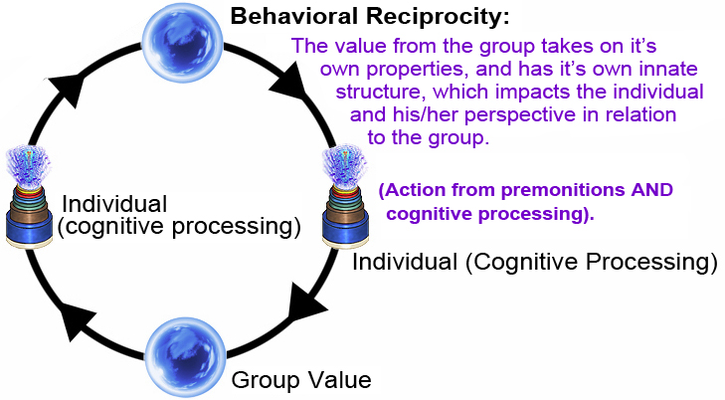
Figure 13. The above image is a section of the:“Micro / Macro Perspective” (Dan Perceval, 2012).
In complex social networks however, behavioral reciprocity creates cultural intelligence, showing complex patterns of intelligence and emotional thought-processing. Groups take on their own properties, behaviors, and attitudes shaped by the group's shared value (“P” & “E” regions of a Social Fabric – figure 5) and interconnectedness of group members (figure 11).
Individual ideas vs Group Opinion(figure 14):
figure 14.
As the sport Xtreme Ice Skating grew, its intricate details as a sport were dropped and sport participants replaced them with more generalized, contagious, group ideas. These ideas came from the natural social connectivity of the sport's social groups – namely ice-skating teams, circles of friends, and online networks – and these ideas spread throughout the sport's broader social network. This organization of people around a contagious ideas and then spreading outward created a Social Contagion (marked: Social Contagion – figure 14).

Socializing Agents:
Socializing agents are ideas that stand out more than others, therefore becoming highly talked about and shared. In other words, those ideas which have become popular and an agent of the social network because of its of social gravity pull on social-spacetime. Socializing agents start as ordinary ideas and become viral. For instance, a famous example of a socializing agent are symbols of action in sport that have become popular such as Michael Jordan's famous dunk (a brand symbol). The dunk itself is the socializing agent, and the social contagion, Michael Jordan, has brought social gravity to this socializing agent. Sport participants and followers latch onto popular ideas and share them among their peers and within other social groups. These groups have a hierarchy of social context to which popular ideas are led by an individual(s) with a vision towards that idea called Group Members (see figure 14). Group members lead and organize social groups around a Social Contagion (see figure 14) which are otherwise known as behavioral contagions. For instance, if I were to put you in a room among strangers to everyone else and you have mingled with certain individuals around certain ideas, those ideas have become socializing agents or possibly contagions.
Social groups result in part from a natural organization of people and ideas coordinating together. In Xtreme Ice Skating, for example, social groups – some of which were ice-skating teams – focused mostly on highly talked about ideas and actions which were socializing agents that became social contagions. Many athletes actually became more popular because of impressive tricks and other socializing agents that they created and presented in front of a Youtube audience.
Much how rumors work, popular ideas are passed around much the same way and become Social Contagions within social groups embedded in it broader social network. The more popular that these Social Contagions become, the more common group values and beliefs emerged from these social fabrics. Eventually, the sport's most talked about values, ideas, and beliefs become embedded within the contagion itself, merging into the core contagion. In Xtreme Ice Skating, the core contagion was: freedom on ice.
Xtreme Ice Skating's contagion as a result a result of social-centric ideas becoming popular, and merging with a core contagion, translated into something more simple and easy for ice-skaters to understand, and by all those who followed. The sport started as individuals and organized together into a social structure (called a Social Fabric). And these highly popular social contagions were embodied in the emotions and beliefs of the sport's followers. One of the strongest (most heavy, gravitational) values of the sport is freedom on ice. This value became the main driver of how almost everyone thought, acted, behaved, and communicated with one another in the sport and its broader social movement even though there were many other sports values attached.
Social interactions among individuals in Xtreme Ice Skating's social movement shared a contagious group value called a group contagion (“Social Contagion” figure 11). The behavior of the “group contagion” resembled a cultural intelligence, an emergent property of complex social systems and their networks. This behavior appears intelligent because of the complexity to which it ravels upon itself that outputs a behavior(s) to which only the sum of its individual parts working together can achieve.
Groups in the sport Xtreme Ice Skating developed this sort of “cultural intelligence,” which developed namely from ice-skating teams and online social media groups. Ice-skating teams in the sport had their own unique culture and specific way of doing things, especially on the ice. No matter what prevailed amongst the team (or group), and no matter where they were located in the world, they all had a sort of collective intelligence that appeared the same in natures – in terms of their tricks, their brand and other sport-related features. Ice-skating were all connected to the same contagion: the sport itself Xtreme Ice Skating. And Xtreme Ice Skating and other similar ice sports and activities became connected together to a much bigger social contagion of “alternative sports on ice.” Teams themselves had a sort of cultural intelligence, but so did the teams themselves socially connected online through social media. This “cultural intelligence” generally is a result of the complexity of a social system to which is interconnected to each other (figure 14) and more specifically, to a more broader, but stronger core contagion (which being, is the sport Xtreme Ice Skating). This interconnectedness of ice-skating teams was a highly efficient way in which individual parts emerge around a common core contagion. And this behavior appears intelligent, such as a flock of birds or an ant-hill. It is these social properties from which individuals and their groups work together that forms “cultural intelligence.” The complexity of a social system can be seen in (Figure 11) by the blue lines which are represented by the internal linking structure of group members to the group innovators (leaders) all linked to its common contagion (see: “Social Contagion” – figure 11). Culture emerges out of these internally linked social structures, and takes on a social emergent property called behavioral reciprocity. It is a behavior to which group members and their ideas within their groups interact with each other in such a way that the group itself creates “group culture,” meaning that the group creates social norms amongst themselves as a result of their learned and accepted behavior(s) and values that are connected to many other groups within a system around a common contagion. This is called “system intelligence.” This video further demonstrates behavioral reciprocity (Nicholas Christakis; 2012).

XIV. Sport Teams and the role of unique individuals in social movements(figure 15):
Figure 15. Structure of Xtreme Ice Skating Team Leadership:
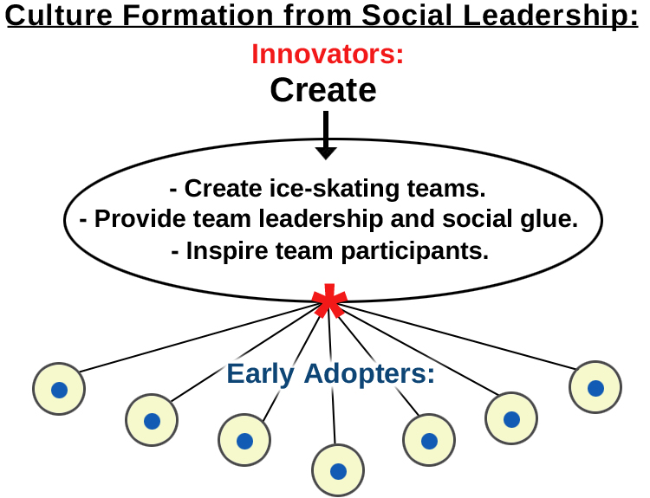
The first participants in Xtreme Ice Skating were Innovators and Early Adopters. They were risk-takers, attention-seekers, and performers. They had special, appealing qualities that defined them as Innovators and Early Adopters. These Innovators and Early Adopters loved showcasing their ice-skating skills in a public forum such during public ice-skating sessions. They performed exhibitions, demonstrations, and stunts in front of crowds [during public sessions] because they publicity brought them more attention. It feels good to be popular and known for it through skill and hard work. They were entertainers. Not only did Innovators and Early Adopters crave public attention, but they also identified with it. It was the essence of who they were. Moreover, Innovators and Early Adopters also aspired to be the very first to exhibit a new sport (Xtreme Ice Skating). They took pride in that. Again, it was the essence of who they were, of being first. It made them feel special. They were the proud to be the first to show everyone a new sport they newly learned, and to also create ice-skating teams based on that. Teams served a valuable purpose to its members: teams helped popularize its individual members while also giving them immediate followers. These efforts positioned team members to be at the forefront of popularity among the public stage of local ice-skating rinks. Teams and its members gained popularity and credibility both at the rink and online. From that recognition teams and its members gained public attention and social status both on and off the ice. These feelings created the emotional and psychological state which helped move them psychologically from the attraction stage to the attachment (in the sport) in the Psychological Continuum Model (figure 7). Team Associations made with the rink, fame on the ice, friendships, and other contributing factors helped team members facilitate this psychological transition from ice-skating (and the sport Xtreme Ice Skating) as an external idea, to an internal, self-idea. The key feature here is that social interaction within teams and amongst other teams helped facilitate this transition the most. Although, from experience, I can assert it is much more than that: social interaction with everyone, ordinary skaters and parents alike, not just team members, served as the compelling factor in social interaction. Social interaction on the broader scale of things – the popularity that came about from talking to everyone, and them wanting to get to know us because of our skills and popularity on the ice – helped achieve the fundamental factor of psychological attachment in the sport. Social interaction is the key driver of the attraction phase of the PCM (figure 7) to the attachment phase. Researchers of the PCM Daniel C. Funk and Jeff James further assert this point:
“Attachment develops when the team elicits responses and tendencies from memory while strengthening internal links between the team and other important attitudes, values, and beliefs. This intrinsic process would help explain how meaning is attached to external associations (e.g., success, pride in place, stadium) and take on internal psychological significance (Gladden & Funk, 2001).
Socially connected ice-skaters in the sport created a more complex social network of skaters by socially connecting to the sport's common contagion and its social movement. When sport participants skated with each other and shared ideas and experiences, they created a sort of ice-skating relationship which helped strengthen their psychological connection to the sport Xtreme Ice Skating as well internal, psychological connections within themselves in relation to their teammates. In other words, a general idea (of ice-skating) shared amongst their ice-skating team helped psychologically strengthen a more specific idea (Xtreme Ice Skating) within themselves. Research in the PCM indicates this fact:
“Over time, continuous activation or mere exposure would strengthen these connecting links and embed the team firmly within the individual’s larger associative network, eventually creating a more complex network and stronger relationship (more direct associative links between the team and other central attitudes, goals and values” (Daniel C. Funk & Jeff James, Psychological Continuum Model, 2001).
Innovators were the founders of ice-skating teams in Xtreme Ice Skating:
After Xtreme Ice Skating established into complex social networks, Innovators within those networks had met with and inspired skaters who came from different countries. As a result, these Innovators popularized both themselves in the sport, and the people whom they engaged with (through the ice-skating rink, and online activity such as Youtube videos). Innovators and Early Adopters of the sport were now working together, pursued making videos of these events and interactions and put them online. They tried to outrank each other in popularity of who had the most views and the most skill. Innovators had much success with this and went on to organize ice-skating events, exhibitions, and ice-skating teams as a result. Innovators used these methods to further captivate more Early Adopters to participate in their teams and to gain a greater following from others in the sport. Team leaders sort of became popular sports figures, adding more connections to their own social network while popularizing their teams and Xtreme Ice Skating in general.
What was the emotional reasoning for Innovators to create Xtreme Ice Skating teams (figure 12)? At first, it was for recognition. Any new team who had a legitimate video of their team practicing or doing tricks together was put on the sport's website. Secondly, Innovators did it for popularity. Innovators were usually the most talented skaters at the rink so having a team and doing exhibitions and events with the team only added to their popularity and recognition with the ice-skating community. And by having more loyal followers and fans, Innovators and their team members (Early Adopters) gained an even greater following. Their teams would sometimes make it to television or newspaper, and this was acclaim from outside the ice-skating community. This transformed the team into a bigger contagion. Innovators were driven to create more contagious ideas in an emotionally intense way so more followers would pursue. They had social qualities which made them more driven, enthusiastic, and passionate than their team members.
Ice-skating teams met regularly at the rink during public ice-skating sessions. Sessions often had lots of crowds where young people could mingle and form social friendships. Public ice-skating sessions also gave skaters a stage to showcase their skill in front of lots of onlookers. Public session goers were their immediate audience. Skaters skated alongside their immediate audience and conversed with them on a one-to-one level. Public session goers who admired the skater's skills, had also solidified a strong social relationship with them because of this interaction.
The power of being both Social and Personal in social movements:
Public-sessions at ice-rinks were [and still are] the perfect venue for promoting ice-skating sports. Skaters who attend them are a captured interest group (target market) for any sport on ice. They became interested Xtreme Ice Skating after seeing it at their local rink, and through many on-ice interactions with them – skating together, performing tricks, and just having fun. These experiences created lots of new fans, followers and sport participants. But knowing the type of person [or market segment] I was interacting with was critical to whether they psychologically attached to the sport or not. If fans were not inspired enough, their attraction to the sport would diminish. If too much excitement was sent their way, they would feel overwhelming or patronized. The right attitude and social signals was key to getting people interested in Xtreme Ice Skating. Body language (with regards to physical closeness) always remained critical. These continual social interactions mattered a great deal when marketing the sport. Getting to know people at a personal level opened up a lot of opportunities for us and developing the sport. This is what paved the way for many fans and followers to develop ice-skating teams and social groups. Their on-ice experiences were often put on Youtube. This helped create lots of excitement in the sport, letting the rest of the world know about who these Innovators were and the participation that was building in the sport. This attributed to the sport's credibility.
Xtreme Ice Skaters promoted the sport mainly through social interactions at ice rinks. Often we entertained public session goers by performing tricks for them. We did this regularly during public sessions at most ice rinks. We became entertainers, in a sense. Xtreme Ice Skaters could step onto any ice (providing the rink permitted the sport) and skate themselves right into the spotlight, getting the attention of the whole rink. We always attracted lots of crowds and interested skaters and ordinary fans. A small percentage of followers became sport participants. The majority became fans and followers. The Innovators were the first ones to try the sport. They were regular recreational ice-skaters before we met them, but usually had some kind of skating background from regularly skating public sessions for years. And a decent amount were figure skaters and some even hockey players. But the one thing these Innovators all had in common was that they already had the mindset of a skater. They typically attended ice skating sessions year round, or if their own sport, frequent participants. We inspired them to bring cameras to the rink and record their own action they should share their skating with the rest of the world; and many did. As they became more attached to the sport, they became ice-skating enthusiasts as a result, setting up entire Youtube channels devoted just to their skating. These Innovators were intent on proving to everyone about who they are and what they could do on the ice. Their passion was centered towards self-promotion and really helped market the sport.
The importance of physical closeness in social movements:
The overall point is that “physical closeness” – skating with potential followers during public sessions – is what kick-started the sport from being just an idea to having immediate followers and sport participants (Innovators and Early Adopters). Sports participants and followers of Xtreme Ice Skating at local ice rinks pursued their interest online, helping to disseminate the sport worldwide. An online social movement came about as a result of this momentum and online social networking. Not only did Xtreme Ice Skaters have fun socially interacting with fans and followers, but befriended other sport participants as well. Our passion for skating was contagious. Every we met kind of got a sense of this – this positive enthusiastic energy. We skated with and befriended anyone who would pay attention to us. And for those who did express interest, they were parents, teenagers, young children – pretty much anyone. This social phenomenon entails the social aspect of “physical closeness” because meeting people and inspiring them is a natural human behavior. We were even able to do it over the internet but it wasn't quite as effective. But when you meet and skate with people in person, they really remember who you are and what makes you “tick.” The next week I would see these same people back at the rink again, and asked them about their lives and how they were doing. This was how I gained fans and followers and became the center of attention on the ice which was a way of promoting the sport. And this was true not just with myself but with many other Xtreme Ice Skaters. They actively engaged with everyone at the rink, inspiring them with positive energy, excitement and passion which led them to come back to the rink again the next week. (Note: physical closeness is a key principle of Social Fabrics, which explains most of this behavior – relating to the laws of Social Fabrics: section VI. 2. “Physical Closeness”).
In summary, fans, followers, and sport participants became “active consumers” of the sport (Xtreme Ice Skating) from the time and energy we spent with them, both on and off the ice. Even though we knew most of our followers were never going to become Xtreme Ice Skaters, we pursued them anyway because it was just a natural thing to do. It was fun being popular and making friends. Social interaction in ice-skating became contagious. We literally motivated, uplifted, and inspired positive energy in everyone around us. We saw this energy pass from person to person. Smiles and happiness are contagious. As there were more people in close proximity to each other who took on our Xtreme Ice Skating contagion, the more likely others too would share the contagion. This social phenomena is described by researcher Dunia López-Pintado in a research paper, “Diffusion in Complex Social Networks,” where she describes this social behavior:
XV. Brands and “hot reasoning”: A brand should convey a feeling or a purpose, something that inspires people to take action. A brand must also embody a vision [of the future] of an emotional construct that inspires those witnessing to take action. If a brand can accomplish this, it has the potential to become a compelling force (a contagion). A contagion therefore has to have enough “social gravity” to attract new nodes or members into its network. These members then assemble into the brand's social fabric's gravity well, creating the potential for a social movement to occur. However, for that level to be reached, the brand must project an intense, emotional construct of its core message to compel its followers to take action. And this works best when the brand's followers have taken on the brand's compelling force as an intrinsic idea, becoming part of the-self. “I don't just eat ice cream – ice cream defines part of who I am. Eating ice-cream is a simple concept, and yet a delicious one but not a compelling force. For it to become a compelling force it must attach an emotional construct of sorts, of “hot reasoning,” to emotionally intense idea. For example: On a hot, summer day, with a gentle cool breeze upon our faces, my best friend and I sit together sharing stories of laughter and smiles, reminiscing over the good times we spend together as we inhale our chocolate, cold, sprinkle covered ice-cream, sitting eagerly before us. This statement is no longer just about ice-cream (as originally proposed), it's about laughter and friendship and it makes two people feel together. This is the job of a brand.
This is a heightened emotional state of awareness called “hot reasoning” (“The Brain, Decision Making and the Unconscious,” Andy Habermacher). It wins invariably over rationally minded ideas. When “hot” ideas attach to feelings, such as friendship, they then take precedence in our decision making. These emotional experiences develop a connection [in cognition] to ideas that fire them. For instance, ice cream and friendship. Or, the sound of seagulls and images or memories of the beach. Likewise, the reverse can happen. Smells of the beach trigger images or sounds of seagulls. This is why after hearing or smelling certain things, we suddenly start thinking about an idea that wasn't there a moment ago. The idea that suddenly appeared was first rendered in our unconsciousness. This is the essence of hot reasoning; we already have a strong inclination into feeling believing in something before we are consciously aware of it. And once we think of the idea, we are more likely to act on it (called “hot reasoning”). Every brand attempts to do this, assimilating outside ideas into things you've already know and love, rendering at the unconscious level, popping into our consciousness as if we've thought of the idea ourselves – we haven't. That's the emotional hijack.
And, if we repeat our exposure to these types of [similar] memories and ideas, we can literally develop new ones from them, by recalling them through confabulation (Kurzweil; 2012): to tell stories in order to recall or piece together a memory. This can change the memory when we recall it by inserting new information [that didn't belong there]. Have you ever recalled a memory of a place, and after revisiting the place realize that your memory of it was innately wrong? Our brain's ability to store and recall information isn't perfect, but often times we change what we think about. We are what we think (Kurzweil; 2012).
Social Forces: leadership, passion, purpose, and inspiration: When we have a “greater purpose in life,” such as the example with the grade school teacher, pride and vision affected the teacher's overall brand attractiveness and attachment to the contagion of teaching. When the teacher's contagion became more “contagious” as a result – meaning more passionate – the contagion itself became more influential and therefore more socially acceptable to others around the teacher. This simply means we can inspire others. More important, this affects the development of social groups and social networks. Successful brands create contagions from simple ideas transforming them into psychological representations of the-self which has the potential to become a social movement. This psychological process – of creating contagions – is achieved primarily through powerful, emotional “social forces” which are defined by: leadership, passion, purpose, and inspiration.
Patriotism: a social experiment in defining a brand: We can also think about branding in the perspective of patriotism. Patriotism in itself, is a powerful idea. The idea of patriotism for most people projects feelings of pride, self-worth, and energy when they hear their own national anthem. Brand should resonate intense emotional feelings as well. But a brand is more than just a feeling or a future reality others would like to live in. It's an idea that is much bigger than the individual, called a contagion. A brand can not have a flourishing social network and social following without a contagion. Just as patriotism represents an idea much bigger than ourselves, so should a brand. A country reflects ideas and self-values that connects internally to its citizens. A brand must seek to do the same thing: create an emotional and psychological attachment to those who follow.
Patriotism is a representation of a “System Social Fabric” (figure 16). It is something that connects every major system in society together, and interconnects with all other systems and social networks within it. [To see the entire image of figure 16 “System Social Fabric,” please see: Micro/Macro Perspective]. System Social Fabrics are large system social structures that are the foundation of society and includes infrastructure, economy, national security, patriotism, and etc.. All these systems are social structures that keep us feeling safe, protects society, and maintains our way of life. In (figure 16), the “economy” (residing at the center of the system Social Fabric) is the largest, most massive object displayed. This is because the economy represents the most stable structure in society. If a society's economy is not stable, then almost every aspect of society [and our lives] are effected – for example: the 2008 Great Recession. During the recession, Societies broke down at the most fundamental level, affecting people's way of life in almost every degree. Another example is during major, catastrophic events such as earth quakes and hurricanes. Remember hurricane Sandy? Or the 2010 earthquake that devastated Haiti?
For a brand to be successful, it must project a a future reality others want to live in. And that future reality must be told as a story which consistently works to fulfill that vision. The brand must also portray an emotional reality that embeds itself within the brand's vision. Some marketers call this “the experience.” Great brands express this experience through emotional storytelling, events, and other outreach programs. The intention of any great brand must be to connect people and ideas together to around the brand's vision.
XVI. Sport Culture and Societal Culture:
All sports have a social “culture” which serves as the foundation for creating social relationships and social structures within social groups and networks. The sport's culture connects players, fans, and athletes together all under one roof of common purpose. Followers of any sport and may not necessarily be sport participants. Likewise, sport participants (players and athletes) may not necessarily be socially connected to the sport. Behaviors associated in forming social relationships and groups within sports (and those outside of the sport as well) are called the “fundamental components of culture.” They are governing rules for all sports.
Fundamental components of Culture (in social networks):
1. Trust (Mavens): (safety) –Trust is the “social glue” that relationships require as a first step in order for them to take shape. Consider this ice-skating scenario with regards to the feelings of “trust”: two ice-skaters interact with each other in an ice-skating rink, during a public ice-skating session where one shares a moment of inspiration with the other. One of the ice-skaters – an unskilled skater – sees a very skilled skater perform a very difficult trick. As a result of being very impressed, the unskilled skater immediately approaches the skilled skater and congratulates him or her for their performance, and does so with enthusiasm. The unskilled skater then proceeds to ask the very skilled skater how to do the trick respectfully. The very skilled skater's social expectation [in this scenario] is to demonstrate the move or at least give some parting advice. Instead, the skilled skater chooses to skate away, demonstrating he or she wants to be left alone, displaying an act of mistrust (and also showing the person is a complete ass). Giving one's time and energy or generosity to others is the glue to social relationships. It is also a way of establishing trust with others. Trust creates the underpinnings of social relationships. It is also part of the Laws of Social Fabrics: law #5: “Protecting the System,” and law #1: “Self-Preservation” (found in section VI).
2. Belonging: (feeling at home) – When we are naturally motivated to work together toward common goals, we're much more apt to feel a sense of certitude (freedom from doubt) with others. Having a natural propensity to work with others brings about a natural sense of belonging and acceptance, paving the way for social connections to become stronger. As a result, more complex relationships form. “Belonging” is related to the Laws of Social Fabrics: law # 2: “Physical Closeness;” and law #1: “Self-Preservation.”
3. Understanding and Acceptance: (the desire to feel important) – Understanding and acceptance are fundamental emotions required in building healthy, social relationships. These feelings bring people together from unlike backgrounds and points-of-view around a common cause or purpose. Acceptance allows people to feel pride and recognition for their participation or contribution toward a group. We congregate around shared ideas as a result of being included amongst others and while feeling valued by others. By itself, understanding essentially creates value in social relationships. People feel valued when their thoughts are considered even though they may differ from others. This behavior connects people to one another, people to groups, and groups to complex social networks connected to broader society. Feeling valued also creates a connection between individual and society. Often this is achieved through a job, public office, or some sort of contribution to others (such as acts of generosity). When value is lost amongst individuals, major problems can occur such as thoughts of suicide, explained by Nicholas Christakis. The above examples are related to the Laws of Social Fabrics regarding: law #3: “Value System.”
4. Contribution: (feeling of self-worth, and feelings of being connected to a higher purpose ) – People tend to have natural propensity to be part of something bigger than themselves. As a result, they contribute to a cause or purpose that makes them feel important as individuals and accepted as a member of society. Contributions come in many forms, but most are valued in the form of time, energy, help, or advice – and/or anything that can't be redeemed through one's time or personal commitment. Contribution may also be a form of self-reward, not just acts of generosity. For example: “I worked extra hard at my job (a contribution) and therefore I want a raise.” All of the above examples are related to the Laws of Social Fabrics regarding: law #4: “Goal Seeking.”
5. Enhancement of 'the-self': (the need to improve the-self) – a natural process in the development of the id and ego that acts in accordance with the reality principle: “the mind has the ability to assess the reality of the external world, and chooses to act upon it accordingly” (“Reality Principle,” Wikipedia.org). Through that process, enhancement of the-self means that an individual aspires to goals and higher achievements. All of the above examples are relevant to the Laws of Social Fabrics regarding: law #4: “Goal Seeking.” The emergence of culture in social groups: When new ideas are started, people socially organize into groups around those ideas. At the center of those groups are its contagion(s). Social groups over time become more complex through its contagion because people psychologically connect to the contagion through interconnections of each other. These connections formulate opinions and behaviors that reflect on the group's ideas and opinions of others outside the group. Behavioral reciprocity (figure 13) is one of them main social components responsible for this behavior. In addition, social conformity (individual's opinions shaped by the group's), and social cohesion (strong social bonds and solidarity among the group) is also responsible for shaping views, values, and perspectives of group members. This creates a sort of social complexity and intelligent behavior that transpires into widely accepted ideas and expectations (of the group), becoming culture over time. Culture is are common shared values and expectations linking to a group purpose. Within those directed feelings members take on thoughts of the-self: self-actualization. These higher level thoughts organize social groups into higher complex social structures called “System Social Fabrics” (figure 16). A System Social Fabric is a complex social network composed of different social networks sharing a common contagion. For instance, all those who enjoy music share the same System Social Fabric as everyone else sharing those same values of music. Defining “cultural identity” in sport: Cultural Associations: Expressions of culture, personality, emotion and lifestyle in sport:
1. Sunglasses: Looking suave. A projection of attraction.
2. Camera angle: Projecting ego and personality.
3. Lighting: Sunlight or artificial lighting during filming).
4. Attire: (fashion) – Team clothing, skater's matched clothing and branded clothing of team members.
5. Facial expressions: (portraying emotions) – Displaying fun, laughter, joy, excitement, etc..
6. Jewelry: Self-image being identified in sport.
7. Hand symbols: Identifies group behavior and social identity (symbols represent circles of safety).
8. Body language (example): physical depiction of a sport participant standing in a certain way (whether during the practice of the sport or in a photo). Style and Presentation (content marketing): 1. How are videos, images, and public appearances being presented to the public?
- Does a certain style of video or presentation work better than others?
- How much culture and brand appeal does the video have?
- Is the style of video related to a particular theme or storytelling experience?
- How often are major milestones in the sport attained?
2. How is content presented in the form of the sport's culture? 3. What are the most important issues to consider when trying to steer cultural identity in sport? The most significant self-values of the sport's culture and brand must always remain clear.
C. Cultural Identity: the Individual vs. the Group:
Sport participants identify with their sport's culture when a sport's intrinsic values (self-ideas) become associated into their everyday thinking (lifestyle). This is a cognitive process that occurs at the attachment phase of the Psychological Continuum Model (figure 7). As discussed prior, the best way to bring a follower from attraction phase to the attachment phase is by social interaction. Social ideas shared amongst a group that become popular (known as group contagions) affect the individuals of the group by solidifying their connection to the group itself and its members. In more specific terms, the psychological attachment of an individual to an idea at the attachment phase occurs when hedonic values (happiness) and link associations (people, ideas, and location in memory) crystallize in memory and cognition within an individual's experience of sport (or contagion). Social group behavior works very much in the same way. From the very beginnings of Xtreme Ice Skating (as a sport), sport followers and participants took on the Social Fabric properties of individual nodes of sport. Their social interaction and social networking with others in the sport was minimal. Group social structures were not highly organized. It's as if a bunch of Xtreme Ice Skaters all got in a room together and were told they could talk but you could hear a pin drop on the floor. As sport participants became more socially connected, they formed social groups online and ice-skating teams, and eventually networked with figure skaters and hockey players, broadening their social network. But as the sport became more socially connected, fans and participants defined themselves in the sport based on their social interaction with group members of other social groups they were attributed to. When this occurs, ideas of sport become self-concept. Self-concept is when followers of contagion see the world according to contagion's ideas and values. Once sport become internal to Xtreme Ice Skaters, they became more resistant to ideas opposing the sport. For instance, if an outsider of a social group were to suggest a new idea to the members of a well-formed social group – particularly if the outsider's idea is not in agreement with group consensus – the outsider's idea will either be immediately rejected or be filtered through rigorous value assessment before it becomes a consideration for social acceptance. This behavior is called social conformity, and overrides group thinking. Social conformity is when group members tend to agree each other based on a common contagion (known as a Social Fabric). Individuals of a group, in other words, will tend to agree with group consensus in fear that they may stand out too much from the crowd (the group). Those who disagree with the group opinion will be subject to much social risk. The types of individuals who might remain loyal to being an outlier of group opinions are Pioneers and Innovators (Diffusion of Innovations – figure 2). They are the types of individuals who have the mental stamina risk-taking qualities to set apart from everyone else because the tend to be leaders and visionaries.

Trust starts in the brain at the Amygdala, and at the Anterior Insular Cortex:
The behavior that comes about from social conformity is in direct connection with reinforcement learning. We learn from people who share our same or similar values, from those whom we can trust, which is based on the social relationships we have with them. Many of the people we trust in life are family, friends, and those in our tight social circles, people we have close, physical relationships with.
Creating social relationships with people whom already agree with our values creates an aura of trust between ourselves and the social group we are in agreement with. This social agreement is built upon trust, over time, which has become a biological instinct based on psychological consistency. We build relationships among those we trust with our lives and safety. “The Amygdala in particular, is known to be especially involved in perceiving threat and anxiety,” Kaplan said, a co-director of the Dornsife Cognitive Neuroimaging Center at USC. He further says that “The insular cortex processes feelings from the body, and is important for detecting the emotional significance of stimuli...which is consistent with the idea that when we feel threatened, anxious or emotional, we are less likely to change our minds” (“Hard-wired: The brain's circuitry for political belief,” Kaplan, 12/23/2016).
When “outside” ideas challenge a social group's Social Contagion (figure 14), members in that social group will perceive a potential threat. Outside ideas or any idea that is perceived as direct opposition to a group's values or seen as too different may pose a threat to the group's existence or social identity. It's as if someone was challenging your inner beliefs about who you are, or why you do what you do, thereby leading you to “protect yourself.” As mentioned in the USC study, when we feel anxiety, we are more likely to stick to our own belief. Our own values and beliefs can be thought of as beloning to our own contagions. These notions become self-ideas when they are realized at the attachment and allegiance phases of the Psychological Continuum Model. This shift of attachment and allegiance signifies that the individual has made a direct value connection to whatever contagion they have internalized, and to the value connection that has rooted itself in the Amygdala of their brain. If a particular value or idea becomes threatened, posing an threat to their own self-values, that person will have an emotional response of an Amygdala hijack: anxiety, anger, and fear.
Additionally, if individuals outside a social group threaten a group's members ideas or its contagion, than a direct value connection can not be made between the individual(s) and the group. The group will then resist any or all ideas or resemblance coming from that individual [who is in disagreement]. Inside ideas or ideas that originate from within one's own social circles are more likely to be socially conformed to because these ideas have originated from within those whom we trust, and their values comport with our own. In Simon Sinek's book,“Leaders Eat Last,” ideas that are “inside” and “outside” a group's thinking has been clearly described in his model of the “Circle Of Safety.” This model is a simplification [but excellent model) of how people behave in social groups, particularly how they develop trust with each other. The more increasing numbers of loyal group members who coalesce around an idea – thereby turning into a Social Fabric – the stronger that idea becomes which holds the group together, and the more likely group members will resist opposite or outside ideas to their own. Individuals in social groups feel safe when all members have agreed to social values or a social contagion (an emotionally self-hijacking idea) that are directly linked to themselves (emotionally) and to all members of the group.
Group culture is a bigger structure that is based upon a social network seated in every day life.

The Cultural Model of Sport (figure 18):
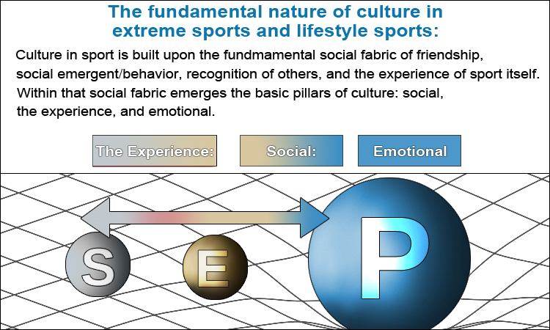
Figure 18. Cultural Model of Sport

The following defines the cognitive phase of elements in the Cultural Elements of Sport model (figure 18):
1. The Experience: (“The super-ego,” extrinsic/intrinsic ideas): “How does one experience sport? This concept relates to anything that is considered to bring happiness or fun or joy (hedonistic approach) to the experience of sport, and includes notions of “escape” from everyday life.
2. The Social: (“The ego,” mostly intrinsic ideas) friendship, sharing ideas, recognition of skills, learning, social, social bonding, emotional support through social interaction. Also pertains to friendship, social bonding, behavioral reciprocity, cultural intelligence, and social networking that brings the player and sport participant from attraction to attachment phase in sport.
3. The Emotional: (“The id, or personality”; intrinsic thought-processing only). How does one socially engage in sport? The “emotional pillar” relates to anything to passion or ideas of self-concept that invoke childhood memories, long-term memories, values, morals, beliefs, or judgment.
Cognitive thought-processing in the Cultural Model of Sport: Emotional thoughts are first processed in the brain unconsciously in an area of the brain called the “Mesolimbic Pathway.” This region includes many distinctive areas of the brain including the Amygdalae, hippocampus, thalamus, hypothalamus, basal ganglia, and cingulate gyrus. However, not all self-ideas are processed in this pathway alone. They also branch out to other areas of the brain including the medial prefrontal cortex, cerebral cortex, and the medial posterior parietal cortex (which is the Neural Basis of the self). Many of our emotions and self-ideas are concentrated in this pathway (evidenced by fmri scans). These brain regions can be assimilated to the various phases the cultural model (figure 18): “The Experience”, “Social,” and “Emotional.” Specifically, “The Experience” is where psychological attachment starts pointing to the medial brain regions: medial prefrontal cortex, cerebral cortex, and etc.. The “Emotional” region is where self-ideas or ideas originating in the brain regions in the mesolimbic pathway – are ideas that have the most weight or emotional influence in sport culture.
The Cultural Elements of Sport (figure 18) is a model of sports culture: a culture made up of emotions, feelings, perceptions, and attitudes that create the Social Fabric of sport. These thoughts can be psychologically characterized into various cultural phases of cognition called, “The Experience,” the “Social,” and the “Emotional” (figure 18). All of these are the psychological backbone to the Cultural Model (figure 18). The model is based off the Psychological Continuum Model. The Cultural Model's key element of fan, player participation and engagement is social interaction. While the PCM (figure 7) does a great job in highlighting social interaction described through various phases of cognition, the cultural model exclusively places emphasis on the experience of sport itself, both physically (the experience) and socially (the social component), including the emotional connection (the emotional).
The Cultural Model of Sport integrated with the Psychological Continuum Model: The awareness and attraction phases of the PCM (figure 7) are both designated and assigned to the “Experience” phase in the Cultural Model (figure 18). The “Social” phase (figure 18), the next state of cognition is where extrinsic ideas transition to becoming intrinsic ideas primarily through social interaction (as indicated in the PCM research paper). The “Social” phase in the cultural model is the equivalency of the attachment phase in the PCM. The social phase is where social interaction plays a larger but key role in the psychological attachment of sport participants to sport ideas, driving their deeper, cognitive states of sport experience. In Social Fabrics, this social phase is the “E” region in relation to the “ego.” Ego can be most affiliated with the part of the brain called the insular cortex: a region of the brain where thoughts of social decision-making and other similar thoughts occur. Social decision making relates to social-emotions, empathy, body self-awareness, and so on..
The last phase of integration, the allegiance phase (in the PCM) is the “Emotional” (figure 18) phase of the cultural model (figure 18). This phase is where most emotional feelings crystallize into self-ideas, such as engaging in a sport until the sport has become a lifestyle – not just something an athlete does in his/her spare time. During this emotional phase of cognition, core attitudes become resistant to change. In other words, as a sport becomes a lifestyle, it becomes less of a recreational activity and more of a focus into one's life and how the person defines themselves. In this cognition phase, ideas of sport have become “self-concept.” Self-concept ideas are tied to feelings of love and passion and are centric to unconscious thought-processing. Sport participants during this phase are more likely to seek out others who agree with them, in addition to sharing their intense feelings of their [sport] values with others.
This social interaction of sport participants with each other becomes sport “culture” when shared as an idea among a group and it becomes commonly accepted. In other words, shared ideas in groups become group culture. Being passionate about something makes people want to share their ideas or cultural views because the emotional element is central to our lives: the “hot” decision-making or emotional-reasoning process. This type of thinking has an impact on cognition, starting at the “Social” phase of sport (or any social idea thereof). Psychological attachment to sport commences when “social” behaviors engages sport participants in an emotional way.
Social interaction helps us transition from extrinsic thinking to intrinsic thinking: Extrinsic thought-processing occurs at the attraction phase of the PCM (Figure 7). To get from extrinsic thought-processing to intrinsic (the attachment phase), social interaction is the main motivational factor throughout this transition. If we first bind people's passionate feelings to a particular sport and then to their social connections with other players in same sport, we essentially can partially emotionally hijack an individual's decision-making process in that sport by sparking unconscious emotional reasoning (hot reasoning). This cognition would take over the player's conscious, rational thought processing and make it more emotional and personal to other players of the sport. In this manner, sport has a social vehicle to which the sport becomes lifestyle to the sport participant. This transition from rational to emotion thought processing is achieved primarily through social interaction (in between the “attraction” and “attachment” phase in the Psychological Continuum Model, Funk & James; 2001). Although other priming factors as involved during this transition – which is a transition from extrinsic to intrinsic thought processing – social interaction is the primary mover of a sport participant's level of attraction to attachment phases of cognition in sport. In other words, simply being social with other players brings about greater emotional attachment to the sport paired with current life experiences. Without social-psychological attachment, sport would be much harder to attain an attachment or allegiance phase of cognition, though, would not render the transition impossible. To explain further, imagine for instance, I placed you on a desert island and gave you a skateboard. The rules are that don't have access to the outside world whatsoever. You only get a skateboard, a place to skate, some various other forms of sport equipment, and a sustained way of life (food, water, and adequate shelter). Nothing else you are allowed: no technology, no people, and no communication with people or to the outside world (phone, internet, radio, etc..). You are completely alone. As castaway on this island – a given a skateboard to occupy your time – you would probably have a hard time becoming psychologically attached or allegiant to skateboarding than if you weren't on this island and instead, had lived and congregated in a world filled with people. But since you're completely alone, including all forms of communication and even images of people (since you have no technology), your psychological attachment to skateboarding would most likely be centered around hedonistic ideas, such as having fun and killing time.
But for skateboarding to become a self-concept – while you are “living on this desolate island,” – would be much harder to attain as lifestyle because there is no social interaction. Social interaction serves to intensify the emotional experience of the things that we do. For example, imagine that – while you are still on this desolate island – that you were to hold a party. While the notion straight off seems impossible because how can you have a party by yourself? – may not be possible, just consider this thought experiment.
The party is set up like a regular party: music, drinks, dancing, etc.. And sure, the party could quite possibly be fun, especially if you role play, but there are limitations to how exciting a party can actually be when experienced alone. Social interaction therefore is a key factor to how emotionally things can be automatically perceived. It's the people in our lives and those around use that intensify our emotional experiences to the things that we do.
Social interaction therefore is a critical first step towards bringing sport participants closer to a psychological attachment to sport (in the PCM). The “Social” phase of cognition is a phase in which it allows us to “piggy-back” extrinsic ideas to intrinsic ones – its emotional cousin. Emotion is invariably what brings us closer to psychological attachment to ideas and things we experience in our world. And sociability is the major vehicle to which delivers that psychological attachment. Perhaps this is why team sports are inherently more popular than individual sports: it's because team sports are inherently social by nature. Social interaction brings people closer together emotionally, both in feeling of pride (serotonin), and physical and emotional connections to others (oxytocin). These hormones perhaps play a pivotal role in the development of ourselves (our “id”).
Social Conformity:
Once the culture of a group takes shape and starts shaping group opinion, anyone going against the group's “mass” opinion would be subject to criticism. Group opinion is an intrinsic value and therefore going against it would potentially trigger a “prediction error” signal (Dr. Klucharev, Brain Mechanisms Of Social Conformity, 2009), or an emotional affront. A point of view that is in opposition to the group would be perceived as going against how people define themselves in the context of the group. If a bunch of tennis players all got together and a basketball player joined them and the basketball player suggested that tennis be more like basketball, than a prediction error signal would most likely be triggered. If a signal is triggered, it would indicate that social conformity (the whole group being in agreement with one another) has been breached because an attribution prediction has not occurred. A conflict of core group values might arise as a result. This is an emotional response to self-ideas that are being encroached upon by an outsider. Social groups are reinforced by people who share common values and of like-mindedness. If a member of the group (an insider) however, opposes the group's values: the insider would then create a conflict of trust from within the group because the insider expressed a view that's too different from the emotional values of the group – but because he/she is considered an insider, there's no immediate wall of dismissal formed – in-fighting in political parties, for instance.
Dr. Klucharev comments :
"We often automatically adjust our opinion in line with the majority opinion," "Our results also show that social conformity is based on mechanisms that comply with reinforcement learning and is reinforced by the neural error-monitoring activity which signals what is probably the most fundamental social mistake: that of being too different from others."
Social conformity, according to Dr. Klucharev is “When we change our decisions and judgments to conform to normative group behavior.” “A prediction error,” says Dr. Klucharev, “was first identified in reinforcement learning models, and is a difference between expected and obtained outcomes that is thought to signal the need for a behavioral adjustment.” Possible outcomes of challenging social conformity is that the outlying idea or outlier him or herself, would be either rejected or ostracized from the group. Social Conformity example in Xtreme Ice Skating: Core fundamental values of Xtreme Ice Skating (regarding it's culture) is creativity and uniqueness. In relation to these values and how they had an impact on “social conformity,” a sport participant in Xtreme Ice Skating thought being too different from the “group” (the sport or team) would normally trigger a prediction error signal – an error signal triggered when a group member is perceived as being “too different” from the group (“Brain Mechanisms Of Social Conformity,” Dr. Klucharev, 2009). In Xtreme Ice Skating, the contagions of freedom (self-expression on the ice) and “creativity and uniqueness” – were the contagions of the sport that if one was to go against, would cause a prediction error signal. A prediction error signal was eventually triggered in Xtreme Ice Skating when the sport adopted ice-skating guidelines (a conflict with the contagion: freedom). Guidelines were created in the sport to instruct sport participants about how to perform various ice-skating movements technically correct in the sport (example guidelines video), however their intent was not articulated properly. Participants of the sport saw guidelines as an element of “control” – “being told how to skate.” The actual intent of the sport's guidelines was to help sport participants become better skaters. However, sport participant's rejected guidelines because they were perceived as a violation of their self-values, both of the sport and who they are personally. Guidelines violated the third law of Social Fabrics, “value system,” with sport participants. To explain, if two individuals expressed moderately different value systems from each other, social unrest between the two would likely not occur, however, if two value systems were at extreme odds with each other, than a prediction error signal would likely be triggered (particularly within a group setting). This would result in social unrest. In regards to Xtreme Ice Skating, various communication tactics tried to rectify the problem, however, sport participants remained staunchly against guidelines. Participant's perceived guidelines in a very singular way: the sport that had changed the very thing that attracted them to it in the first place. “Freedom on ice” is the contagion of Xtreme Ice Skating and was now being endangered by sport guidelines.
The answer to the prediction error signal problem was eventually realized: the problem had to do with the power of acceptance, and the ability to choose. As a result, I created a panel of decisions-makers called “Xtreme Ice Skating Board of Directors:” a governing body of sport participants who made decisions about the the sport and created agenda items to which board meetings were convened around, and meetings to which were finalized by a process where board member's votes had steered the direction of the sport. Board agenda items were voted on and policy items which received the most amount of votes became official sport policy. Sport participants, once again, felt like they were in control of the sport again, and that their freedom in the sport was once again restored.
It's important to note that most board members were Innovators – individuals who were extremely passionate about the sport, and who were loyal participants of it from the very beginning (in their own mind).

XVII. Conscious vs subconscious thought-processing:
Nicholas Christakis, “Blueprint”
- implications of social-spacetime.
- implication of a conscious manipulation (dopamine, adrenaline reaction of a threat) caused by emotional thought processing of perceived SAFETY and DANGER, its affect of the group based on behavorial recprocity, and the “prediction error signaling” of individuals affecting the rest of the “in-group” preception of out-groups, and its affect on individuals inside its own “in-group,” called a social fabric.
- A “circle of safety” is called a social fabric, which is a social network, or an individual's own social fabric.
- conscious thought-processing on how it affects group behavior vs unconscious thought processing of leadership and safety.
1. Societal Subconscious Ties (as feedback loops connected to survival):
A societal subconscious tie is a survival mechanism that exists in society, as the societal level in all people, that also exists in their brains as spiraling dopamine projection pathways (see below), which are tied to the first law: fear, security, survival, and safety (which are explained by any of the eight sub-laws of the first law of Social Fabrics). A societal subconscious tie, in short, represents our “energy” to survive, or our will to survive. This is calculated in the equation “Social = Spacetime,” as in “energy = space * social resources,” or “E=MC²” equation, which shows how our social world is interchangeable in its entirety, in all its forms in Einstein's equation, which is the same thing as the equation of “Social = SpaceTime.”
a. Societal subconscious spiraling circuits: These are the spiraling dopamine projection pathways in our brain, projected onto society, represent all of our brains in society as a societal aggregate, and can be interpreted as the “Modular Prospective of Society” (shown below).
b. Spiraling dopamine projection pathways: These pathways in the brain are actually spiraling feedback loops (as in spiraling DNA) that exist in the brain, that are projected from one brain center to the other, projecting to each other back and forth as to form a loop or a feedback, such as the loop formed from fear produced in the amygdala, to the nucleus accumbens, projected to the ventral medial prefrontal cortex where upon an internal feedback loop is established, such as heroin seeking. But this feedback look – when looked at through the perspective of not just drug addiction but as societal subconscious spiraling circuitry, which is connected to our own dopamine feedback loops ( as if society has a “hive mind”) – we can interpret some of these addictions as a spiraling dopamine projection pathways attached to survival mechanisms, sparked by innate fears such as bigotry, and further amplified by social signaling (through the nucleus accumbens, as a feedback loop from that structure to the Ventral Medial Prefrontal Cortex), such as using a social media accounts to post bigoted statements to inject more “heroin” or fear, meaning more dopamine into people's systems, tied to societal-wide spiraling circuitry, which is a subconscious addiction in society attached to fear. And this addiction becomes a full circuit when social signaling – such as bigoted statements made through social media – become tied to signaling which induces people to feel safe through the polar opposite of such signaling. In other words, bigoted statements are made, and in the same spiraling pathway, but in the oppposite direction – as in DNA in electromagnetic polarity from 3,6,9,12....to 12,9,6,3 in reverse (a full circuit or feedback loop is formed, creating a constructive interference pattern or spiraling dopamine feedback loop) – that makes people feel safe because they are receiving signaling of safety from the polar opposite of bigotry statements, such as “keeping people safe from those who don't look like us.” For example, in politics, some figures have said (and acted), on “putting up a wall on the border of the USA to protect you from people who don't look like us.” When this happened, was the ultimate turning point towards positive numbers for the political leader who acted on this idea and who said it and proposed it. Adolf Hitler did almost the same thing, but in different ways and through a different social context of signaling. People became addicted to Adolf Hitler's “cocaine messaging,” and essentially found themselves killing jews because they felt fear of “people who didn't look like them.”
* c. Societal Subconscious Social Resources, and Societal Social Resources: These are social resources, as interpreted through the model “Grand Theory of Social Spacetime” – a binary tree network that represents the entire brain structure – social resources that exist out of the reach of ordinary people, that can not be controlled under the rule of law, and are used for social manipulation (called social engineering), to either 1) suppress people's human rights, 2) give a social resource back to society in a positive way such as water and electricity, or 3) social resources as just mentioned such as water, electricity, hospitals, police and other social resources required for survival, and to keep society functioning (as to prevent mass hysteria attached to the will to survive), which are used by the very few people in society or one person in society. In other words, such social resources are controlled by the rich and the powerful or the very few who therefore, in a sense, control society because of their grip or control on such vital social resources. One example of this aside from those mentioned, are “price fixing” from pharmaceutical companies, or to that of oil, or control over social media platforms that are too big, or big banks that are too big to fail. If a bank is too big to fail, it is a societal subconscious resource, because it is linked to a survival mechanism.
Societal Social Resources (and quasi functions of social resources tied to societal perspective):
If a societal social resource is not necessarily linked to a social resource of survival, because it provides its main resource as something not needed for survival, such as Facebook, then it exists as a quasi function of survival. This means that Facebook is seen as a social media platform” as a societal social resource (that is not subconscious, but instead, conscious), but because it is so interconnected to the economy, it is a “quasi” societal subconscious resource. People see Facebook as something that's not required for survival, but underneath – in many aspects – it is, because of its vast social structures connected to the economy. The immediate perspective of Facebook would be – for example, an “indirect value connection,” or “semi indirect value connection,” – but innately, Facebook is so connected to the economy (the 5th sub-law, tied to the 2nd sublaw) that it is actually a direct value connection (tied to money, food, shelter, heat, rent, etc..).

In essence, if a business is too big to fail, it becomes attached “Time” tied to “Social” in the formula “Social = SpaceTime.” This means that a company that is too big to fail has implicated so many so many nodes or people in society in “Space,” that its affect on “Time” as a social resource directly impacts people's survival mechanisms in “Social,” (our social energy, time and energy, and our will to survive). When Leehman Brothers failed as a bank, that impact spread throughout the rest of the economy, like a domino effect, causing the rest of the economy to fall out (like a nuclear fall-out, as presented in the Terminator movie: “You will not survive the nuclear fall-out in this area”). Someone's actions brought about from the control of such a vast social resource in society connected to survival, can impact or determine whether someone else lives or dies, or whether they can feed their family or not and starve to death because of someone else's actions – not because of their own. “Too big to fail” reaches beyond personal responsibility and implicates everyone else in society at the societal level, because that social resource is a societal social resource or a societal subconscious social resource. And these implications can get vastly complex in the social manipulation of society, especially when they are used in conjunction with spiraling dopamine circuits in society, connected to spiraling dopamine projection pathways.

Modular Perspective of Society:
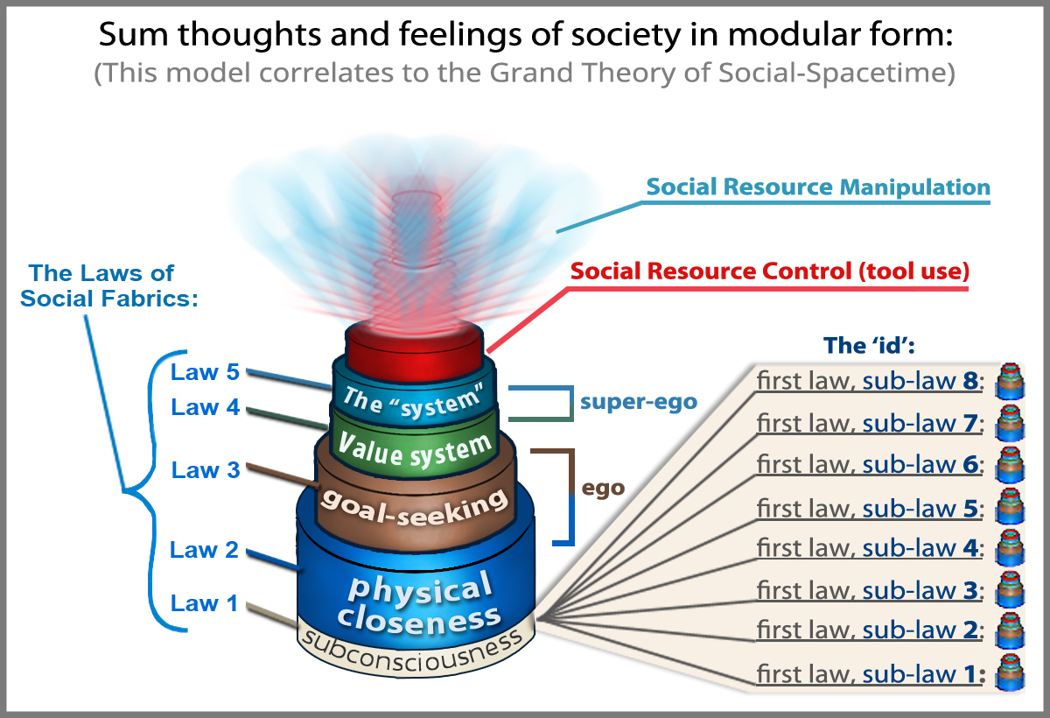
Inspiration & Fear:
Inspiration is what connects us to contagions. It creates purpose. And dopamine drives that purpose into something attainable. The hormone formula for inspiration is adrenaline (energy), serotonin (leadership) – to be inspired towards something greater than ourselves through someone or something else, and an impressive vision tied to an inhibitory dopamine response, meaning, something that is superhuman that is impossible to attain but we aspire to it for that reason, making it an inhibitory (impossible) dopamine response. This point of inspiration causing the inhibitory dopamine response of inspiration must be delivered only through the social object (person) or thing projecting it and not attainable through the self. If it becomes attainable through the self, it no longer remains an inhibitory dopamine response and becomes something attainable, through the process of reward signaling by dopamine neurons. Inspiration is like magic; once you're able to understand the magic trick, it's no longer magic.
Fear also connects us to connects us to contagions, in the form of amygdala hijacks. An amygdala hijack is when fear is created out of the threat of our survival mechanisms, creating a firewall between the subconsciousness and the consciousness, blocking the consciousness mind from higher level thinking such as aspiring to dopamine goals. However in the reverse, the part of the brain that regulates fear projected from the amygdala is the 'ventral medial prefrontal cortex.' This brain structure has a lot to do with how we categorize information and how we regulate fear and emotion being projecting by the amygdala.

Engram Cells and Engram Complex (the circuitry of the brain that represents the Golden Ratio of Mathematics):
- To be updated in further research, but the engram complex is a cluster of cell networks in the brain that represent patterns which make up memories, to which connect to each other in a chain-like fashion (similar to how social fabrics or circles connect and tie to each other in social-spacetime).
Conclusion:
The basic idea of this paper is to understand how psychological and sociological constructs of society form together into one framework called the Social Fabric framework. The Social Fabric framework can potentially model social movements, contagious ideas and other social aspects of society. While the next step of this project is to create mathematical models so they can be programmed to simulate social movements, the final stage of this project is to be able to use this technology to make remarkable predictions about social movements before they arise, including acts of terrorism, civil unrest (rise to dictatorship), and other threats to society.
My hope is that the ideas outlined in this paper can inspire the creation of a mathematical, programmable model able to [some day] predict events, such as those of terrorism, war, cyber war and other occurrences which may save lives.

References:
Books:
• Malcolm Gladwell – “The Tipping Point”; 2000.
• Malcolm Gladwell – “Blink”; 2005.
• Ray Kurzweil: “How to Create a Mind,”; 2012.
Research papers:
Social Conformity: (Dr. Klucharev)
www.sciencedaily.com/releases/2009/01/090114124109.htm
Diffusion of Innovations – Everett Rogers
https://en.wikipedia.org/wiki/Diffusion_of_innovations
Network Cosmology:
https://www.sciencedaily.com/releases/2012/11/121119140545.htm
Andy Habermacher “Hot reasoning”: “The Brain, Decision Making and the Unconscious,” Andy Habermacher.
Reality Principle:
http://en.wikipedia.org/wiki/Reality_principle
Psychological Continuum Model: Daniel C Funk & Jeff James; 2001.
https://en.wikipedia.org/wiki/Psychological_continuum_model
“Diffusion in Complex Social Networks,” Dunia López-Pintado; 2004.
“The Sociological Science Behind Social Networks and Social Influence”: Nicholas Christakis, 2012.
https://www.youtube.com/watch?v=wadBvDPeE4E
“Hard-wired: The brain's circuitry for political belief”
https://www.sciencedaily.com/releases/2016/12/161223115757.htm
Skeleton Key:
https://www.sciencedaily.com/releases/2012/06/120601231549.htm
PVH activity is essential in driving both appetite and consummatory behaviors
https://www.sciencedaily.com/releases/2015/12/151203135959.htm
Tracking the Unconscious Generation of Free Decisions Using UItra-High Field fMRI: Bode; 2011.
http://journals.plos.org/plosone/article?id=10.1371/journal.pone.0021612
“Fractal Brains,” Wai H. Tsang; 2012.
https://www.youtube.com/watch?v=axaH4HFzA24
Nicholas A. Christakis: “Blueprint: the evotionary originds of a good society”

Tim Levine: (“default to truth”)
https://www.youtube.com/watch?v=ztq-G8-bsWo

