Social-Spacetime
The 5th Dimension of Reality
© Copyright 2021 Dan Perceval.

Preface:
The first three dimensions of the universe are three spatial dimensions: forward and backward, left and right, and up and down. Next, is time, the fourth dimension. And finally the 5th dimension, which is matter in spacetime (E=MC²) that has become aware of itself – through constructive interference patterns – allowing simple states of matter to remain glued together over time to become ever more complex until it becomes self aware (matter that knows itself from other matter). Given enough time and complex conditions, matter can “glue” itself together over time (figure 1) and create DNA. The 5th dimension is essentially the presence of life inside the first four dimensions. Life therefore is the 5th dimension, matter able to look at itself in the mirror at the same point in time and “vibrate” with itself, multiple waves emanating from the same energy point due to constructive interference patterns. I postulate that this is the “ring” we hear when in complete silence, due to this continual sharing of information of stored energy states emanating from waves of matter from D.N.A. [1,2,3,4] as they remain glued together over time.
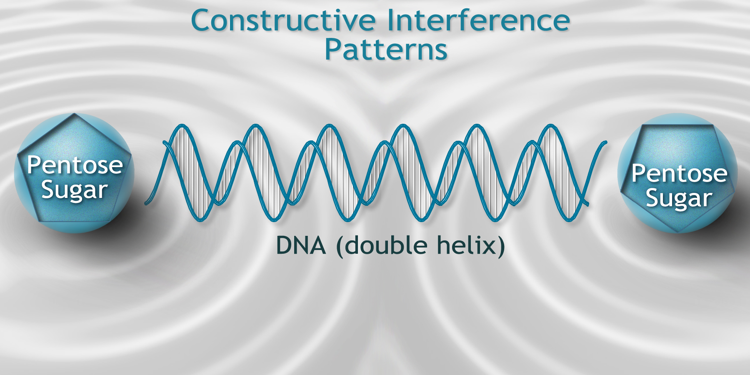
figure 1.
DNA Constructive Interference Patterns:

What is Social-Spacetime?
Social-spacetime is the social dimension of reality (or life itself) sitting inside Einstein's spacetime – which is the first three dimensions of space plus the fourth dimension time. The 5th dimension is social reality, the world we live in created by life itself:
Social (life) + Spacetime (E=MC²) equals Social-Spacetime.

Social-spacetime is a visual, cognitive, and neuroscientific theory of our social world deeply rooted within the principles of Einstein's spacetime related to physics itself. When life is present in ordinary spacetime, its neural networks create ideas and hubs (that I call contagions) that result in the formation of a new dimension of reality called social-spacetime. The “social” dimension of social-spacetime is the byproduct of life itself and how it interacts with spacetime.

In social-spacetime, life, is driven by survival mechanisms called the Laws of Social Fabrics. These laws exists where life exists. Planets devoid of life do not have these laws or survival mechanisms of social-spacetime and therefore lack the social dimension of reality. We can see lifeless worlds in atmospheres with very little oxygen present due to the lack of photosynthesis. But even in spacetime in all places throughout the universe including those places where life too exists such as on Earth, there are laws that protect the universe, laws which keep planets in their orbit – rather than a law breaking every now and then in the universe, sending planets hurtling away from their star(s). Einstein's laws of spacetime are always upheld in the universe except in black-holes (according to present scientific theory). And the laws of social-spacetime are always upheld as well, as long as life is supported.

Life can be sustained as long as there exists three basic principles of the 5th dimension: 1) survival, 2) homeostasis, and 3) survival of the species (reproduction). They can be further broken down into one simple concept: “protecting one's existence.” If you were to convert this principle into a formula it would be too general of an expression to explain all the possible nuances of life and all its occurrences. We therefore must create a hierarchical, enumerated list of survival mechanisms and complex survival behaviors to describe the most complex behaviors. These behaviors must also be “nested” inside one another to account for the infinite amount of possibilities that life creates. For example, living in a coronavirus society, our lives are being threatened by covid-19 all while, we are trying to protect our own financial security while the virus shuts down our jobs, businesses, and the economy. This complex scenario has many survival mechanisms acting upon it. However, by nesting survival laws inside one another into higher level laws, allows us to explain this complex situation by finding simplicity within complexity.
Our actions and thoughts represent both our simple survival mechanisms and complex social behaviors. Both are driven by our hormones guided by principles of survival called “The Laws of Social Fabrics” (chapter II). These laws, interwoven into our genetics and network structures in our bodies, guide our hormones. The Laws of Social Fabrics therefore can be used to model human behavior because they represent survival (as well as homeostasis and survival of the species or reproduction). In essence, these laws define the very nature of life itself. Additionally, there are higher level laws that exist above the level of survival that explain the complex nature of our social behaviors, such as movement in the environment and higher-level thinking. For example, we are more likely to be aware of people in our close physical space than those standing at a distance from us. These behaviors describe principles of survival as well as complex social behaviors. In figure 4 (on page 7) you can see the result of these behaviors as a visual construction of social reality in social-spacetime.

The “fabric” of Social-Spacetime (its constituent parts):
In figure 2, there are three constituent parts of social-spacetime that make up its actual fabric: “space” (the first three dimensions), “time” (the 4th dimension), and “social” (the 5th dimension). “Social” represents our survival mechanisms, subconscious ideas, and contagions. “Space” is mass, and it includes our conscious ideas. “Time” is causality, or anything that accumulates utility over time such as dead leaves of an ancient rain forest transformed into crude oil over time. All three constituent parts of social-spacetime make up the 5th dimension of social reality, the world we live in created by life itself.
figure 2:
(Constituent parts of Social-Spacetime)
Social: (energy: survival mechanisms [“social mass”], subconscious ideas, and contagions)
Space: (mass: life, matter, and social objects: people, conscious ideas)
Time: (causality: utility, social resources, time and energy)
Social-SpaceTime's constituent parts are interchangeable:
Figure 3 shows the social-spacetime formula: 'social = spacetime'. All three parts of this formula are interchangeable, such as in Einstein's spacetime mass and energy are interchangeable. For example, it takes time to turn ordinary mass into energy, as mentioned with the rain forests. Likewise, it takes time, meaning causality, for scientists (or social objects) to convene to discuss ideas about “social” or survival mechanisms to convert them into a social resource, such as an effective treatment for a disease. Similarly, social resources such as time and energy can be converted back into space or “mass” (people). For instance, a man who engages in physical labor (energy) over a period of time can produce a social resource such as a crop that is consumed by a pregnant woman who then later gives birth to a child or “mass,” thereby interchanging time and energy with space or “mass” (the newborn child).
figure 3.
Social-Spacetime Theoretical Formula:
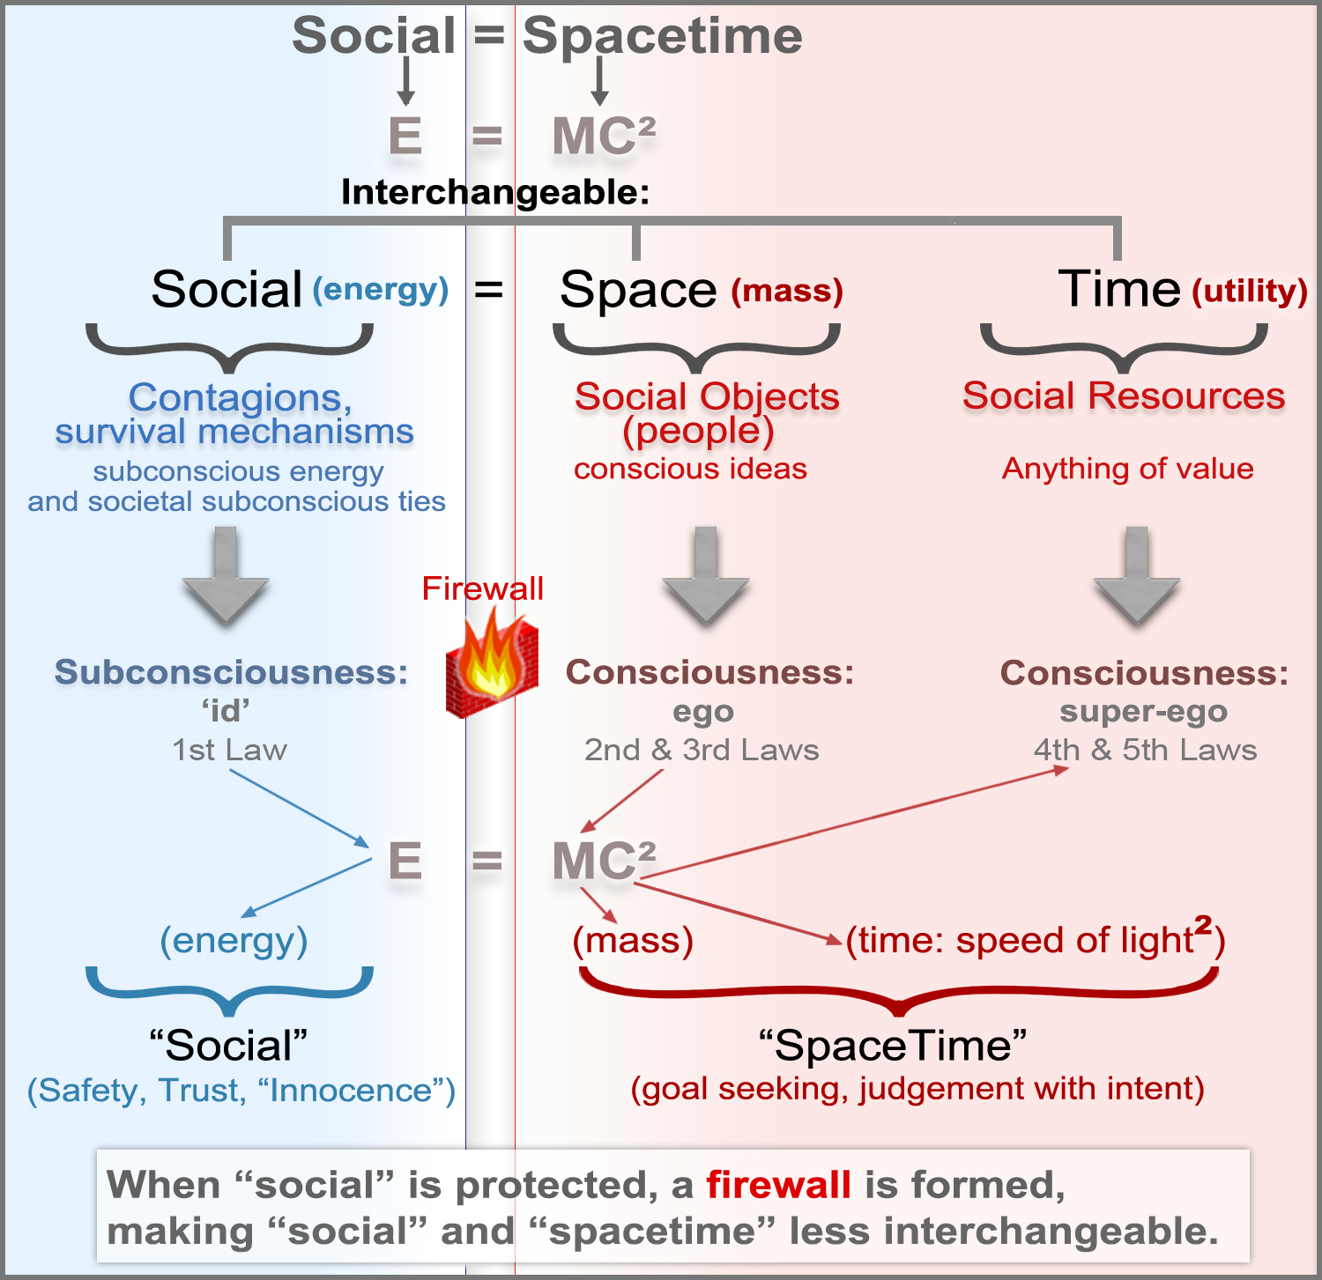

Id, ego, and super-ego (in figure-3) defines the Psychological fabric of social-spacetime:
In figure 3, on the left side of the equation (in blue) is subconsciousness of the human psyche. This region reflects the first law of social fabrics, our survival mechanisms. Here is where our subconscious thoughts transpire to become part of the id, the social dimension of social-spacetime. Once thoughts reach our consciousness, they become part of the “space” dimension of social-spacetime. Essentially this defines who we are in three-dimensional space and how we consciously interact with the physical world around us. Physical closeness (2nd law) and goal seeking (3rd law) are therefore part of our conscious dimension of space in social-spacetime. This entails how we seek out goals in space and time such as food, water, and shelter. However, we are more than just mammals seeking out simple goals. We are complex social beings. We have super-ego's that allow us to engage in complex thinking and planning which has allowed us to reshape the world we live in. The area in pink (on the far right) defines the fabric of time, which is when our simple goals become complex behaviors. Here, time interchanges with utility (usefulness) to create social resources.

“Amygdala Hijack Firewalls” prevent interchangeability in social-spacetime:
In figure 3, when “social” in social-spacetime is protected, you are protecting someone's survival mechanisms, called an amygdala hijack firewall. If you're engaged in this activity, you are making it harder for the person whom you're protecting to violate your own survival mechanisms. For example, consider the idea of someone's life whom you are actively saving from certain death, who might try to take your own life at the same time. They will have a hard a time doing this because their life depends on your survival. Imagine someone hanging off a cliff holding onto your hand for dear life as you're trying to pull them to safety – at that moment in time, they're not going to try and take your life. While this may seem like an outlandish scenario seen only in movies, consider the context of this situation taken in everyday life. How many times have you helped someone in your life, only for them to turn around and violate your survival mechanisms? This happens all the time. People often violate us for money and power (or for other reasons). Basically, people try to use their social resources on the right side of the equation (in pink) to harm our survival mechanisms on the left (in blue). This means they are trying to use their social resources in the dimension of time in social-spacetime to manipulate or harm our survival mechanisms on the left in the dimension of “social” in social-spacetime. Consider for example, what would happen to you if you had saved someone's life, but they later conspired to harm you in some future event? This person in the future will have a much harder time getting away with that goal because in the minds of witnesses and observers watching, or through video evidence, you will have set up an amygdala hijack firewall between you and that other person because you had protected their life first, thus helping you in a court of law when suing them (if the event is well documented). Additionally, you can also do harm to them first to save your own life in self-defense, which is why “protecting life” is the same sub-law as “immediate danger” or “saving one's own life.” Either way, 'the rule of law' protects our survival mechanisms in society.
Energy States of Social-SpaceTime:
In figure 3, both “social” on the left of the equation (in blue) and “spacetime” on the right of the equation (in pink) by default, are in a state of equilibrium, meaning they are in equal energy states. As previously mentioned, when [you] as a “social object” (a person) protect the survival mechanisms of your own life or someone else's, you're creating a “firewall” between social and spacetime, preventing someone else from using their conscious ideas in “space” and “time” from violating your survival mechanisms in social. In the minds of observers of that event where you are seen protecting survival mechanisms, of either yourself or someone else, you will have disrupted the neutral energy state between “social” and “spacetime,” making them less interchangeable with each other because you have established a firewall between the two. This means you are making it harder for someone on the right of the equation in spacetime to violate your survival mechanisms [or someone else's] on the left of the equation in social.

Preventing yourself from being compromised:
If you want to use an amygdala hijack against someone because they've violated your survival mechanisms, thereby holding them accountable for their actions or ideas, you must first ensure that protective cultural elements or credible resources exist in society to protect your amygdala hijack so that you are not compromised. This ensures your amygdala hijack remains well protected, and that your safety is not put at risk. This will prevent compromise of both you and the social resource you are working with. Listed below are the ways you can prevent compromise:
1) the event or idea tied to a person is actually in violation of a survival mechanism;
2) you know exactly which survival mechanism(s) is affecting the event or situation;
3) the amygdala hijack being protected is considered fact – not truth because truth is subjective reality, which can be debated because it's a conscious idea. Fact is part of objective reality, the processing of thoughts in subconsciousness;
4) the social event or idea tied to your amygdala hijack must be well recorded, documented, or witnessed, and must be a trusted source;
5) there are sufficient credible resources in society (protective cultural elements) such as a free press, social networks, government agencies, police, and other social structures available to protect the factual idea you are putting forth to support your amygdala hijack and any due process that might emanate from it;
6) enough trust is in the “social mass” or survival mechanisms of your safe object – meaning an overwhelmingly majority of people in society believe the fact you are putting forth, and trust that it will protect them or their best interests. Your amygdala hijack must also be ensured safe so anyone protecting your amygdala hijack can't be compromised themselves. If your amygdala hijack is unsafe, someone can undermine it and use it against you. If you are compromised, someone can blame you for any loss or damage to physical or intellectual property connected to your amygdala hijack. Or worse, you can be set up to do things against your own personal will, against your own safety, or against the safety of others.
7) Be careful with your ties in social-spacetime. Do not create a “double negative,” or commandeer an unsafe object by inadvertently connecting it to another unsafe object. 1) Ties are created by amygdala hijacks, amygdala dopamine hijacks, amygdala hijack firewalls, and amygdala dopamine hijack firewalls. 2) Ties are broken by dismantling them. 3) Dismantling severs ties or gravitational spheres of influence between contagions and objects in social-spacetime by disproving them with factual information from a credible resource(s), which requires your information to be delivered in an emotionally salient way within proper social context.
8) Be careful with your underlying societal subconscious ties in social-spacetime. Societal subconscious ties mean 'unconscious bias,' which is equivalent to our survival mechanisms (the first law) in society such as racism or sexism, which could also be tied to a societal contagion(s). Sometimes unknowingly you can connect your safe object to these societal subconscious ties simply by using a firewall to protect people's safety, or by forming an amygdala hijack against someone else – or even simply by dismantling an unsafe object. In doing this, you can either increase social mass that is not intended to be safe, increase awareness of an unintended unsafe object subconsciously connected to your safe object, or deflect attention away from your safe object to another unintended unsafe object connected to your safe object. Sometimes these ties must be dismantled first before creating a new amygdala hijack firewall to protect your safe object. If dismantling does not work, you must create a new contagion in social-spacetime to reconnect it to the safe modular, subconscious form of it in society (referring to figure 5). For example, you can create an indirect value connection to another unsafe object that's similar in social context to the object harming your safe object, but a much safer version of it called “getting out in front of something.” This is essentially how you “cancel out” the unsafe object. For example, consider you're in the ocean on a boat, and you observe two equally but opposite waves cancel each other out. You can do the same thing in social reality using subconscious energy or survival mechanisms that look like your safe object. So you conjure up another wave (or ripple effect) that looks just like the unsafe wave to cancel itself out – an object that's equal in magnitude and size but has no emotional salience or relevancy connected to your safe object. You can then send it back in the direction of the unsafe object, causing it to crash into itself, canceling itself out. This will reduce the harmful affects of the unsafe object connected to your safe object through any societal subconscious ties. When using this technique, make sure you use an indirect value connection, which is an ego-to-ego or 'super-ego to super-ego' connection. This will make your wave or 'ripple effect' a safe version of itself. Sometimes however, the best thing to do, is nothing at all if all solutions examined do not lead to a safe or permissible outcome.
9) Be careful not to attach unsafe objects to your contagion.
10) Be careful with people's individual subconscious energy or the will to do anything to survive. They may use any means possible to protect their own survival, even if it means violating someone else's survival mechanisms, or destroying the entire fabric of society to protect themselves. Also, a person or network of people who have lots of subconscious energy may do the opposite to protect themselves: they may sacrifice some or all of their survival mechanisms in order to protect the current system they feel safe in.
11) Always keep a map of your social-spacetime connections to use for reference. Use this map in conjunction with the modular perspective of society (in figure 5) to correlate your ideas to the right social-spacetime contagions in society to ensure that your ties between objects and societal subconsciousness patterns (aggregates of society) are correct. This will allow you to make precise predictions of situations you're analyzing.
12. Do not create hypothetical situations that are unsafe or are tied to things that are not safe, unless of course the situation really happened as you say it has, or the hypothetical situation is highly likely to occur given the burden of proof based on the context of the situation.
Agents of Change Create Causality:
Causality is the dimension of time in social-spacetime. Causality is created by two main agents of change: 1) social objects: people, and their ideas and contagions, and 2) social resources: food, energy, land, and technology. Both agents exist as nodes inside social-spacetime. A node is created when both its speed and location are known. For example, you're in the middle of the ocean on a boat and you contact the coast guard for help. And you manage to rattle of your current speed, but you're unable to give them any information about your current location. Under the information given, the coast guard will not be able to act as an agent of change to help you because your location or “space” in social-spacetime was not made known. When all three constituent parts of social-spacetime are known however: social (survival mechanisms), space (location), and time (speed and direction), they can potentially crystallize into agents of change, such as the example of the coast guard and be able to protect your survival mechanisms. These agents attract other nodes, connecting social fabrics together in the vertical y-axis in hyperbolic space – like different levels of a building, spreading through three-dimensional space upward and outward. These network structures vary in size, and are linked to their cosmological counterparts: asteroids, planets, solar systems, galaxies, and etc..
The Nature of Causality in Social-Spacetime:
Inside any social network however, causality (the dimension of time) creates the summation of everything that ever happens in life including the actions we take, the things we say, and even our own thoughts since they too affect our body language. These behaviors when perceived by others, can become socializing agents and spread significantly throughout social-spacetime, creating a “ripple effect.” Ripple effects are usually created by contagions or social objects (people) with high amounts of social mass (or a large gravitational sphere of influence). Ripple effects can impact other social networks to a significant degree, depending on its size and strength. For instance, a contagion's ripples can permeate through groups, group clusters, systems, and so on... These ripples can also impact social structures far from its contagion, called gravitational reach. For example, New York was at the epicenter of covid-19 in the United States, but the virus itself eventually reached throughout the rest of the country.

Plasticity of social networks:
Agents of change determine a network's plasticity or likelihood of change. This condition is based on three properties: 1) whether social network structures are present, inserted, or taken out (dismantled) from its parent network, or are tied to another contagion, 2) [how] much of that change is made in the overall network, and 3) how interconnected its internal social network structures are throughout its parent network, or are tied to another contagion. A better way to describe this is through a simple thought experiment. If I were to drop a huge boulder into the middle of a pond, you would see a big wave reach across the entire pond. But if instead I dropped a pebble instead of a boulder, you would observe a small ripple effect take place at the center of the pond, which would probably not reach the shore. This time, however, I want you to imagine that I dropped a huge bolder into the middle of a pond with lots of really big trees sticking out of it. The wave generated at the center of the pond would slam into the trees first, disrupting the wave's initial impact, then hit the shoreline with lesser intensity. These “trees” sticking out of the pond are equivalent to “culture” or self-correcting mechanisms in a social network. They function as networks which have stiff self-correcting mechanisms (like trees), which help to prevent change in its parent network. Sometimes “trees” can be connected to other trees throughout their roots, strengthening each others stability in the pond, making them more sturdy and thereby better protected if a wave ever hits them. In the U.S.A.'s system of governance, this idea is analogous to the three separate but equal branches of government: legislature, judicial, and executive, each supporting each other, providing a “check” or balance to one another. At higher network levels in social-spacetime, this same idea can be assimilated to smaller network structures or “smaller trees” which provide structural support to the rest of the social fabric of society.

Figure 4 shows a societal network. It has very little plasticity, which means it doesn't change often. These networks have rigid social structures nested inside of them like “trees” sticking out of the pond which are vastly interconnected smaller social network structures (in blue and red circles). They add to the parent network's overall stiffness because they increase its size and interconnections throughout its parent network, helping to prevent change.

Culture provides stability inside social networks:
Culture creates stiff, more stable network structures because culture itself is an emergent property of complexity. Networks that have culture embedded within them have more nodes, and nodes which are more interconnected. This becomes possible when emergent properties of behavioral reciprocity and prediction error signaling strengthen ties between nodes and contagions in its own parent network. Furthermore, these structural ties can crystallize into self-correcting mechanisms in the network, creating more nodes while also strengthening ties between existing ones. The more stable a network is, the lower its plasticity will be, or less likely to change because additional self-correcting mechanisms are present in the network.
Single Node Contagions:
When a contagion materializes in social-spacetime it typically attaches to a social network – or in other words, social objects (people) attach to it. However, contagions can exist without a social network called a single node contagion. For example, an impending bridge disaster might exist that no one yet knows about – called a single node contagion. However, once people realize the bridge is an imminent threat, a social network of construction workers (social objects) are prompted to fix the bridge, transforming the bridge from a single node contagion into an ordinary contagion with a social network attached (of construction workers).
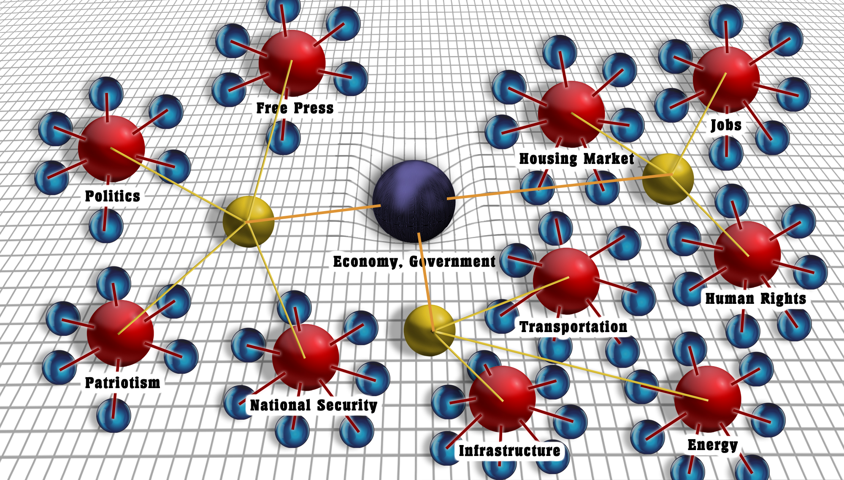
figure 4.
Societal Social Fabric

A contagion's social mass is equivalent to its gravitational reach, and how interconnected its social structures are in social-spacetime. Social mass size is also determined by how many nodes or contagions exist inside of a network. The presence of a contagion(s) inside other social networks therefore, increases the size of its parent network's social mass. Contagions that have social networks attached contain more social mass than 'single node contagions' or 'single node social objects' (individual people). Thus, the size of a social network can be classified in accordance to the number of nodes and connections it has. For example, there are single nodes, groups, group clusters, systems, system clusters, and societal networks.
Complexity in social-spacetime:
Complexity obscures our ability to act in accordance to our genetics guiding our behaviors. For example, I often see people staring at their phones while crossing a very busy traffic corner, putting their lives at risk. In the absence of technology however, we possess a much greater sense of fear and are more aware of dangers around us. However, when we're submerged in technology, we are more distanced from our natural survival mechanisms. Technology therefore interferes with our hormones, affecting our thoughts and behaviors. For example, if you are addicted to your phone, your body is releasing a much higher amount of dopamine than it normally should. This dopamine effect creates a feedback loop prompting our bodies to produce a lot more of it [₇] in the presence of technology (like drugs). As a result, technology causes ripple effects in social-spacetime, affecting our behaviors across all social network structures in society. This happens when societal social behaviors project downward into hyperbolic space towards a societal core contagion (like technology), creating a dopamine spiraling circuit in society. This is similar to how spiraling dopamine projection pathways [₇] work in the brain. They are circular pathways that exist between societal contagions and society itself, creating an interwoven feedback loop into the fabric of society. Technology therefore is a powerful agent of change (such as our phones). However, not all agents of change are positive. Technology for instance, is counterproductive to our survival mechanisms even though technology allows us to create social resources such as vaccinations and cures that enable us to save lives.
Because technology is such a powerful agent of change, it creates a ripple effect in social-spacetime that permeates across not just individual social fabrics but across almost every other social fabric in society. As society becomes more technologically advanced, so does its social complexity. Ripple effects therefore impact everything in its path, like a tsunami, changing everything in its gravitational reach in social-spacetime. And the greater the impact of ripple effects caused by technology or complexity, the further we are separated from our natural survival mechanisms. The degree to which ripples affect society is determined by: 1) a contagion's social mass, 2) how many other contagions exist within it or connect to the contagion's network from an outside network, 3) and how interconnected the contagion(s) are in its parent network. The further you go outward from a contagion – such as the “the economy” in figure 4 – the less you'll feel its impact in social-spacetime. Covid-19 for example is a virus that infected a significant amount of people living in New York, where it made its initial impact. The infections and deaths resulting from that infection, spread out quickly across social-spacetime to the rest of the United States. Over time however, social objects (people) attached unsafe contagions and social ideas to covid-19, causing the ripple effect to become even more severe, allowing the virus to reach across the rest of the country with much greater intensity, turning the initial infection into a second wave infection. Moreover a third wave infection came about due to the continuation of unsafe policies and social ideas in combination with colder weather – when more people are indoors and are physically closer to each other (2nd law), causing the virus to spread much faster.
Time and Utility are Interchangeable:
The effect of “time” on mass in social-spacetime is utility (or usefulness). Time and utility interchange to create social resources. A social resource(s) has usefulness (utility). Usefulness typically takes on greater complexity over time. Time therefore has a significant impact on complexity because time interchanges with mass (“space”), turning mass into an object(s) of complexity.
II. The Laws of Social Fabrics:
The Laws of Social Fabrics represent our biological instincts (principles of survival). Each law is listed in order, from our most crucial survival mechanism: the 1st law, to our most complex social behavior: the 5th law. In addition, these laws are hierarchical in nature and represent the human psyche: the id, ego, and super-ego. They are classified in order from simplicity to complexity.
1. General definition of SAFETY/TRUST/SECURITY/FEAR, FACTS (the 'id', survival, self-gratification):
Sub-laws of the first law “SAFETY/TRUST/SECURITY /FEAR” in order of importance in accordance to survival:
------ simple survival ------
1st: Amygdala hijack (immediate self-preservation – SAFETY/TRUST/DANGER):
Protect the-self at all costs such as being attacked by wild animal, unless it's for a cause greater than the-self.
2nd: Fulfilling immediate basic needs (energy, and homeostasis of: heat, staying cool, dry) : water (energy), food (energy), clothing (homeostasis), sleep (homeostasis), shelter (heat or fire, and staying cool from too much heat or sun - homeostasis), paying rent (shelter – homeostasis). For example, we stay cool by sweating, or by seeking out shelter from the sun.
3rd: State of well-being such as illness or sickness (immune system: homeostasis).
4th: Sex and maternal/paternal instinct, childbearing, innocence (reproduction or survival of the species).
------ complex survival ------
5th: Socially complex resources that make SAFE, or make us feel SAFE: Money, Power, Fame, Religion: The values of money and power can take the place of the first 1st law if they devolve to immediate safety and trust. For instance, [money – as the 5th law] can take the place of the 2nd law when people can no longer afford food. And when lack of food turns into starvation, [money] becomes the 1st law of survival (as well as the search for food in the environment).

6th: Love (family, relationships): Do I love someone?
(love, bonding, relationships, acts of kindness, witnessing acts of kindness.)
7th: Health: Psychological and Physical health (Health, Education, Inspiration, Happiness, and well-being): Is my psychological health and physical health intact?
- Psychlogical health (mental well-being): Freedom of speech (as noted in the U.S. Consitution).
8th: Freedom to CHOOSE, to protect lower level sub-laws (highest level complexity of survival): The power to choose one's own will in society to protect their own survival mechanisms or someone else's. The freedom of choice does not include conscious free will, such as wanting to do something or goal-seeking, because these notions are conscious thoughts.
2. PHYSICAL CLOSENESS – the “Neighbor Effect” (the “id” and “ego”):
Physical closeness, called the “The Neighbor Effect,” determines whether you trust somebody physically close to you or not. Physical closeness is based on feelings of trust and security as well as potential risk. People who are physically close to us are more likely to affect our current state of mind than those who are at a distance from us.
1st (trust): Can I trust someone physically close to me? This includes a multitude of feelings: self-preservation, love, sex, sexual infatuation, maternal/paternal instinct, etc...
2nd (danger): Entering too close into someone's personal space. If someone whom you don't know or you don't trust gets too physically close to you, they might set off your fight-or-flight mechanisms, depending on their level of physical engagement with you. Likewise, if you walk up to someone unannounced or get too close to them, you might make them feel anxious or extremely uncomfortable. But if you start charging at them, they will definitely react out of immediate fear or sense of danger.
3. GOAL SEEKING (the “ego”):
Goal seeking represents the ego. The ego fulfills the needs of the id.
1st: Seeking out or finding something you're looking for, or attaining something such as money, a job, car keys, food, chores, a lost item, a family member, fixing a relationship, and other real-world self-goals related to the reality principle. The reality principle has to do with how the mind comes to understand the world in accordance to our survival mechanisms (relating to the first law and all its eight sub-laws).
4. VALUE SYSTEM – Personal beliefs & Morals (“the ego and super-ego”):
Value system represents the ego and super-ego, which is higher level thinking. More complex thoughts and emotions transpire here and are carried out in a conscious, self reflective way. This is where we come to understand things such as good and bad, and helpful vs not helpful. These ideas become part of how we define ourselves in social reality in how we relate to others. These notions are more complex than those in the subconsciousness.
1st: “Do I perceive someone's beliefs or value values (such as morals and ethics) to be in alignment with my own?”
Description: We seek out experiences and relationships with those whom we have similar values and beliefs with in order to attain feelings of trust and safety.
Types of value system connections:
1. Direct value system connection: Sharing similar or same emotional ideas or values. This type of value system connection creates automatic feelings of trust whereby seamless social connections are made.
2. Indirect value system: Sharing similar, or same [rational] or [semi-emotional] ideas or values. Value connections made here are either “ego to ego,” or “super-ego to super-ego” value connections. These type of value system connections do not create automatic feelings of trust, because subconscious, emotionally salient connections are not made, meaning our survival mechanisms (the 1st law) are not being focused on, or are being protected.
5. PROTECTING-OR-CHANGING THE SYSTEM TO WORK FOR THE-SELF (the “super-ego”):
Protecting or changing the system represents the super-ego or very high-level thinking that relates to social resource control or social resource manipulation (relating to the Grand Theory of Social-Spacetime).
1st: Does the system, or person (or people) maintaining the system work in favor of “my” needs and values, both in the short-term and long-term?
2nd: If the system does not favor my needs and values, I therefore must change the system so that is protects my survival mechanisms and higher-level needs.
We actively work to protect or destroy the system [if]:
1. my immediate needs in the system are being threatened (taxes, healthcare, power, health, wealth, resources, freedom, etc...); or,
2. my value system (law 4) inside the system is being threatened; or,
3. I have a greater need to destroy or save the system because my life is being threatened or my freedom is being threatened.
III. The Laws of Social Fabrics are “nested”:
The Nested Laws of Social Fabrics are the original laws in chapter II nested inside one another. Nesting allows you to see simplicity within complexity. For example, if you see a bear in the woods and it starts running towards you, your immediate reaction would be to run. This shows that you are acting on the first sub-law of the first law of social fabrics: immediate danger. However, the bear running towards you is acting on the second law, physical closeness, in accordance to [its] survival mechanisms: protecting its young, finding food, etc... Now let’s assume that the bear running towards you is much further away (the 2nd law, physical closeness). You would now perceive the bear to be less of a threat. However, if your child was running next to you as the bear was chasing after you, you would experience more social complexity. For example, what if the bear closing in on you, went after your child instead? Would you fight the bear to save your child's life, or would you run away? Since this situation is about survival (the 1st sub-law), your reaction will always be to protect life whether it's your own or your child's. Survival is therefore the most significant law, and it is the most simple.
The context of this situation shows us that physical closeness plays a predominant role in how we behave in physical space in accordance to our survival mechanisms. For example, we are always seeking out food, water, shelter, and sleep to fulfill our most basic needs. When these basic needs are met, we look to attain higher-level needs. For instance, you might search for your car keys in order to go to the movie theater. This means you are acting on higher lever laws of social complexity (goal-seeking), rather than lower level laws of survival. Still, you need your car keys and your car to go to work every day so you can continue to make money (2nd and 5th sub-laws), to be able to put gasoline (a social resource) into your car so you can go to the movie theater to enjoy yourself. As you can see, there are numerous Laws of Social Fabrics nested within each other that describe this situation. And in the same way, nesting laws inside one another can be used to describe any social situation in life, no matter how complex. If you learn to nest laws inside one another, you can begin to understand simplicity within complexity in our social world. The Laws of Social Fabrics are a hierarchy of laws. They are also equal to the Golden Ratio in mathematics which represent fractals (self-similarity and nesting). This allows you to explain any situation in life regardless of complexity.
The Neuroscience of Emotionally Salient Objects in Cognition:
When our thoughts originate at the subconscious level of cognition, they crystallize into simple survival mechanisms. As they reach consciousness, they become increasingly complex. This process starts with simplicity, with emotionally salient stimuli coming in from sensory input (of any social situation). Neutral stimuli from this input are then outweighed by any emotionally salient stimuli. The “winning” stimuli are then compared to any previous neural pathways of similar social context and similarly learned behavior. Any patterns that match become a coupled pattern, and fire in a “hand in fist” like way [5]. Together over time, these commonly fired neural pathways turn into learned behavior. Your view of the world therefore is a lens of everything you experience (sensory input), re-experience (dopamine feedback loops), through what's good and bad (survival mechanisms), and what's helpful versus not helpful (social resources) all tied to trust and safety. This is the process to which the mind comes to understand the world to keep us alive (called the reality principle).
Our minds therefore are always seeking out the most important, relevant ideas about our social world to keep us alive based on things we trust, tied to things we perceive as safe. Often times though we believe incorrect conclusions about situations in life, regardless of our “instinctual” reactions to them. This happens because our subconscious feelings get attached to our passions, goals, and desires from our consciousness. These emotions project onto our subconscious as coupled emotional value sets, creating feedback loops from our consciousness to our subconsciousness (primarily to our ventral medial prefrontal cortex before hitting the amygdala). This means that our emotional conscious ideas have latched onto our subconscious thoughts (survival mechanisms), overriding them with emotionally salient thoughts tied to addiction (such as the nucleus accumbens, a part of the brain tied to drug addiction). As a consequence, people continually walk across busy intersections with their heads in their phones as cars are careening by them. In other words, due to their addiction to their phones, dopamine has shifted people's fear response upward. As a result, more fear is required to sense danger in that same situation. Feelings of trust and safety therefore attach to our addiction based behaviors in our consciousness tied to our subconsciousness. This drives away fear because addiction (such as our phones), ties to feelings of safety in our subconsciousness through addiction-based dopamine feedback loops. These loops are the reason why emotional hijacks and amygdala hijacks work against people – because our consciousness can be hijacked by our subconsciousness, subverting our ability to stay safe. Much of these behaviors are processed in the part of the brain called the ventral medial prefrontal cortex, where things perceived as dangerous are “re-categorized” into things perceived as safe. This is further amplified by the dorsal striatum, where addiction based behaviors become habit learned behaviors [6]. Here, thoughts are tied to dopamine signaling, increasing cravings of addiction (to dopamine for instance connected to our phones). Ordinarily these pathways work in accordance to nature. However, our biological machinery is not equipped to deal with this level of technological complexity. It is throwing off our dopamine circuitry and hormones in our bodies, where people are no longer sensing danger the way our genes have intended us to. This cultural phenomenon, woven into the fabric of society affects our behaviors. Today, you can expect to observe a couple sitting at a dinner table in a restaurant with their phones out in front of them. This shows you who or what is more important to them. Today's world has turned into a technological feedback loop, projecting complexity onto society, affecting all of us.
Finding simplicity within complexity:
Technology obscures our ability to see simplicity because technology itself is an emergent property of complexity. Complexity therefore causes “ripple effects” felt throughout society. To eliminate decision-making errors caused by these ripples or waves – such as those caused by complexity, you must first understand how a social situation relates to the Laws of Social Fabrics. For example, you can find out how someone's personal goals (3rd law) are affecting their decisions by first finding the survival laws or Laws of Social Fabrics attached to them, and to the social situation, which allows you to see the survival mechanisms or simplicity within the situation. These laws will help you figure out all the possible scenarios that may arise from the social situation because they represent survival contagions. Then backwards converge them to a single point to find the contagion being acted on the most, and this will show you how someone's goals are being primarily affected by the event(s), social objects (people), and social resources connected to the social situation they're connected in. This will allow you to tie your objects and contagion(s) together to find out how someone's decisions are related to the social situation. Essentially, you are finding all of the constituent parts of “social,” “space,” and “time,” and figuring out how they interchange with people and their social resources, and survival mechanisms.
The general feeling of safety and trust is connected to the 2nd law of physical closeness:
Feelings of trust and safety emanate from our subconsciousness. When we're around family members, friends, or a significant other, we typically feel safe. Moreover, the more time you are physically close to someone – causing the release of oxytocin [8] – the more likely you are to feel safe around them. Over time, by being physically close to them, you are more likely to gain their trust. As a result, they will feel safer in your presence. Feelings of trust and safety therefore are connected to physical closeness and physical safety. For that reason, we expect people in our social relationships to reciprocate those same feelings. That is why family, friends and acquaintances insist on shaking our hands, giving us hugs, or 'fist pounding' whenever we greet each other, because they reinforce those social bonds of trust and safety. And likewise, mutually warm feelings signify a relationship exists between you and the other person. If individuals whom you may come into contact with develop feelings of trust and safety towards you, they will connect themselves and their social network(s) to you. Social bonding and social relationships therefore are built upon trust, based on safety (the first sub-law). Weak social relationships however are built on minimal safety and almost no trust. For example, someone whom you are acquaintances with, you would expect them not to physically hurt you. However you probably wouldn't trust them with your life, health, or financial security. Likewise, a strong relationship is built entirely on trust based on physical safety (and health and financial security). You would probably entrust these survival mechanisms with your family, spouse, or very close friend. However, most social relationships outside of this context, have some mixture of trust inbetween that, of family and an acquaintance. When feelings of trust, safety, and security solidify in a network, they can significantly strengthen ties between people (nodes) and social relationships (networks).
The Modular Perspective of Society:
The modular perspective of society in figure 5 shows society as an aggregate mirror image of the human psyche. In other words, similar parts of the whole of society are equal to the same parts of the situation you're observing. Euclid, who lived around 300 BC, considered the founder of geometry, once said: “Things which are equal to the same thing are also equal to each other” (relating to The Golden Ratio of mathematics). In essence, social situations connected to the whole of society are equal to one another in their constituent parts. Furthermore, you can find these modules yourself by finding the aggregate patterns of society based on the Laws of Social Fabrics. Then, compare them to any emotionally salient patterns found in the social situation you're observing to better understand its social context.
In figure 5, you can see the grouping of 'societal values' listed as modules. These modules represent the sum of the human psyche of society, shown on the left (in blue) listed as “Law 1,” “Law 2,” and etc.. You can relate those modules to the social situation you're focused on. For example, “sub-law 1” represents aggregate behaviors of the “fight or flight” part of the 'id', which defines 'societal subconsciousness.' You can use this module(s) to tie objects together in the social situation you're analyzing.
figure 5.
“Modular Perspective of Society”
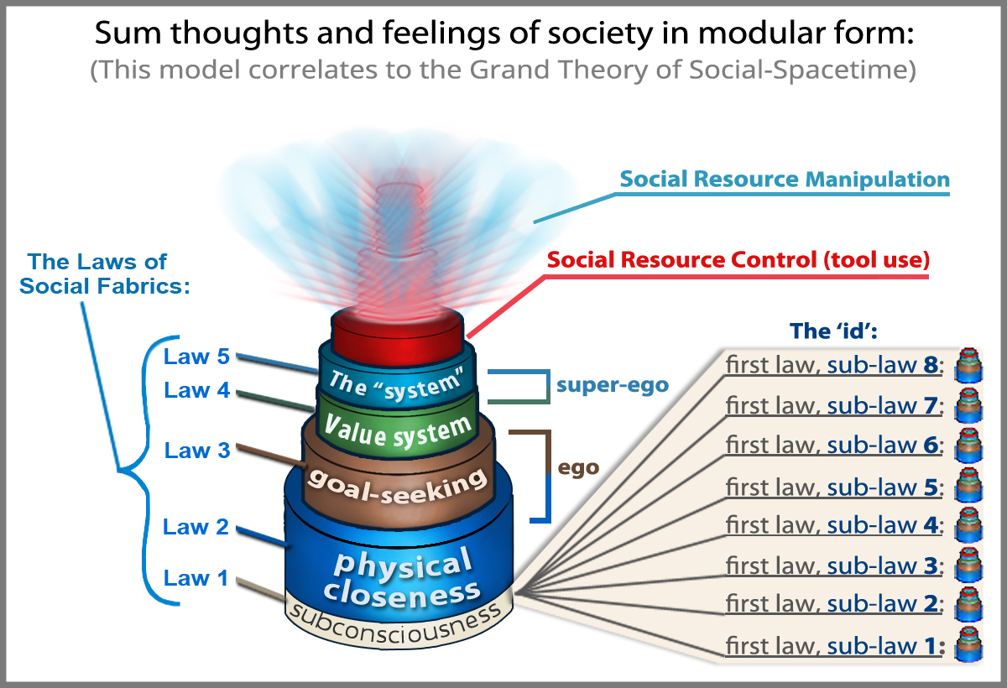

“The Perfect Human Society”:
Perhaps we can create a great human society where human suffering becomes a thing of the past. “Societal firewalls” can be set up using protective cultural elements – self-correcting mechanisms tied to safety and survival – that interweave throughout the fabric of society, preventing the dark side of humanity (our consciousness) from ever being interchanged with our survival mechanisms ever again (our subconsciousness).
Figure 6.
The Nested Laws of Social Fabrics
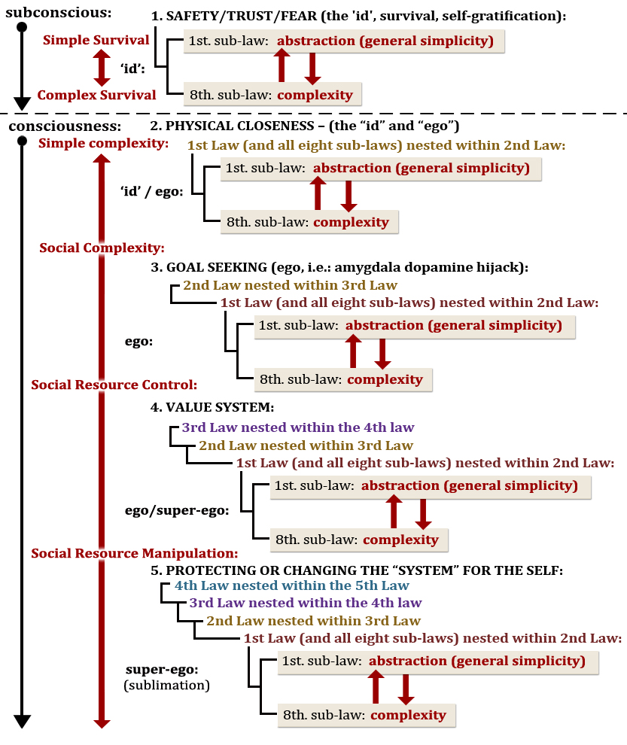

References:

1. “369 D.N.A. Geometry for Stretch & Winding Strings.” Youtube, uploaded by ThePaulTM, 23 October 2014, https://www.youtube.com/watch?v=8UPD2_gEjvM
2. Poponin, Vladimir. 1992, “The DNA PHANTOM EFFECT: Direct Measurement of A New Field in the Vacuum Substructure.” AssociaCao Medico Espirita Do Brasil. http://www.amebrasil.org.br/html/pesq_phantom.htm
3. “The 369 DNA Non-Chaos Metro for creating PERFECT 3D ORDER.” Youtube, uploaded by ThePaulTM, 31 March 2013 https://youtu.be/ArZLXHVVV5I?t=253
4. “DNA Geometry and Navigation part 1” Youtube, uploaded by ThePaulTM, 14 January 2014 https://youtu.be/wtZeZ3NeR9E?t=382
5. Tsang, H. Wai. Fractal Brain Theory. Tsang, H. Wai. 2016. pg 389
6. Volkow, Nora D., Wang, Gene-Jack., Telang, Frank., Fowler, Joanna S., Logan, Jean., Childress, Anna-Rose., Jayne, Millard., Ma, Yeming., and Wong, Christopher. “Cocaine Cues and Dopamine in Dorsal Striatum: Mechanism of Craving in Cocaine Addiction.” The Journal of Neuroscience, 6 26(24):6583– 6588 6583. June 14, 2006, https://www.jneurosci.org/content/jneuro/26/24/6583.full.pdf
7. “Keramati, Mehdi., Gutkin, Boris. “Imbalanced Decision Hierarchy in Addicts Emerging from Drug-Hijacked Dopamine Spiraling Circuit.” PLoS ONE 8(4): e61489. April 24, 2013, https://journals.plos.org/plosone/article?id=10.1371/journal.pone.0061489
8. “Simon Sinek: Why Leaders Eat Last.” Youtube, uploaded by 99U, 4 December 2013 https://www.youtube.com/watch?v=ReRcHdeUG9Y

