Culture of Freestyle Ice Skating:

The "CULTURE" of Freestyle ice skating:
IV. Example in use:

ENHANCEMENT OF THE-SELF (Power, notoriety, and recognition):
The primary appeal of Freestyle Ice Skating (FIS) is "showing off" or enhancing the self. This is a critical aspect of not only Freestyle, but ANY activity that focuses on the artistry and creativity of the self, because it reaffirms the perceptual self-image. The "self" is the most sought-after trait in Freestyle by the very nature of what the sport is. Moreover, Freestyler's are prone to be very egotistical and competitive by nature, because the sport's participants are mostly young people (mostly 25 and under). This also means that most participants are still going through an identity-crisis phase. Freestylers are literally defining themselves to a great extent by WHAT they do (Freestyle), how good they are at it, and to whom they interact with.
The main purpose of FIS is to enhance oneself in regards to attraction, popularity, and skill. For freestylers, having "flow" or looking "smooth" is part of the enhancement of the self - - out of fear of looking odd, or unattractive. And this is a huge consequence that is greatly avoided by Freesylers and in particular, those still going through an identity-crisis. This explains the primary reason why Freestyler's resent the "choppy look" of Xtreme Ice Skating, rather, how Freestyler's may describe XIS. But to Xtreme Ice Skaters, this "choppy look" is a direct result of the self looking to satisfy a direct need: being a thrill-seeker on the ice, and wanting to to over-use power, speed, and quick directional changes to achieve this feeling of adrenaline rush on the ice. This is the very nature of Xtreme Ice Skating, and the very thing Freestyler's do not like because of fear of looking unattractive. Therefore, the two sports have an innate clash of culture because of difference in the direct needs of the participants that each sport provides to satisfy the ID. The EGO is how one accomplishes these needs by living a particular lifestyle to enhance their own self-reflective personality traits to reinforce the attributes of their identity. People will do things to prove what they believe.

An expression of CULTURE by a freestyler. A statement of VALUE:
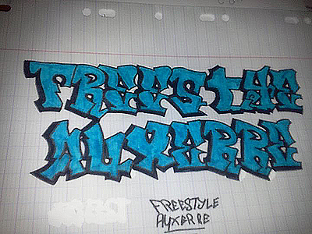
FREEDOM:
The primary personality attribute of FIS is freedom. The participants attracted to FIS choose individual sports much more than team sports simply because it is a reflection of personality type. Moreover, these participants are much more attracted to individual sports that have no rules associated with them as opposed to ones that might have only a few. These participants choose interests that best represent themselves, as opposed to personality attributes of just having fun. Also, FIS participants seek out others who agree with their personal values. This is called social conformity or social identity. However this is probably a universal trait, no matter what the personality-type is.

Social Conformity reference:
http://www.sciencedaily.com/releases/2009/01/090114124109.htm

DANCE:
What does dance have to do with popular culture?
Dance is all about freedom in expression of the self: breakdance, hip-hop style culture, DJ nights, strobe lights, friends gathered in a circle, showing off in front of a crowd, flashy and sometimes queer clothing and/or attributes such as two males holding hands playing "footsie", and Freestyle is merely an outlet for these Freestylers to do so. The creativity of dance culture also extends to the creativity the skaters have over their own individual indentities to express it in society amongst friends through sport. For instance, freestyler's like to color their skates, create different designs on the their skates, mount lights or strobe lights on their skates, and use colorful laces and/or bladeholders and/or "T-blades", which are gaudy-looking, or flamboyant. This "look" sets them apart from everybody else. That's the whole intent: to be different. A lot of the ice-skating moves or techniques used in freestyle are especially flamboyant and Freestylers reinforce these values. It seems as though Freestylers are insecure individuals, so Freestylers have to prove to themselves otherwise by expressing these attributes and personality traits.

THE SOCIAL ASPECT:
Most freestylers are afraid to be different, especially when going against the grain, or speaking out against the conventional thought. They will not defend someone whom the overall group does not like or find attractive yet, and is not associated with them. Moreover, they will scorn these people or anyone seen as dissenters.
Freestylers coalesce around an ice-skating team and show off their ice-skating "muscles" (by sense of ego and reference: THE SELF) by creating team t-shirts, Facebook groups (online social networks), logos, and videos. However, Freestylers like to be different as long as it has to do with: "us"(Freestylers) vs. "them"(everybody else). And this is a way of seeking respect. It may also be the reason why a lot of tricks in Freestyle have nothing to do with ice-skating at all. It is because these tricks make freestyler's look better, and therefore, separates themselves from everybody else: "them." A lot of Freestyler's have gotten news coverage of their teams. These teams try to make a name for themselves because of popularity and respect (around the world). This probably means that Freestyler's are seeking press/media coverage NOT because of business per say, but they are seeking enhancement of the self (item #4 above). This is within the social fabric of the compelling force (shown in image above).

POP-MUSIC & POP-CULTURE:
Freestylers are all about popular music (music that is seen by most as cliché), and popular culture: being a teenager, showing off, trying to stand out, and being different on purpose. This is what Freestyler's aspire to. The resounding resemblance of all of this is that it closely emulates the lifestyle of a teenger going through an "identity-crisis", - - something that all young people go through, though at different levels. Most skaters in this group are comprised of young males aged 18-25 with approximately 10-15% of them being female.

MUSIC:
Questions: Why do Freestyler's use "pop-music" to represent their sport? If Freestyle was supposedly in existence for decades, than why is it being rebranded as new?
The skating style has been around for decades, but the organization of Freestyle itself is new. Freestyle is emerging as a sport -- though not quite yet. This is what is considered new in Freestyle. Fresetylers feel as though they have created a culture, and a sport because of significant changes of organizing and growth they have seen throughout.

V. Defining "Ego-Identity" in Xtreme Ice Skating:
1. Semi-strong to strong identity values or attributes that not do change much throughout someone's life):
Thrill seeker: adrenaline, action-packed, speed, power, fear of danger.

VI. Social Fabric and defining cultural identity:

A. Identifying cultural identification: ("compelling force"):
1. Sunglasses:
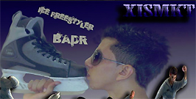
2. Camera angle:

3. Lighting: (sun or artificial)

4. Attire: (fashion)
- Team clothing, skater's match their clothing and team brands. Black and green are popular colors.

5. Facial expressions: (portrying emotions)
- This is questionable. Maybe some sign of displaying confidence. But also displaying fun, laughter, joy and the like.

6. Jewelry:
7. Hand symbols or gang symbols:


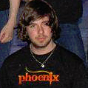
7. Hand symbols or gang symbols:




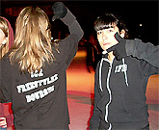

8. Body language:




B. Relation of "Identity" through culture:
1. One's "identity" is defined by a social group(s) and culture attached to such social group(s) that one is part of and bases their identity on.

Identity in relation to Gender:
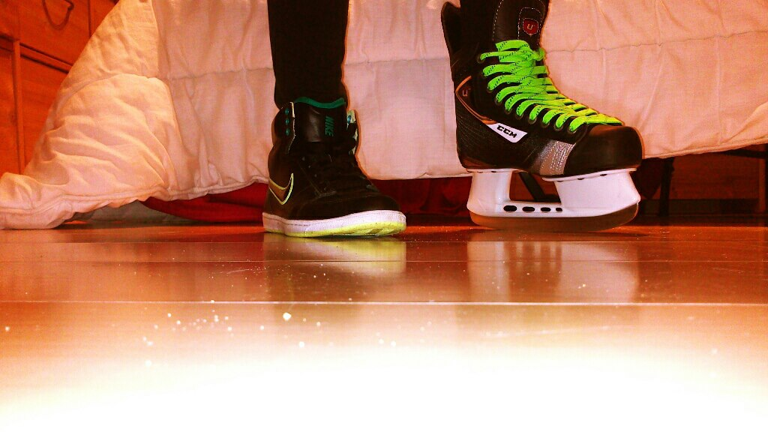
The skater commented: "This is not because I put some hockey skates and sneakers that I am a boy missing.! I also put some heels so speaks not for nothing.! "
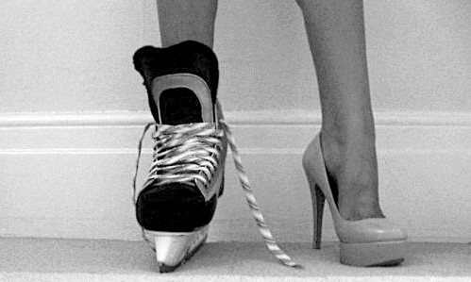

2. Where and how often are brands, team names, symbols are used in other areas of interests other than ice-skating?

C. Style and Presentation (branding and marketing):
1. How are ice-skating videos and images presented to the public?
- Is it a certain style?
- How often does this style change?
- Is the style in relation to a particular theme or social fabric?
- How often does the style change?
2. How is CONTENT related to CULTURE?

