The Laws of Life
An approach of physics and social fabrics to explain life.
copyright © Dan Perceval 2021

1. The presence of liquid water to easily create polarization (the precursor for polariton chemistry) to easily produce dipole transition, meaning an oscillation, to create electricity or electromagnetism to create constructive interference patterns:
Water, allows for the concentration of energy for diffusion to occur, or organic chemistry. One strand of DNA contains hydrogen that is slightly positively charged. It will be attracted to a slightly negative ion on the other strand, creating hydrogen bonds to hold the two strands together. Some examples of nonpolar molecules include fats, oils, and waxes because they do not have a difference in charge. They therefore separate from water. Water is polar, meaning it has a difference in charge. Light induces a wave-like alternating electric field in a medium (water) that is able to interact with polar structures and produce dipole transitions.

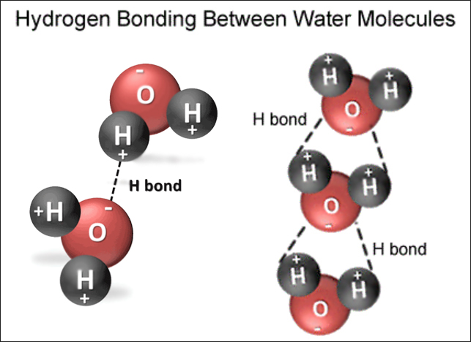
3,6,9 rule:
30+60+90 = 180°

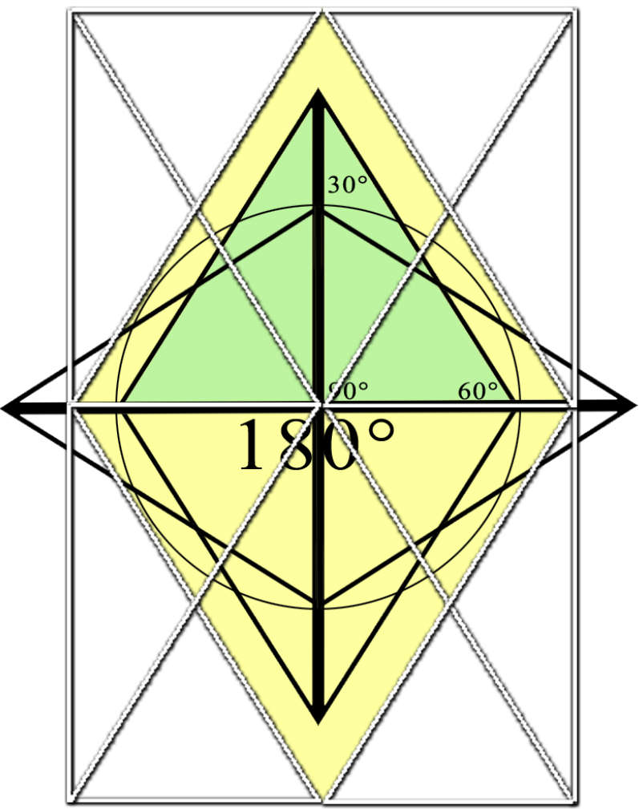
Two 30°, 60°, 90° triangles (in light green) = 180°

In water, “It is clear that in WATER (such as in a 30°, 60°, 90° triangle) there are two (vertical) planes of reflection (as shown in the image above) which lie parallel to the axis of rotation. These are appropriate for symmetry operations." In other words, water is isomorphic. It somehow helps to provide greater symmetry to prevent overlap.”

Link to science article from first paragraph of first law.

Sub-law 1:
Constituent parts of molecules are present to create constructive interference patterns.
Sub-law 2:
A way for stored energy to build upon itself, called duality chemistry (self-similarity), by way of polariton fields (binary tree formation induced by 1st electron shell formation interaction within polariton field).
θ = π/2 : The axis of rotation (of a molecule wave function – chapter 3, page 11) orients itself perpendicular to the molecular axis due to the centrifugal force, i.e. θ = π/2 is a constant value.

Rotations around the shown axes belong to the symmetry operations that transform cubes and tetrahedrons into themselves called duality (chapter 3, page 19.

Duality (mathematics):
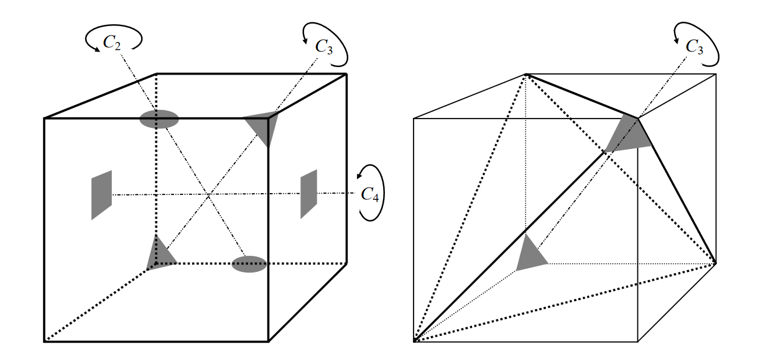
“There are five nested cubes in the dodeca. Sometimes I'm wondering if it is a 'dodeca' or five cubes.”

Sub-law 3:
Mechanism that allows for the transfer of energy (ATP → ADP).
“More recent studies have demonstrated how electric forces are essential for ATP synthesis. Specifically generated membrane potentials are able to act as a motor in mitochondrial ATP synthase, so ATP synthesis is enhanced ... From this evidence, the question that arises is why would a light-induced electric field not have the same effect? When cells are treated with oligomycin and are light-irradiated, ATP synthesis is blocked but the increase in membrane potential is not [58]. This increase in the mitochondrial membrane potential is also observed when isolated mitochondria are irradiated, which leads to an Fig. 4. This scheme shows where the enzyme phospholipase C breaks down PIP2 to form IP3 and DAG. A phosphate structure in IP3, the same as in ATP, bonds to CH2 terminal in DAG [44]. Is it reasonable to propose that light, through its induced electric field, and electric pulses share the same mechanism in ATP synthesis by altering the mitochondrial membrane potential?

2. Physical closeness:

Sub-law 1:
Sharing of electrons:
Water is a medium that allows physical closeness to occur in order to propagate chemical bonding ( sharing of electrons).
“When a laser light (800 nm) approaches neurons, without being in direct contact with the cells, their dendrites grow towards the laser spot. The authors propose that dipoles in cellular cytoplasm feel a weak optical dipole force directed to the center of the laser spot. Due to this force, the dendrites are orientated and grow following the lines of force of the electric field E.”

Sub-law 2:
Self-modification:
Water is a medium to which particles can easily get physically close to each other, and in a more controlled or stable medium (liquid water) wherein an electric current is easily formed (to create constructive interference patterns) and to easily allow self-modification.

Sub-law 3:
Self-symmetry in H20 (chapter 3, page 20) (Wigner-Theorem):
“It is clear that in water there are two (vertical) planes of reflection which lie parallel to the axis of rotation. These are appropriate for symmetry operations. Two symmetry operations are sufficient to describe all necessary symmetry operations. These two are rotation by 2π/n around an axis, and reflection in a plane. To avoid a product of operators when performing one symmetry operation, we use in addition to rotation and reflection further operators which transform molecules and crystal building blocks into themselves. These operators fulfill the requirements (in each point group), that we associate with the mathematical definition of a group: by combining two operations we get an operation that belongs to the same group.”

All the symmetry operations together build:
Cn Rotation through the angle 2π/n,
σ Reflection about a symmetry plane,
Sn Rotary reflection,
i Inversion at a center of symmetry,
E The neutral element.

Quantum wave functions:
- “The probability distributions for the first five states (chapter3, page 10) of a harmonic oscillator represented by the density of shading. Note how the regions of highest probability (the regions of densest shading) move towards the turning points of the classical motion as v increases.”
Pi Wave:
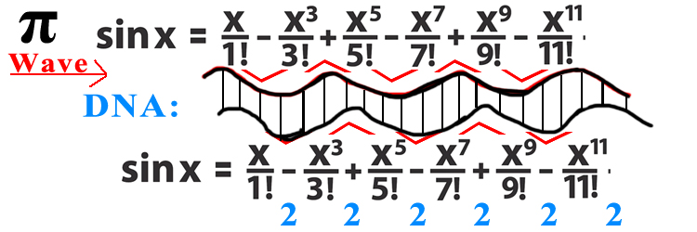
- The first five states of π (as noted above) may potentially act as a harmonic oscillator. There appears to be spiraling fibonacci spirals within Schrodingers equation (in the visual sense) that act as harmonic oscillators. These are connected to quantum wave functions, seemingly as polar arrays skipping by 2:
3.14159265 ÷ C° (299,792,458 m/s) = 0.9542690329377999 = 93 = 12 = 3
adenine?
< skip 2 digits in π >
897932384 ÷ C° (299,792,458 m/s) = 0.3338697471456826 = 10 = 1
guanine?
< skip 2 digits in π >
643383279 ÷ C° (299,792,458 m/s) = 4659624640322678 = 74 = 11 = 2
cytosine?
< skip 2 digits in π >
288419716 ÷ C° (299,792,458 m/s) = 1.039431222517395 = 57 = 12 = 3
thymine?
< skip 2 digits in π >
993751058 ÷ C° (299,792,458 m/s) = 3.314796725726139763 = 76 = 13 = 4 (base chemical pairs)

Sub-law 4:
No overlap of physical space to prevent errors:

Sub-law 5:
Gain the most energy from spreading out of physical space (using fibonacci spiraling circuits):

- In water, “It is clear that in WATER there are two (vertical) planes of reflection which lie parallel to the axis of rotation. These are appropriate for symmetry operations." In other words, water somehow helps to provide greater symmetry to prevent overlap.
- - “The Fibonacci pattern allowed some solar panels to collect sunlight even if others were in shade. Plus I observed that the Fibonacci pattern helped the branches and leaves on a tree to avoid shading each other.”
Spiraling dopamine circuits directly related to the Golden Ratio of Mathematics (1.618034) of the “fibonacci sequence,” wherein this mathematical phenomena allows for the use of all physical space without anything ever being overlapped. This is very important when it comes to protein folding, DNA, and everything else in the human body, because it prevents errors, namely cancer. This also allows nature to make the best use of space, such as a tree for example, that's able to collect the most sunlight because of its physical spacing between its leaves and branches.

3. Preservation of an energy state (such as DNA):
Sub-law 1:
Matter looking at itself in the mirror to create constructive interference patterns:
Matter that looks itself in the mirror (with reverse ionic charges, 3,6,9 configuration) that allows itself to store its own energy state in time in a double helix array. “We have found a shape-preserving, polariton-like superposition ^Ψ of an electromagnetic field and collective Raman coherences.” “It is remarkable that in this process pulse shape and quantum state of the initial light pulse are mapped onto collective, metastable states of matter in which they are stored.”
https://www.arxiv-vanity.com/papers/quant-ph/0001094/
It is envisioned that magnetic skyrmions may be used as bits to store information in future memory and logic devices, where the state of the bit is encoded by the existence or non-existence of the magnetic skyrmion. This can all be stored in a 3D geometric processor in vector form with a spiraling vector pattern, called “magnetic skyrmions AND Gate,” are part of an electronic band structure.

* What does it mean for matter to look at itself in the mirror? A molecule presents itself as a symmetry operation that can fold in upon itself in water thereby creating greater complexity in spacetime. For example, with a rotation around an axis of symmetry, ammonia and water molecules can both exchange their hydrogen atoms in such a way that the orientation and shape of the molecules after the rotation are the same as they were before. This means that two molecules can be bonded together (to share electrons) to create a bigger wave (a more complex energy state) called constructive interference patterns, that keeps its original energy state – meaning its orientation and shape in both time and space – thereby creating a contagion in spacetime that maintains its original stored energy able to look at itself in the mirror. This allows the molecule structure to vibrate with itself and another molecule at the same frequency and rotation as was before the chemical bonding, allowing more complexity within the structure to take place. With more complexity, the molecular structure will not only maintain its own energy state through mathematical symmetry, but because it can maintain this energy state over time with other molecular structures it can create even more complexity. Greater complex molecular structures allows greater emergent properties, which create even more complexity, creating a feedback loop constructive interference patterns, allowing for even more complexity to form through vibrational energy of self-symmetry through 180° reflection, and 30° and 60° rotation. This creates the 3,6,9 configuration of the universe. This is done when atoms, electrons, or molecules bond (shared electrons or “quantum energy space”) with another molecule and and rotated in spacetime to thereby create a mirror reflection of itself through self symmetry – thus creating a circuit or polar circuit array of opposite charges through spin and reflection in water through hydrogen bonding, such as in pentose sugar in DNA, maintaining its energy state through the complexity of the mathematical symmetry of the system within itself.
* While the universe may be equal to 12, the universe in regards to the dimension of time is equal to 1 (causality) which is infinity + randomness. This allows time to keep stepping forward without creating any feedback loops in spacetime. If a feedback loop where to be created at any point in time, a paradox would be created. The universe would then instantly destroy itself. In a black hole, causality stops, creating a value of 0, where causality ceases to exist. Mass can have infinite density when time doesn't exist, but not infinite energy or infinite space, which explains Hawking Radiation. Einstein's equation was never wrong when explaining a blackhole. It's just that a black hole isn't spacetime. It's merely space, which explains Einstein's equation of E=MC² breaks down at the center of a black hole. His equation includes the speed of light, causality. And causality doesn't exist in a black hole. A new equation is needed that explains E=SM (spacemass) instead of the C²). Outside of a black hole, a paradox is impossible because time (causality) exists. If causality exists and you can still create constructive interference patterns – matter that can look at itself in the mirror through time, as if matter can time travel into the past to look at itself; but matter does this instead through mathematical symmetry and mirror reflection of Pi at 180° of self folding and self reflection – this prompts matter to obey the laws of the universe and forces matter to give off and or take in an energy state, because it has managed to maintain its own energy state. With this logic, we can therefore assume that the same law exists for physics (in the Laws of Physics) whereby the most complex law of physics is the Higgs Boson particle field. This field is a constructive interference pattern that allows energy to cross over “to the other side” of the equation of E=MC² to become mass. The Higgs field therefore must obey the same laws of physics meaning, the laws of causality wherein and nothing can travel into the past. This means that, in the Higgs field, when matter is created (through a constructive interference pattern), energy must be either given off or converted into something else as the process is occurring.

Sub-law 2:
Competition of the surrounding environment:
If a scientists tries to recreate life as it was when it first formed on this planet, the experiment will ultimately fail – because life when it first formed was fragile and very simple. Life today would easily out compete it for social resources and destroy it. Therefore, an experiment such as recreating life as it first emerged on this planet, must be in a controlled environment wherein there is no competition of other life (a sterile environment).

Sub-law 3:
Energy that knows itself from other energy.

Sub-law 4:
Energy that can fix itself (an immune system) through self-correcting mechanisms – because energy can recognize itself, such as an immune system, that maintains homeostasis.

4. Carrying out instructions from stored energy states (such as proteins read out from DNA to create cellular processes):
- Stored energy states that allow for “random learning” to take shortcuts in evolution.
This condition has to do with what's called “Newton's three body problem,” where such randomness in a system cannot be predicted but its overall patterns (its contagions or prime numbers in a fibonacci sequence) can be predicted, and exhibit certain patterns (like the bands in the double split experiment). This is what scientists call “chaos theory.” This makes evolution move much faster – an exponential increase in change of the overall system due to a significant, random change in the environment (such as an asteroid which wiped out the dinosaurs, or volcanism, which led to an exponential jump in evolution, allowing humans to walk the planet).

6. Did cells used to divide based on exothermic temperature? Do cells function like thermal machines?
“The first cells might have used temperature to divide.” link

- If this is true, it might mean that “the forces driving the development of life are fundamentally simple." "And second, is that temperature gradients matter in biochemical processes and cells can function like thermal machines."

